Title:
Professional development of teachers: Using multimodality and reflective peer review approaches to analyse digitally recorded teaching practices
[Accepted by the Teacher Development journal on 18th Jan. 2013 (ref: Decision Letter (RTDE-2013-0117.R1)]

Author:
Sai Y. Loo

Lifelong and Comparative Education Department, Faculty of Policy and Society, Institute of Education, University of London, 20 Bedford Way, London WC1H 0AL, England.
s.loo@ioe.ac.uk

Abstract:
Recording technologies have been used in teaching practices. The emphasis on the quality of teachers and teaching in a recent White Paper (Department for Education 2010) in England and the necessity to optimize teaching resources due to the current global recession have prompted a re-assessment of recording technologies to pedagogic practices. In this article, the application of digital technology to analyse teaching practices may be classified into four approaches using: pedagogic theories of learning, reflective approach, ‘technical’ aspects of the digital technology, and multimodality framework. This article offers a socio-cultural framework of multimodality and reflective peer review to analyse teaching practices of and by qualified teachers. The findings of this article include: a structured approach of analysing the multi-modes of pedagogic practices, and a collaborative and supportive peer review of post teaching sessions. These findings have implications for teachers’ continuous professional development, teacher education, teaching institutions and policy-makers.

Keywords:
Teaching; Digitally recorded teaching session; Multimodality; Reflective peer review; Professional development

Introduction
Well-qualified teachers and quality teaching are essential elements in any education sector whether it is primary, secondary, further education or higher. The quality of “teachers and teaching”, is emphasized in the government White Paper (Department for Education 2010, 9) ‘The Importance of Teaching’ in England as the crucial factor in the determination of students’ performance.

Also relating to teachers and teaching was a report by Foster (2005), in which he called for a greater application of technology in teaching settings. Contextualizing the above points to the current economic situation, England and other developed countries have experienced budgetary tightening as a result of the recent global recession, which started towards the end of the first decade of the twenty-first century. This budgetary tightening has implications for the application of financial and non-financial resources in an area like education.

It is with the backdrop of the above points, which are a greater emphasis on teaching, a better use of technological resources, and a financially constrained environment that this article focuses on the professional development of teaching for qualified teachers. It does this by using firstly, digitally recorded teaching sessions and secondly, a combination of two approaches/conceptual frameworks of multimodality and reflective peer review to analyse the teaching sessions.

There are five sections. After the introduction, which provides the rationale, aims and structure of this article, the second section investigates the two inter-related conceptual frameworks: multimodality and reflective peer review to evaluate the digitally recorded teaching sessions. The next section gives details of the project, which the findings of the article are based on. The fourth section discusses the findings and the final section offers implications and applications arising from the discussions of the article.

The two inter-related conceptual frameworks

This section focuses on the two conceptual frameworks of multimodality and reflective peer review. It sets out the inter-relationship between the two frameworks, which are connected by a social cultural dimension. It also suggests that these two frameworks complement each other for the purposes of this article. The purposes are to enhance teachers’ professional practice through the analysis of digitally recorded teaching sessions. This section is organised into: the four groups of researchers on the use of recorded teaching sessions and how they are related to the conceptual frameworks in this article, the relationship between the two frameworks and the explanations of the two frameworks.

Researchers using recorded teaching sessions may arguably be classified into four groups. The first group of researchers uses pedagogic theories of learning (Mitchell, Marsh, Hobson and Sorensen 2010; Dyke, Harding and Liddon 2008; Abell and Cennamo 2004) to analyse the digitally recorded teaching sessions. The technologies may result in either synchronous or asynchronous recordings. The second group of researchers applies a reflective approach to evaluate the recorded teaching sessions (Grant and Kline 2010; Harford, MacRuairc and McCartan 2010; Newhouse. Lane and Brown 2007). In particular, Tripp and Rich (2011) reviewed 63 studies of recorded teaching sessions, which employed reflective frameworks to analyse them. The third group of researchers acknowledges the relevance of recorded technologies and the ‘technical’ aspects of the technologies are emphasized (Odhabi and Nicks-McCaleb 2011; Gardner and McNally 1995; McConkey and O’Connor 1981). Finally, the fourth group of researchers uses multimodality approach to analyse the recorded teaching sessions (Anastopoulou, Sharples and Baber 2011; Kress 2010; Lemke 2009; Yandell 2008).

All the four groups of researchers acknowledge the socio-cultural contexts. However, the term ‘contexts’ require a more explicit explanation as “less attention has been given to the difficult task of conceptualizing relations between” teachers and learners and the social world (Chaiklin and Lave 1996, 5). Chaiklin and Lave (1996) put forward an argument for a theory to analyse activities in situ such as teaching activities. Using context as a platform for analysis, Chaiklin and Lave (1996, 7) suggested that a relational approach be adopted when viewing “person, activity and situation as they are given in social practice, itself viewed as a single encompassing theoretical entity”. This context, from the perspective of this article, may include: policies, teaching institutions, teacher education and professionalism, disciplines, politics and institutional changes (Kress et. al. 2005, 21).

Turning to the first group of researchers, the possible influence of technologies was not taken into account in their analysis of teaching since they use traditional pedagogic theories. Arguably, one may suggest that a reflective approach can incorporate the use of digital technologies into the analysis framework on teaching practices. More explicitly, it is third and fourth groups of researchers that acknowledge the application of recorded technology may have an impact of how teaching practices can be perceived and analysed through a technological lens. The third group of researchers focuses on the technical aspects of their chosen technologies and as a result of this approach excludes the import of ‘theory into practice’ elements of teaching (which means relating pedagogic theories to teaching activities). Lastly, with the fourth group of researchers, the choice of using a multimodality framework incorporates the multi-modes of teaching activities within a socio-cultural environment as well as acknowledges the application of digital technologies. The approach of this article offers an inter-relational approach of the above four groups of research on recorded teaching sessions. By using multimodality, the article acknowledges the use of digital technologies in recording teaching. The approach of reflective peer group review relates to the use of reflective practice. These two approaches in combination seek to analyse pedagogic activities with a view to improving teachers’ professional practices.

As regards the relationship between the two conceptual frameworks, this article offers a nuanced approach to analyse digitally recorded teaching practices. The first approach is the application of ‘multimodality’. The reasons for using multimodality are firstly, it is a schema to analyse the different modes (e.g. visual imagery, sound and text) of teaching activities, which takes into account the socio-cultural contexts (Kress 2010; Jewitt 2009; Kress, Carey, Bourne, Franks, Hardcastle, Jones and Reid 2005). Secondly, this approach is particularly useful in the age of multi-media (as opposed to the reliance of textual analysis previously) where digital recordings of teaching may be employed in the analysis (Kress 2010; Jewitt 2009; Kress et. al. 2005). The second approach refers to the use of a reflective review (Pollard, Anderson, Maddock, Swaffield, Warin, and Warwick 2008; Hillier 2005; Schôn 1991) by peers. This approach can offer a supportive and constructive dimension to evaluate the recorded teaching sessions in a collaborative context within a socio-cultural environment (Chaiklin and Lave 1996). This approach is a further expansion of the socio-cultural contexts in which teaching practices occur. By using this second approach, teachers may arguably learn and construct new perspectives in a collaborative setting with time to reflect after the teaching activity. The two frameworks employed in this article – multimodality and reflective peer review – are thus related. They are related by socio-cultural dimension, where the specific contexts of the teachers, the learners and the pedagogic environment need to be considered. Further more, the two approaches are related by one common purpose, which is to understand better the teaching practices via digital technologies in order to enhance the teachers’ professional development. Thus, this article offers a nuanced, rich understanding and supportive dimension to analyse digitally recorded teaching practices.

Multimodality approach
Referring to the concept of ‘multimodality’, meaning is constructed through different modes, which are shaped by socio-cultural environments (Kress 2010; Jewitt 2009; Kress et. al. 2005). These modes may include “image, writing, layout, music, gesture, speech, moving image, soundtrack”..”..furniture, clothing and food” and they create meanings in these environments (Kress 2010, 54). From the perspective of digitally recorded teaching sessions, multimodality approach “provides tools for analysing and describing” (Jewitt 2009, 15) the multi-modes of classroom practices within a socio-cultural context. This form of approach to understanding meanings in visual displays, in classroom layout, in the teacher’s delivery, in learners’ posture together with written and oral activities may provide a greater understanding of classroom activities. The teaching activities relating to image, sound, text and physical space are arguably more obvious modes. According to the multimodality approach, in order to have a clearer overview of teaching practices, the context needs to be included with pedagogic interactions.

The multi-modes of meaning making in pedagogic practices were observed in English language and science classes for 13-14 years old learners in England (Kress et. al. 2005; Kress 2009). In order that the multi-modes of teaching are captured for analysis and evaluation, digital technologies (e.g. digital camcorder) may be employed to record image, sound, movement and physical setting (Jewitt 2009; Marsh 2005; Alvermann 2002). Alongside this capture of image, sound and movement, there is a relationship with the notion of ‘context’. The Latin root of ‘context’ refers to the ‘weaving together’ and Cole (1996, 135) describes it as “a qualitative relation between a minimum of two analytical entities, which are two moments in a single process”. From the perspective of this topic, teaching activities in a session exhibit several ‘moments’ such as the use of images, speech, texts and physical movements in the teaching process. The Findings and discussion section below will examine the specificity of these contexts in relation to a digitally recorded ‘Taking History’ session.

Reflective peer review approach
Teachers are encouraged to reflect on their own professional practice, whether they are in teacher training courses or after qualifying from these courses (Pollard et al. 2008; Hillier 2005; Schôn 1991). For instance, Pollard et al. (2008, 49) view “critical reflection and systematic investigation” as a central part of a teacher’s professional practice. This includes an enquiry of classroom practice and techniques of enquiry (Pollard et al. 2008). Using Pollard et al.’s approach, this article focuses on: an analysis of the multi-modes of classroom practices including those of the teacher, learners and learning environment (from ‘an enquiry of classroom practice’), and the application of digital recording of teaching sessions, listening, questioning, and discussing pedagogic practices in a peer group setting (from ‘techniques of enquiry’).

From the perspective of a peer review approach, “each individual is criss-crossed with connections to others whether on the basis of gender, level of economic income age, employment status, occupation, fashion, cult – and so on” (Schostak 2006, 101). Relating the participants in the peer review to Schostak’s definition of connected persons, they are qualified teachers from different disciplines and teaching settings who voluntarily participate in the project (for more details, please refer to the next section). This participation takes the forms of peer review and digital recordings of teaching. The participants advocated and expressly created a supportive and conducive peer review environment by explicating the ground rules for such a collaborative and supportive participation at the start of the project. These ground rules were drawn up between the participants/reviewers by common consent in order to provide a conscious relationship between the participants in this peer review process. Each reviewer “provides a point of view and a locus for action that takes the other and otherness into account” (Schostak 2006, 102).

Furthermore, the ground rules included a constructive criticism approach of the multi-modes, which came out of the teaching sessions in which alternative strategies were offered and discussed together. Also, personalised issues were not encouraged in the peer review in order to focus on the aim of the peer review process (which was to analyse and evaluate the videoed teaching sessions by reflecting on them after the recordings). Lastly, the focus should be on pedagogic and/or learning issues observed from the digitally recorded session.

Research project
The findings of this article are based on a one-year project. The Work-Based Learning for Education Professionals Centre, based at the Institute of Education, University of London, funded the project. The purposes of this study were to ascertain a structured approach to assist qualified teachers from different pedagogic, life and disciplinary backgrounds to enhance their pedagogic practices through the use of digitally recorded teaching sessions. Six qualified teachers took part voluntarily. They were tutees of the author when they were enrolled on the Postgraduate Certificate of Education (Post-compulsory/FE) (PGCE) programme at the same institution at varying periods. The research design consisted of digital recordings of three teaching sessions of the same student cohorts of each of the six teachers. These recordings totalled 18. The rationale for this approach was to prevent any abnormal student behaviour resulting from the use of digital recording equipment. The teachers eventually selected one recording of their teaching sessions for peer review. The author chose the data relating to the ‘Taking History’ teaching session of Teacher A for the purposes of this article. The research methodologies included questionnaires and focus group interviews in addition to the peer review process to capture the data. The focus group interviews and peer review process were recorded on an audiocassette and the data was later transcribed for analysis.

Please note that the terms ‘teachers’ and ‘teaching’ are used generically and are not targeted to a specific education sector. Teachers, for the purposes of this article include those from different teaching settings (e.g. further education colleges, adult and community institutions and higher education institutions) who had different specialist knowledge (e.g. dental hygiene, dance and information technology), occupational knowledge and life experiences. With reference to this article, which focuses on the digitally recorded ‘Taking History’ teaching session of Teacher A, her disciplinary and pedagogic experiences are different to her peers (i.e. Teachers B – F), who form the rest of the peer review group. Details of these teachers will be highlighted at the start of the fourth section of this article and in Table 1 in the appendix. Further education colleges in England are education institutions for learners age 14 and above. A significant proportion of subjects offered by FE colleges are in the vocational related areas. Adult and community institutions provide a wide range of usually non-accredited courses for adult of all ages with a wide range of experiences and abilities in community settings rather than formalised teaching settings.

Findings and discussion
This section is in two parts, drawing on multimodality and reflective peer view approaches. In the first part, the findings from the project will be indicated and following on from the first part, there is a discussion of the findings under the following headings: reflections of multimodality approach on the digitally recorded session; perceptions of reality; learning from peer review interaction beyond the recorded session; and the technical challenges of digital recordings. These headings should not be viewed as discrete but inter-relational as they formed parts of an overview of the analysis. The reason for the four headings is to provide a structure for analysis rather than one amorphous whole, which may appear unfocused. The main focus of this section will be on one specific digital recording of the teaching session, “Taking History” which features a tutor/teacher (who is also a participant in the project) and her learners in the dental hygiene discipline. The learners were first year candidates of a professionally accredited programme at a higher education institution. The recorded session lasted 53 minutes and six seconds. Six photographs/frames from the session will be used to support the discussion. Furthermore, the responses of the peer reviewers will be incorporated into the discussion below. The rationale of this approach is to have a detail inter-related investigation of the teaching practice using multimodality and reflective peer group review.

Findings
Referring to data from the project (Table 1), there were four females and two males. Their teaching/work settings included: three with further education colleges, two with adult and community institutions, and one with a school of dental hygiene and therapy. The subject areas taught were watercolour painting, palmistry, information technology, health and social care, dance/choreograph, life skills, dental hygiene/therapy, and psychology. Some of the participants taught in more than one disciplinary area. The age of the participants ranged from the late 30’s to mid-50’s. Their academic attainment levels ranged from: level four (e.g. first degree, Postgraduate Certificate of Education (PGCE), and Certificate of Education) with three participants and level 5 (e.g. doctorate, masters, and postgraduate diploma) with three participants. The years of teaching experience of the participants ranged from three to 17. They all had experiences of working in industry or in a professional capacity before turning to teaching. These socio-cultural contexts need to be taken into account in the discussion together with the socio-cultural framework of analysis (i.e. multimodality and reflective peer review).

Reflections of multimodality approach on the digitally recorded session
The discussion of the videoed session, which uses six photographs for illustrative purpose, is based on the multimodality approach. The objective of this investigation is to provide an overview of the digitally recorded session from the perspectives of multi-modes of pedagogic activities, which can be used in the peer review.

Photograph 1. “Start of the session” (Session time: 1 min. 10 secs.)

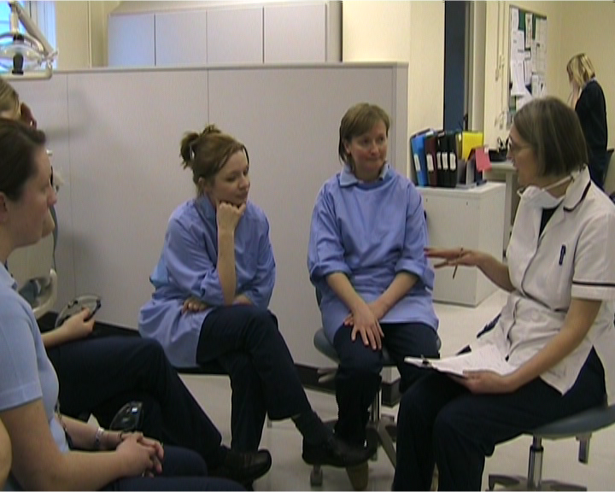

In the first photograph above, there were three significant aspects – physical environment, dental hygiene discipline and human dimension - which came out of the peer discussions. The first aspect was the physical environment in which the session was held. The room was arranged more like a simulated dental surgery than a conventional classroom. The other aspect is the identification with the discipline, with the learners’ and tutor’s uniforms (Participant A as in Table 1) and equipment. The third aspect is a human dimension, which arguably may not be similar to other teaching sessions. There was a member of staff positioned at the top right hand corner of the photograph, who was taking a phone call at the desk area. From the perspective of the learners and tutor/teacher, this might constitute a distraction as initially presumed by some of the peer review participants. But on re-visiting the preceding images, the learners and tutor appeared not to be distracted by this phone call. Perhaps the notion of a simulated working environment of a dental clinic might account for this phenomenon.

Photograph 2. “Handing out the handout” (Session time: 7 mins. 47 secs.)

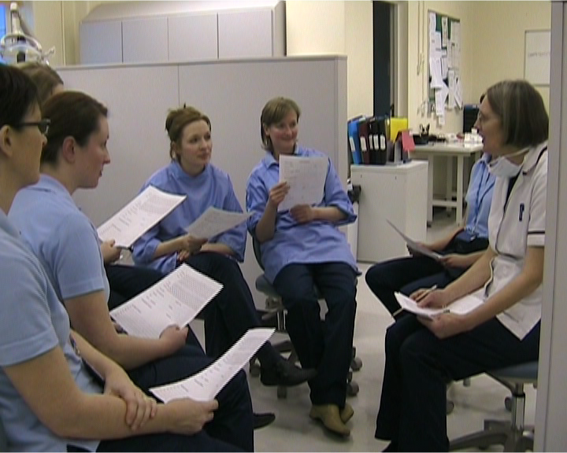

This above second frame focuses on the briefing of the simulated workshop of taking an oral history of a patient through the use of a hand out partly to re-cap the previous session. During this part of the session, the tutor used her voice (tone, pace and pitch), hand and body gestures, and movement whilst seated on her chair to brief her learners. The real-life images (as a photograph in this article for illustrative purpose and as digital recording for the peer review participants) included visual, audio and text-related modes.

Photograph 3. “Student joining the session” (Session time: 15 mins. 13 secs.)

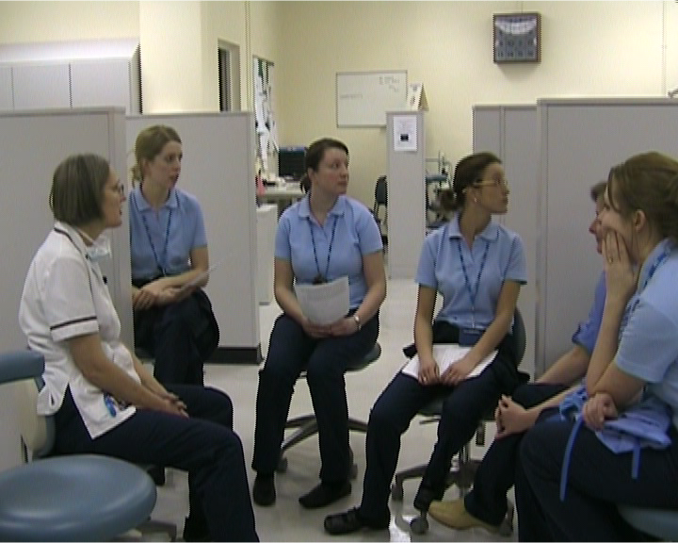

In this third photograph, the peer review participants highlighted several multi-modes of interest from their observation of the recording. The multi-modes included: the learners’ gaze, the perceived inattention to the tutor, the positioning of the group, and the use of language. At the start of the teaching session, two of the learners were being examined in a viva and the learners were conscious of the importance of the viva activity on their two colleagues, as the outcome would affect their examination results. This context might explain the apparent inattentiveness of the learners in this picture as at this specific point one of the viva colleagues came through the door. The positioning of the tutor at this particular point is of interest as the tutor/peer review participant indicated in the peer review that she was conscious of the imminent possibility of the viva candidates joining her session.

Photograph 4. “Getting ready for simulated ‘Taking History’ (Session time: 20 mins. 34 secs.)

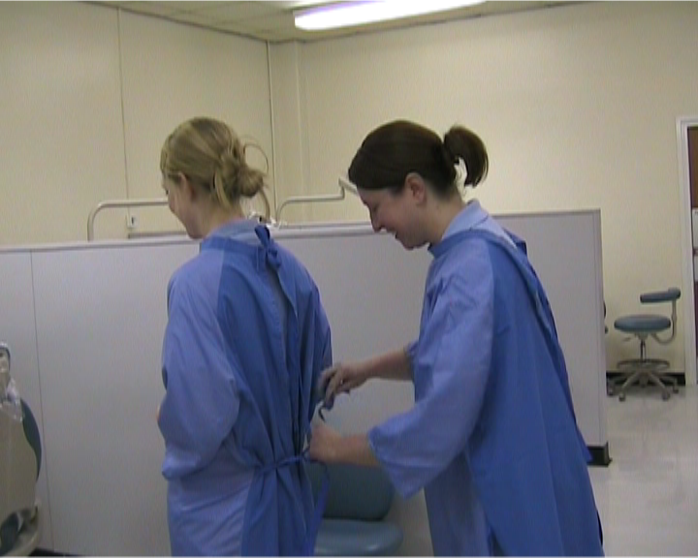

This fourth frame offers a different dynamics to the previous three photographs. The peer review participants observed that there were physical movements in terms of the learners and tutor standing up, getting ready for the ‘Taking History’ exercise and the shift in pedagogic emphasis from the tutor to the learners. The re-positioning of the participants in the videoed session indicated another change of mode. It also re-enforced the specificity of the discipline in terms of simulated activities of patient and dental hygienist, preparation such as the putting on of uniform, the arranging of equipment, the switching on of the lights for observing a seated patient, and the positioning of the patient in the dental chair etc. These activities act as re-enforcement of and a disciplinary induction into the professional world of dental hygiene.

Photograph 5. “Conferring with tutor/teacher” (Session time: 31 mins. 33 secs.)

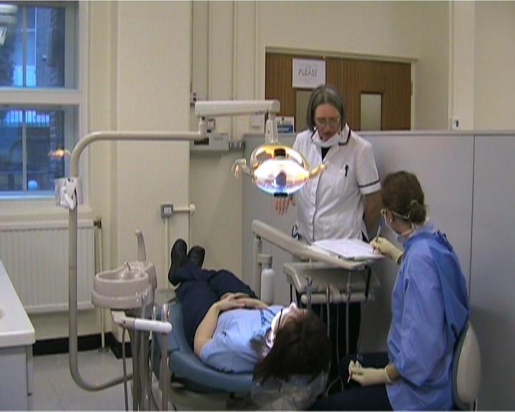

The peer review participants observed another change in ‘mode’ in teaching and learning approaches. These approaches included: role-play, questions and answers, conferring with the tutor, pair working, and simulated working. The tutor was going round the cubicles to check on the progress of the learners and she was open to questions from her learners. She was also offering useful advice from her occupational experiences on the topic of taking oral history from her occupational-practice patients.

Photograph 6. “De-briefing after the simulated session” (Session time: 50 mins. 01 secs. The session finished at 53 mins. 06 secs.)

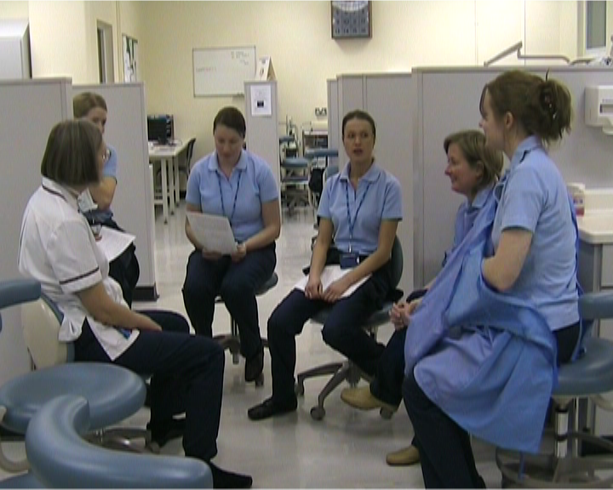

The last photograph related to a de-briefing exercise before the finish of the session. The tutor had the attention of the learners by providing a summary from her observed perspective of the activity and also opportunities for the learners to express their views and to ask further questions. This de-briefing and summing up approaches are illustrative of different teaching approaches in a teaching session.

Relating to the six photographs as described above, single photographs/frames do not capture the entirety of the ‘Taking History’ teaching session. For example, the pre-sessional activities and behaviours of the tutor and learners are not noted. The learners came into the ‘classroom’ appeared to be slightly animated on the one hand and enthusiastic to be ready for the les0son to begin on the other hand. They appeared to know each other well and perhaps the size of the group of eight created a cohesive body of people to work with. Their smart appearance in their attire of similar coloured tops and trousers and keenness for the lesson to begin gave an impression of a professional attitude. The habitus of the environment which included the physicality of cubicles, equipment, reception/office space located at the end of the room, tutor, staff members and learners in laboratory-like attire served to create a professional appearance. The manner in which the tutor signalled the start of the session by her gestures, posture and speech supported this professional and inclusive approach.

The simulated ‘Taking History’ session after the briefing might be viewed as a semiotic mode-meeting point of the everyday knowledge and experiences, disciplinary knowledge, and occupational knowledge (Vygotsky 1986). The everyday knowledge and experiences referred to the learners’ personal experiences of visiting a dental clinic and their awareness of the functions of a dental hygienist. The disciplinary knowledge referred to the technical and scientific aspects. Technical in the sense that knowledge is required to operate the necessary equipment and other artefacts in this session. In addition to the technical knowledge, scientific knowledge is also required by the learner in order to apply it to this specific ‘Taking History’ simulated session. The scientific knowledge might arguably relate to the topics (e.g. anatomy, psychology and physiology), which had been covered in other teaching sessions. However, the individual learner would need to recontextualize this knowledge for the purposes of selecting and applying the relevant knowledge to the specificity of this simulated session (Evans, Guile, Harris and Allan 2010). The notion of ‘Putting Knowledge into Work’ setting, in this case a simulated one, illustrates the relationships between the different types of knowledge and experiences in this semiotic mode-meeting point. The final type of knowledge referred to was the occupational knowledge in which the activities of role-playing as patient and/or dental hygienist in a simulated habitus with the supporting equipment, instruments, formalised forms for completion in the taking of patients’ oral history and the support and guidance of a tutor with occupational and pedagogic knowledge and experiences, all served to create a possible approach of learning to be a professional dental hygienist.

The combination of the three forms of knowledge in a simulated environment provided the learners with a sense of professional space and a possible bridge between the classroom and the real world environment of dental hygiene. The tutor might play a critical role to enable her learners to be inducted into the real world of dental hygiene. This role might include relating: the disciplinary knowledge with occupational experiences, the temporal dimension of a busy dental clinic, and the perceptions and fears of patients.

The other tacit aspects of the digitally recorded session, which might not be obvious in the six frames included: positioning, posture, gaze and gesture of the tutor and learners. These are also part of the symphony of the multimodality concept in which the tutor regulates the functions of her teaching session. An example of the incident, which illustrates these tacit aspects, relates to the duration around photograph 3 ‘Student joining the session’. The tutor was positioned in the circle in which she could see the anticipated learners returning from the examination viva. The tutor’s anticipation might include her posture to turning in the direction of the door and her absence of the handout during this briefing session unlike her learners who still had their handouts to hand. The gazes of some of the learners away from each other and in particular away from the tutor and towards the doorway also illustrated their anticipation of the return of their colleagues. These multi-modes were supported by a fleeting silence from the group. As the student entered the room with the other learners’ gaze on the in-coming student, the tutor hand gestured to welcome her and to offer a space in the briefing circle. This was followed by a verbal welcome.

There were other examples of these tacit aspects of the multimodality concept. They included in the briefing and de-briefing parts of the teaching session where the tutor would invite her learners to seek clarification of points and to provide insights into the activities. This was done through silent pauses, facial encouragements and hand gestures. These examples illustrated arguably the inclusiveness of the tutor rather than a display of power relationship between her and her learners.

The final point, which is not immediate to the readers of this article, is the relationship of the recorded session to external modes such as assessment, inspection and accreditation. The various teaching strategies indicated above (such as the handouts, the role play of patient and dental hygienist, and the de-briefing) provided an overview of how the three types of knowledge (personal, disciplinary and occupational) and their application might be connected to assessment, inspection (Office for Standards in Education, Children’s Services and Skills 2011 and 2006) and accreditation. The simulated role-play might be used as an assessment for the purposes of this course. The briefing, the use of hand outs and the de-briefing approaches provided examples of the different teaching approaches by the teacher and by extension, the programme of the varying pedagogic approaches the learners were given opportunities to acquire knowledge and skills.

Finally, the environment (such as the physical arrangement of the room, the simulation of professional practice and the attire of the teaching staff and learners), and the types of knowledge and occupational experience of the teaching staff served to support the professional capabilities of the programme for it to be accredited by the relevant professional body. The teacher/participant was asked by a reviewer in the peer review whether there was any flexibility in pedagogic approach on the topic of ‘Taking History’. To put this questioning into context, the reviewer was a full-time teacher of IT, art and palmistry in an FE college who might have different socio-cultural experiences in terms of teaching setting, a more arts-related discipline and arguably younger and more academically disadvantaged learners (Table 1) to that of the tutor’s experiences. The tutor’s reply was that there was not a lot of flexibility in the course. The course covered a large amount of knowledge with time constraints (just an afternoon to cover ‘Taking History) and further more, included the additional pressures of a professional accreditation. She went on to indicate that the learners did not have any occupational experience of ‘Taking History’ and the handout was a way of making sure that previous disciplinary knowledge relating to this topic was adequately covered and built on in the session.

In summary, the specificities of the socio-cultural-related multi-modes of this session must be explicated in order that interested parties (such as teacher, learners, peer reviewers and readers of this article) have an informed overall perspective of the digitally recorded teaching session for discussion, reflection and analysis. Turning away from the specific socio-cultural contexts of the recorded teaching session of ‘Taking History’ to the peer review discussion, three main themes were ascertained which were perceptions of reality, learning from peer review interaction beyond the digitally recorded session and the technical challenges of digital recordings.

Perceptions of reality
From a peer group perspective after watching the recorded teaching session, one of the participants (who specialized in health and social care and was a full-time teacher at an FE college – Table 1) captured the spirit of the related discussions by this remark:

“I think viewing the [digital recording] with those involved demonstrated that an observer may not be aware of the bigger picture. Learners in a classroom etc. are not blank canvases. There may be other factors going on: in the learners’ lives; learning environment affecting them; the group dynamics; and the teacher-prospective rapport. An observer either attending in person or watching a recording would not necessarily be aware of these factors.”
Participant B.

The above remark referred to the incident relating to the entrance of a learner who had just came from her examination viva (please refer to Photography 3 ‘Student joining the session’ above). Understanding the social and pedagogic contexts (as referred to in the previous part) helped the reviewers to appreciate this sequence of events. This perception of reality could only be enriched by an appreciation of the socio-cultural contexts. Some of the modes as visually evidenced such as the gaze of the learners and tutor, the positioning of the tutor in relation to the door and the anticipated silence before and immediately after the entry of the viva learner provided clues to a change in class dynamics. The explanation of the social and pedagogic contexts gave the peer reviewers a richer understanding of this part of the recorded session.

The digitally recorded teaching session also offers the tutor/reviewer another perception of reality over and above that of her perception as a tutor in the session. She referred to the time of the session when one of her learners entered the ‘classroom’ as indicated in frame 3 ‘Student joining the session’ (please refer above). She reflected on this incident in the peer review:

“I was not aware of it until I watched it myself and particularly this time. These students were not paying attention to me; they were just thinking what is going on in this other room where their colleagues were being examined. Gosh, this was something I have not realised if I did not watch that tape. This is a plus point of having the tape to play back.”
Participant A.

The replaying of the digitally recorded teaching session allows the recorded participant [A] additional space and time (as indicated by Jewitt 2009; Kress et. al. 2005; Lemke 2009) to reflect on the group dynamics (and multi-modes of pedagogic activities), which was not picked up in the real-life situation (Edwards et. al. 2007). This replay enabled the observed participant to discuss with her peers the group dynamics (in terms of gaze, posture, facial expressions and voice of the people in the session) and to provide additional insights into the discussion. The peers in return could act as a ‘fresh pair of eyes’ to bring out other issues which might not have been identified by the recorded participant. Thus, the use of a peer/tutor review of recorded teaching sessions serves as a useful tool to reflect and to gain a greater understanding (by means of acute observation and constructive discussion by the participants) of the recorded teaching session.

Learning from peer review interaction beyond the digitally recorded session
The results of a reflective peer group discussion following the viewing of the recorded teaching session covered the salient findings of a major review of recorded teaching sessions by Tripp and Rich (2011) around the three aspects of reflection. These aspects included: a useful space for reflection, the advantage of establishing a framework to analyse recorded teaching sessions, and a preference for a collaborative reflective approach. These might be encapsulated by a reflective comment by Participant C, who was a part-time teacher in dance (Table 1):

“The observation of [digitally] recorded sessions promotes self and general awareness and reflection which are valuable meta-cognition skills to learn in any professional training.”
Participant C

From the perspective of this article, an established space (both cognitive and temporal) was highly helpful in reflecting on the digitally recorded ‘Taking History’ session. The two-dimensional framework of multimodality and reflective peer review created a nuanced and structured approach for discussion and reflection. The collegial approach to an agreed set of guidelines for collaborative reflection created a strong sense of ownership and peer support in this activity.

In addition to the three aspects of reflection, the results from this small-scale survey also provided new and richer aspects, which were not reported in Tripp and Rich’s review (2011). These included: a comparison of teaching styles, the applicability of non-specialist observation, reflection and post-teaching action, and the subtlety and tacit nature of teaching.

With a comparison of teaching styles, Participant D, a male teacher who worked full-time at a further education college with specialisms in information technology, art and palmistry (Table 1) gave the following remark:

“Use of [digital] camcorder has the advantage of looking at how other teachers teach. The PGCE course did not allow that. At least in this [peer review] approach, one can look at how others do it and then discuss it. It offers a way of bench-marking, gives us more tools and also allows you to be yourself.”
Participant D

His comments reinforced the advantage of recorded sessions in which one could re-visit the recordings to gain insights into the sessions. Arising out of the peer review, these insights included learning from other styles of teaching as well as reflecting on how these styles might be relevant to one’s teaching contexts. This form of comparison might be helpful in refining a teacher’s pedagogic approach. However, the specificity of the teacher’s pedagogic contexts might be different to another teacher’s due to variations in the types of learners, programmes, teaching settings, regulations and related professional body (as in the case of the dental hygiene programme). In addition to these specific socio-cultural pedagogic contexts, one must also take into account that each teacher is an individual with different life, occupational and disciplinary knowledge and experiences together with arguably different pedagogic aims. As part of the peer review discussions, Participant F (a female teacher who specialised in teaching life skills with personal experiences of homelessness and extreme poverty and her learners included those who were vulnerable and often associated with drug abuse) highlighted her pedagogic aim was that of humanist approach (Rogers 1961). She remarked that this aim might influence her choice of pedagogic strategies compared to another teacher with a different aim such as a behaviourist approach (Skinner 1968). What this meant was that a humanist approach might involve changing the organisation of the learner in terms of his/her behaviour, perception and personality. The role of the teacher was one of a facilitator using open-ended group discussion and enabling learners’ questioning beyond the confines of a curriculum. Contrasting this with Skinner’s approach, the behaviourist approach could involve repetitive rote learning strategy in the classroom with a measurable outcome. The role of the teacher in this example was to train the learners to produce quantifiable results in response to a specific form of assessment.

Referring to the applicability of non-specialist observation, the discussion of the peer review was with reference to the reflection of the participants’ teacher education. A remark, which exemplified this area of discussion included:

“There was a value in a non-specialist observation as the observer could go in with an objective mind because he/she was not a specialist, then he/she would look at pedagogy (and not subject knowledge). There was value in itself. This would be 360 degree evaluation.”
Participant C

Participant C, a female part-time teacher who specialised in dance and her learners included retired learners who had mobility issues (Table 1), reflected on her own teacher training experiences where some of her teaching sessions were observed by a non-specialist teacher. A non-specialist teacher (not in the discipline of dance in this example) might focus on pedagogic activities rather than disciplinary matters (such as technical knowledge). This pedagogic focus might provide a richer insight into teaching as exemplified by the above discussion of the videoed ‘Taking History’ session using the conceptual framework of multimodality. However, this does not mean that observation by a specialist in the disciplinary area is of no benefit. Far from it, a specialist observer could focus on the disciplinary aspects of the teaching session, which might then relate to the pedagogic aspects to provide a holistic perspective of the session.

The third aspect, which was highlighted in the peer review, was on reflection and post-teaching action. Participant A (dental hygiene teacher) reflected on her teaching colleague’s action:

“I have one colleague who records her own lecture purely for her own professional development on how she can improve her lectures. I thought that was a very insightful feature.”
Participant A

The above remark was illustrative of Schôn’s (1991) notion of reflective action where a teacher viewed her recorded teaching sessions to reflect and fine-tune her pedagogic practice for her professional development. This is also an illustration of an individual’s self-reflection as opposed to a peer-assisted reflection.

The last aspect relates to the subtlety and tacit nature of teaching, which included this remark:

“There is so much about the subtlety of teaching which you can’t write about in great detail but much easier to look at it, like a [digitally recorded] session, and to discuss it.”
Participant E

This final aspect came up in the peer review by various participants, which was exemplified by Participant E (Table 1). She worked part-time at an FE college teaching art. She had previously worked as a community worker in numerous settings such as community centres with learner of different ages. She compared the similarities of art discipline with teaching in which a lot of the knowledge and activities could not be easily explicated. Furthermore, she explained that it would be easier to demonstrate, use analogies and metaphors and provide visual aids to assist in the understanding of the topic in question (Polanyi 1966; Nonaka and Takeuchi 1995). The tacit nature of teaching can be re-visited and reflected upon using the suggested framework in this article unlike an unrecorded teaching session. The tacit aspects of the ‘Taking History’, such as the sensitivity of applying the dental equipment on patients, and the negotiation of taking history, communication with patients and visual observation of the patient’s simultaneously, were expanded by Participant A in the peer review session by her use of analogies and metaphors alongside her descriptions of some of her occupational experiences in dental clinics in this country and abroad.

In summary, the above four aspects which arose out of the peer review indicated that it was important that socio-cultural contexts be taken into account in any pedagogic discussions even in a collaborative, supportive and with a democratically agreed set of guidelines and objectives in order that nuanced and reflective insights might be explored.

Technical challenges of digital recordings
As with any reliance on technologies, and digital technologies are no different, there may be issues with their application. These included the poor sound quality in parts of the recorded ‘Taking History’ session. This might be due to the arrangement of the cubicles and the quality of the equipment. With the latter aspect, and if the past trend is anything to go by, future digital recording equipment will improve in its functionality such as sound and visual capture. The other issue, which is not related to the quality of equipment, is the capture of the atmosphere. In ‘Taking History’ session, the briefing and de-briefing parts of the session where the teacher and her learners were in a circle formation between the cubicles illustrated a. the space constraint in which the recording took place and b. insufficiency of the camera lens to capture a 360 degree angle albeit at a two-dimensional perspective. The insufficiencies in terms of sound, angle and two-dimensional capture gave a different sense of the reality of the teaching session.

Conclusion
Teaching is a socio-cultural related activity involving people and artefacts, as explained in the Introduction section, the ‘Two approach’ section and throughout the ‘Findings and discussion’ section. This article, with the backdrop of financial uncertainties, the greater governmental emphasis on the quality of teachers and teaching and the application of technologies, provides a socio-cultural framework of multimodality and reflective, collaborative and democratically agreed guidelines of peer review to investigate and enhance teaching activities. Based on the small sample of six participants, the uses of digitally recorded teaching sessions do not appear to differ markedly from other research (Tripp and Rich 2011; Grant and Kline 2010; Harford et al. 2010; Mitchell et al. 2010). The uses included: opportunity to view how others teach, promotion of self and collaborative reflection, a fine-tuning tool (Convery 2009), and a source for comparison and for highlighting teaching approaches. Using a specific digitally recorded teaching session, ‘Taking History’ for a focused investigation, the article has highlighted the various multi-modes (e.g. environment, dynamics, regulatory requirements, professional accreditation, teaching approaches, tacit and non-verbal communication, and the role of knowledge types) for analysis. In addition to these aspects, digitally recorded sessions offered different perspectives of reality as observed collaboratively and/or individually. Furthermore, a post-recorded review offered additional insights into: a comparison of teaching styles, the applicability of non-specialist observation, reflection and post-teaching action, and the subtlety and tacit nature of teaching.

It is important to mention that there are caveats to the findings from the small-scale sample in which the participants were volunteers and therefore they are not a representative sample of teachers. In addition to this, the discussions in the article are highly context specific and the generalisability of the findings may require caution.

Having stated the above caveats, there might be implications arising from the findings with reference to: the continuous professional development of teachers, teacher education, teaching institutions and policy-makers. The socio-cultural framework offered in this article provides a structured and coherent platform for teachers to understand and improve their teaching in a collegial and supportive manner in response to the growing pressures of explicated continuous professional development as indicated in policy documents by the government in England (DfE 2010). The socio-cultural framework of reflecting on digitally recorded teaching would also be useful in teacher education programmes as this approach would provide trainee teachers opportunities to observe, compare and analyse different teaching styles collaboratively in different contexts, which relate to: teaching settings, disciplines, environments, specialist and non-specialist observations, levels and learners. Turning to teaching institutions, the proposed framework of multimodality and peer review may enhance their quality of teachers and teaching by provided a structured, supportive and collegial approach. An expansive approach to teaching quality enhancement would serve stakeholders (e.g. learners, parents, teachers, management, employers and policy-related institutions) by an improvement of pedagogic activities. As regards policy-making, this collaborative framework to improve teaching might be incorporated into policy-making activities such as drafting of teaching standards. Finally, in terms of extending the possible implications of the findings of this article, an application of this proposed socio-cultural framework might include teachers from other professions in their specific work settings such as clinical educationists in hospitals.

Acknowledgements

I would like to thank the reviewers for their constructive comments. An earlier version of this article was presented at the British Educational Research Association Annual Conference, University of Manchester, Manchester in September 2012.

References
Abell, S., Cennamo, K. and Brophy, J. 2004. Videocases in elementary science teacher preparation. In Using video in teacher education, ed. S. Abell, K. Cennamo and J. Brophy, J., 103-129. Amsterdam: Elsevier.

Alvermann, Donna. 2002. Adolescents and Literacies in a Digital World. New York: Peter Lang.

Anastopoulou, S., Sharples, M. and Baber, C. 2011. An evaluation of multimodal interactions with technology while learning science concepts. British Journal of Educational Technology 42, no. 2: 266-290.

Chaiklin, Seth, and Jean Lave. 1996. Understanding practice: Perspectives on activity and context. Cambridge: Cambridge University Press.

Cole, Michael. 1996. Cultural Psychology: A Once and Future Discipline. Cambridge, Massachusetts, USA: The Belknap Press of Harvard University Press.

Convery, A. 2009. The pedagogy of the impressed: how teachers become victims of technological vision. Teachers and Teaching 15, no. 1: 25-41.

Department for Education (DfE). 2010. The Importance of Teaching. Cm 7980. London: The Stationery Office.

Dyke, M., Harding, A. and Liddon, S. 2008. How can online observation support the assessment and feedback, on classroom performance, to trainee teachers at a distance and in real time? Journal of Further and Higher Education 32, no. 1: 37-46.

Edwards, M., Jones, S. and Murphy, F. 2007. Hand-held video for clinical skills teaching. Innovations in Education and Teaching International 44, no. 4: 401-408.

Evans, K., Guile, D., Harris, J. and Allan, H. 2010. Putting knowledge to work: A new approach. Nurse Education Today 30, no. 3: 245-251.

Foster, Andrew. 2005. Raising the potential: A review of the future role of further education colleges. London: Department for Education and Skills.

Gardner, J. and McNally, H. 1995. Supporting school-based initial teacher training with interactive video. British Journal of Educational Technology 26, no. 1: 30-41.

Grant, T. J. and Kline, K. 2010. The impact of video-based lesson analysis on teachers’ thinking and practice. Teacher Development 14, no. 1: 69-83.

Harford, J., MacRuairc, G. and McCartan, D. 2010. ‘Lights, camera, reflection’: using peer video to promote reflective dialogue among student teachers. Teacher Development 14, no. 1: 57-68.

Hillier, Yvonne. 2005. Reflective teaching in further and adult education. London: Continuum.

Jewitt, C. 2009. An introduction to multimodality. In The Routledge Handook of Multimodality Analysis, ed. C. Jewitt, 140-150. London: Rouledge.

Kress, Gunther. 2010. Multimodality: a social semiotic approach to contemporary communication. London: Routledge.

Kress, Gunther, Carey Jewitt, Jill Bourne, Anton Franks, John Hardcastle, Ken Jones, and Euan Reid. 2005. English in Urban Classrooms. London: RoutledgeFalmer.

Lave, Jean, and Etienne Wenger. 1991. Situated Learning: Legitimate Peripheral Participation. New York: Cambridge University Press.

Lemke, J. 2009. Multimodality, identity, and time. In The Routledge Handook of Multimodality Analysis, ed. C. Jewitt, 140-150. London: Rouledge.

Lifelong Learning UK (LLUK). 2006. New overarching professional standards for teachers, tutors and trainers in the lifelong learning sector. London: Lifelong Learning UK.

Marsh, Jackie. 2005. Popular Culture, New Media and Digital Literacy in Early Childhood. London: RoutledgeFalmer.

McConkey, R. and O’Connor, M. 1981. Teaching Through Video: an experiment with student speech therapists. British Journal of Educational Technology 2, no. 12: 98-106.

Mitchell, N., Marsh, B., Hobson, A. J. and Sorensen, P. 2010. ‘Bringing theory to life’: findings from an evaluation of the use of interactive video within an initial teacher preparation programme. Teacher Development 14, no. 1: 15-27.

Newhouse, C. P., Lane, J. and Brown, C. 2007. Reflecting on teaching practices using digital video representation in teacher education. Australian Journal of Teacher Education 32, no. 3: 1-12.

Nonaka, Ikujiro. and Hirotaka Takeuchi. 1995. The Knowledge Creating Company: How Japanese Companies Create the Dynamics of Innovation. New York: Oxford University Press.

Odhabi, H. and Nicks-McCaleb, L. 2011 Video recording lectures: Student and professor perspectives. British Journal of Educational Technology 42, no. 2: 327-336.

Office for Standards in Education, Children’s Services and Skills (Ofsted). 2011. Press release: Raising expectations for teacher training. London: Ofsted. [WWW document]. http://www.ofsted.gov.uk/news/raising-expectations-for-teacher-training.

Office for Standards in Education, Children’s Services and Skills (Ofsted). 2006. The initial training of further education teachers: A survey. London: Ofsted.

Pollard, Andrew, Julie Anderson, Mandy Maddock, Sue Swaffield, Jo Warin, and Paul Warwick. 2008. Reflective teaching: evidence-informed professional practice. London: Continuum.

Polanyi, Michael. 1966. The Tacit Dimension. London: Routledge and Kegan Paul.

Rogers, Carl. 1961. On Becoming a Person. Boston, MA: Houghton-Mifflin.

Schôn, Donald. 1991. The reflective practitioner: how professionals think in action. Aldershot: Avebury.

Skinner, Burrhus. Frederic. 1968. The Technology of Teaching. New York: Appleton-Century-Crofts.

Schostak, John. 2006. Interviewing and Representation in Qualitative Research. Maidenhead, England: Open University Press.

Tripp, T. and Rich, P. 2011. Using video to analyze one’s own teaching. British Journal of Educational Technology 1, no. 27. doi:10.1111/j.1467-8535.2011.01234.x.

Vygotsky, Lev. 1986. Thought and language. Cambridge, Massachusetts: The Massachusetts Institute of Technology.

Yandell, J. (2008). Embodied readings: Exploring the multimodality social semiotic resources of the English classroom. English Teaching: Practice and Critique 7, no. 1: 36-56.

Table 1: Details of the participants

Participating teachers  Gender  Age | Teaching settings  Academic attainment level | Full-time/Part-time  (No. of teaching hours per week)  Years of teaching experience | Curriculum areas | Work/occupational experiences
A  Female  50’s | Dental hygiene institution  Level 4 | Part-time  (approx. 10 hrs/wk)  7 years | Dental hygiene, psychology and biology | Working as a dental hygienist.  Lived and worked abroad with the Navy.
B  Male  50’s | Further education college  Level 5 | Full-time  Over 3 years | Health and social care | Worked in the health and social care sector. NVQ assessor.
C  Female  30’s | Adult and community  Level 5 | Part-time  (approx. 5 hrs/wk)  5 years | Dance and Feldenkrais movement | Lived abroad.
D  Male  50’s | Further education college  Level 5 | Full-time  15 years | IT, art and palmistry | Worked as graphic artist, palmist, homeopath, reflexologist.  Worked and lived in Australia, Switzerland and the US.
E  Female  50’s | Further education college  Level 4 | Part-time (4 hrs/wk)  17 years | Art – painting, printing and drawing | Worked as a community worker at women’s centre on art projects and under fives project.
F  Female  30’s | Adult and community  Level 4 | Full-time  6 years | Life skills and IT | Lived abroad in her adolescence and had experienced homelessness and extreme poverty.

