Title
The physiological variation of the retinal nerve fibre layer thickness and macular volume in humans as assessed by spectral-domain optical coherence tomography

Authors
L. Balk¹, J. Sonder^{1,2}, E. Strijbis^{1,3}, J. Twisk², J. Killestein¹, B. Uitdehaag^{1,2}, C. Polman¹, A. Petzold ^{1,4}.
- Department of Neurology, VU University Medical Centre, Amsterdam, the Netherlands
- Department of Clinical Epidemiology and Biostatistics, VU University Medical Centre, Amsterdam, The Netherlands
- Department of Anatomy and Neuroscience, Section of Clinical Neuroscience, VU University Medical Centre, Amsterdam, The Netherlands
- Department of Neuroimmunology, UCL Institute of Neurology, London, UK

Correspondence
L.J. Balk
Department of neurology, MS Centre, VU University Medical Centre
De Boelelaan 1118, 1081 HZ Amsterdam, The Netherlands
Email: L.balk@vumc.nl
Phone: 0031-20-4440717

Word count
Abstract: 244
Manuscript (excl tables, captions, references):

Grant information
The MS Centre of the VU Medical Centre is partially funded by a program grant of the Dutch MS Research Foundation.

Running head
Physiological variation of retinal thickness

Abstract
Purpose With the introduction of spectral domain optical coherence tomography (sd-OCT), changes in the retinal nerve fibre layer (RNFL) thickness and macular volume (MV) can be detected with a high precision. This study aimed to determine whether there is a physiological quantifiable degree of variation of these structures in humans.

Methods This study took place during a 10 km charity run at VU University Amsterdam. Weight, height, hydration status, RNFL thickness (ring scan,12 degrees around the optic nerve head) and MV (20x20 degrees) were assessed in all 69 subjects (44 runners, 25 controls) using the Heidelberg Spectralis with eye-tracking function. The sd-OCT scans were assessed before running (normal status), after running (more dehydrated status) and 1-1,5 hours after finishing the run (rehydrated status). Controls were measured at the same time intervals as the runners, but did not participate in the running event. Changes over time were assessed by general linear models (GLM), correcting for repeated measurements.

Results In runners, a significant increase of both the RNFL thickness (94.4 μm (baseline) to 95.2 μm (rehydration), p=0.04) and MV (288.9 μm (baseline) to 291.0 μm (rehydration), p<0.001) over time was observed. Controls did not show significant changes over time. Anatomically, the physiological change of RNFL thickness was most marked in the nasal sectors.

Conclusion This prospective study demonstrated a significant physiological variation of the RNFL thickness and MV at a proportion which, on an individual patient level, may be relevant for longitudinal studies in neurodegenerative diseases.

Introduction
Neurodegeneration is a major problem for a range of neurological diseases and there is a lack of techniques that can readily quantify the process. Recently there has been wide interest in the hypothesis that analysis of the retinal nerve fibre layer (RNFL) could act as a marker for neurodegenerative processes in de central nervous system.1-4 Research in this field was largely driven by the use of time-domain OCT (TD-OCT) in patients with optic neuritis (ON) and multiple sclerosis (MS).^{5,6} A consistent finding is that loss of RNFL occurs in the range of 20 μm following ON and 7 μm in MS without ON.⁶ The estimated annual loss of RNFL thickness in MS patients without ON is about 2 μm compared to 0.1 μm in controls.⁷
OCT is a non invasive technique that can generate a cross sectional image of the RNFL by scanning the retina with a beam of light. The interference patterns of the back-scattered light are used to generate a high resolution image.^{8,9} Besides the RNFL thickness, which measures unmyelinated retinal axons that are continuous with the optic nerve, OCT technology allows for volume scans which provides information about both the axons and their ganglion cell bodies.^{2,10} In the macula, the ganglion cell bodies account for about 34% of the total macular volume (MV). As yet, OCT has been successfully used to monitor retinal ganglion cell axon loss in a number of ophthalmological diseases,¹¹⁻¹⁶ but more and more recent reports emphasise the usefulness of this technique in neurology.^{2,4,17-21} This is partly due to some advantages OCT has in a routine clinical setting; it is relatively easy to perform, time-efficient and less resource demanding than MRI based assessments of brain atrophy.²²
Using high-resolution sd-OCT technology makes it possible to detect changes in the RNFL thickness with high accuracy (1.14-2.39 μm)²³. For comparison, the diameter of retinal ganglion cells is about 15 μm.²⁴ It may therefore be possible to reliably detect changes in RNFL thickness related to physiological factors at a cellular level.
Consequently, it is important to assess this effect, because physiological variation in the range of the anticipated annual change of RNFL thickness (0.1-2 μm) may influence data interpretation from longitudinal studies on neurodegeneration.
Hence, the objective of this explorative study was to determine whether physiological variation can cause changes of the RNFL thickness and MV, detectable by SD-OCT.
Methods
This study was approved by the medical ethical committee (protocol number 2010/336) and the scientific research committee (protocol number CWO/10-22E) of the of the VU University Medical Centre in Amsterdam, the Netherlands.

Study design
The study design was prospective with longitudinal data assessment. The study took place at the VU University Medical Centre Amsterdam on the 23rd of November 2010. The setting was a 10 km. charity run to support MS research. The over 800 participants of the charity run were informed about the possibility to participate in this study at time of subscription. Included subjects were measured three times and were first scanned before the start of the charity run, which represented a ‘normal’ situation. Thereafter, the subject started his/her 10 km run, and within 5 to 10 minutes after the subject had finished the second scan was performed. All subjects were advised to refrain from drinking during the race and before the 2nd scan to attain a more dehydrated status. Afterwards, the subjects were advised to drink water and sports-drinks to re-hydrate again. The third and last scan was performed 1.5 hours after rehydration. Control subjects were also measured three times, at the same time intervals as the runners, but did not participate in the running event and did not perform any other strenuous exercise on the day of scanning.

Subjects
All subject included were of good general health. There were 44 participants of the charity run and 25 controls included. Due to limited scanning time at the day of the event, only one eye of all runners and only 6 controls were scanned on the day of the charity run. Of the remaining 19 controls, one eye was scanned on subsequent days, although strictly adhering to the predefined time intervals. Both runners and controls were eligible for inclusion in this study if they were 18-60 years of age. Exclusion criteria were any ophthalmologic or neurological conditions or myopia of more than -6.0 diopters. The study adhered to the tenets of the Declaration of Helsinki and informed written consent was obtained from all included runners and controls before study entry.

Optical Coherence Tomography
OCT images were acquired with an SD-OCT (Spectralis®, Heidelberg Engineering Inc, Heidelberg, Germany. Software version 1.1.6.3), using dual beam simultaneous imaging, with the eye tracking function enabled. Baseline and follow-up scans were co-registered to allow for optimal anatomical alignment of the retina.
The accuracy for repeated RNFL thickness measurements of the Heidelberg Spectralis used in this study is excellent (coefficients of variation 0.42%-1.45%; intraclass correlation coefficients above 0.95).^{3,23,25,26} Likewise, the reproducibility of MV measurements gives a coefficients of variation below 0.5% and ICC of 0.96.²⁷⁻²⁹
A circular scan with a 3.4-mm-diameter circle (12 degrees) was used. The ring scan was centred manually on the optic nerve head (ONH) after activating the eye tracking function in each subject. Likewise, the MV scan (20 x 20 degrees, 25 sections) was manually centred over the macula after activation of the eye tracking function.
The following quantitative OCT data was collected: the global mean RNFL thickness around the ONH as well as sector specific RNFL thickness (temporal, temporal/inferior, temporal/superior, nasal, nasal/inferior, nasal/superior and papillo-macula bundle, figure 1B). The volume scan provides both volume data (mm³, in grey) and mean retinal thickness (μm, in black) per quadrant of the macular area of the retina (figure 1F). In this study the global mean of the circle scan and the average thickness in μm of the inner area of the volume scan were included in the analyses, thus avoiding interpolation from the data. Fixation control during retinal OCT scanning was achieved using an internal fixation point. All OCT scans at the charity run were performed by one trained observer (AP) to minimise the analytical error.

Quality control
All OCT scans underwent consensus quality control by two trained observers (LB, AP). Criteria for scan rejection were as published³⁰: (1) poor quality (signal strength < 15 dB) (2) algorithm line failures, (3) decentration artefacts and (4) boundary line errors. Scans failing quality control were excluded from the analyses.

Physiological parameters
Demographic data (ethnicity, age, sex), and physiological data (weight, height, hydration status) were collected. For ethical reasons the subjects hydration status was assessed non invasively (AP) using validated clinical signs (dryness of the tongue or mucosa, skin turgor, capillary refill time)³¹ and by calculating the change of weight (∆ weight = weight pre run – weight post run). All runners were asked to go to the toilet before the first weight assessment the to ensure that any weight loss before and after the run was caused by perspiration.
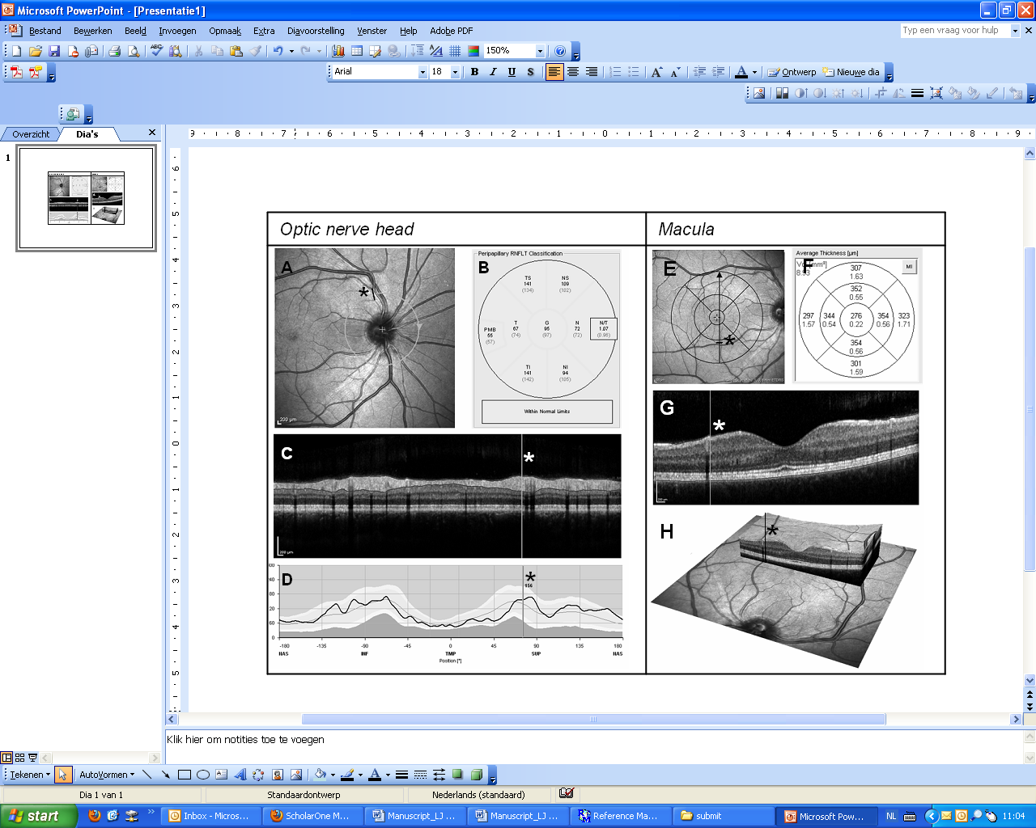
Figure 1. The two scan sequences used in this study. (A) A circular scan centred on the optic nerve head. The ring scan starts at the arrow head seen to the right of the circular line (nasal sector). For orientation a small black line is inserted (asterisk). (B) The data is expressed in μm RNFL thickness for each retinal sector and the papillo-macula bundle (PMB). (C) Cross sectional image of RNFL (B-scan, averaged from about 200 A-scans). The vertical grey line corresponds to the position of the asterisk shown in (A) next to the superior temporal retinal artery and vein. (D) The RNFL thickness is measured across 768 locations. The baseline data is shown by a closed black line . The normative data is given in shades of grey, where the whitish layer in the centre corresponds to the 95% normal range, the dark and lighter grey areas represent values outside the 99% confidence interval of the normal distribution, indicating outside normal limits. The vertical grey line corresponds to the position of the asterisk shown in (A) and (C). (E) A volume scan, centred on the macula. The scan consists of multiple aligned scans of which the black arrow indicates one. For orientation a small black line is inserted (asterisk). (F) Circular lines on the plots represent 1-, 3-, and 6-mm scan diameter. The innermost circle defines the fovea, an area with few retinal ganglion cells. The data in the inner sector and inner and outer quadrants is expressed in macular thickness (μm) and macular volume (mm³). (G) A cross sectional image of macula in which the vertical grey line corresponds to the position of the asterisk shown in (E). (H) A three-dimensional image of the macula, visualising the retinal layers. The black line corresponds to the position of the asterisk shown in (E) and (G).
Statistical analyses
The Body Mass Index (BMI) was calculated as weight in kilograms divided by height in meters squared (kg/m²). It was planned to dichotomise the subjects into normally hydrated and dehydrated based on the clinical signs (dryness of the tongue or mucosa, skin turgor, capillary refill time)³¹ and loss of weight.
Baseline characteristics were compared between runners and controls using independent-samples t-tests (continuous variables) and χ² tests (dichotomous variables). Since the RNFL thickness and MV were measured three times within every subject, it is useful to use longitudinal data analyses methods since these methods take into account the fact that the repeated observations of each subject are correlated. To assess if there was a difference in RNFL thickness and MV between the three longitudinal measurements and to see if these changes over time were different between the runners and controls, multivariate analysis of variance (MANOVA) was used, by means of General Linear Models (GLM) for repeated measures. In figures, the data for the runners and controls was normalised to baseline (100%) for ease of visual comparison. The mean relative changes of the groups were based on means of individual of changes, which were in turn calculated for each of the 768 A-scans of the circular scan.
In addition to the analyses where the global mean of the circular scan was used to describe changes over time, additional analyses were performed with use of extended data of the circular scan. Instead of using sector specific RNFL thickness values, all individual scan points were used. A circular scan consists of 768 consecutive scan points, together forming a circle around the ONH, as shown in figure 1A (grey circle). Analysing all scan points might give a more detailed depiction of the anatomical location where changes in RNFL thickness occur and makes it possible to relate these changes to the underlying anatomy. All 768 scan points were equally divided in 12 clockwise sectors. Subsequently, linear multi-level analyses were performed, including interactions on sector level, to determine differences between runners and controls for every retinal sector.
Moreover, assuming weight loss as a measure for hydration status, the effect of hydration status was explored more in detail. To determine the impact of weight loss due to perspiration and evaporation, all analyses were repeated after excluding subjects in the lowest tertile of weight change to see whether this changed results.
Statistical analyses were performed using SPSS 17.0, except the multi-level analyses, which were done using MLwiN 2.22 (University of Bristol, Center for Multilevel Modeling, Bristol, UK). A significance level of 5% (two-sided) was assumed.

Results
Of all subjects assessed for eligibility (both runners and controls, N=91), 18 were excluded prior to the first scan because of eye-disease (N=3), age > 60 (N=9) or only showing up after the run had already started (N=6). All included runners finished the 10 km charity run. None of the runners was however, dehydrated. In fact, skin turgor and capillary refill time were suggestive of an hyperaemic state. Runners lost on average 1.03 kg during running (range 0.4-2.4 kg).
Of all scanned subjects (N=73), 4 were excluded as they failed quality control because of decentration artefacts (N=1) or algorithm line failure (N=3). Figure 2 summarises the the flow of subject in- and exclusion.
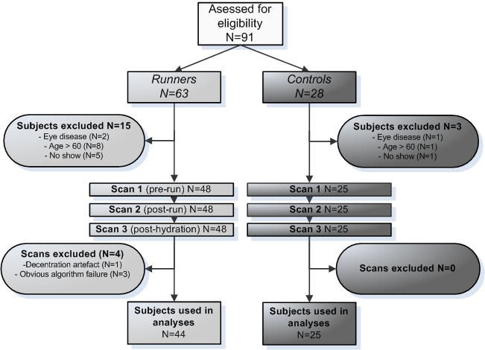

Figure 2. Flowchart of subjects recruited in this study. On the left side the in- and exclusion of subjects and scans are depicted, as at the right side the same aspects are shown for controls. In total, 44 runners and 25 controls were included for statistical analyses.

Changes over time and difference between runners and controls
Table 1 shows the baseline characteristics of the runners and controls. The groups were matched for age, height, weight and BMI (p>0.05 for all comparisons). There were more males in the runners group compared to the control group (p=0.01). The mean RNFL thickness and MV between both groups were comparable at baseline (p>0.05 for both comparisons).

Table 1 Physiological characteristics of all subjects at baseline. The percentage, mean and standard deviation (SD) are shown.
 | Runners (N=44) | Controls (N=25) | p-value
Sex (% male) | 77% | 44% | 0.01
Age (years) | 42.3 (10.6) | 38.1 (13.3) | 0.19
Height (m) | 1.80 (0.1) | 1.74 (0.2) | 0.07
Weight (kg) | 78.5 (12.7) | 75.3 (11.2) | 0.30
BMI | 24.0 (2.8) | 23.8 (3.5) | 0.77
Mean RNFL thickness (μm)  Baseline scan | 94.4 (10.2) | 96.9 (9.7) | 0.40
Inner macular volume (μm)  Baseline scan | 288.9 (20.1) | 279.6 (17.1) | 0.06

There was a significant change from the baseline RNFL thickness (p=0.04) and MV (p=0.00001) in the runners, but not in the controls (table 2). Of note, the significant physiological change of the MV in the runners occurred mainly after oral re-hydration.

Table 2 Physiological change of RNFL thickness and macular volume following exercise (scans 1 & 2) and oral rehydration (scans 2 & 3), presented as mean (SD)
 | Scan 1  (pre-run) | Scan 2  (post-run) | Scan 3  (post-hydration) | p-value*
Runners
Mean RNFL thickness (μm) | 94.4 (10.2) | 94.9 (10.5) | 95.2 (10.4) | 0.04
Inner macular volume (μm) | 288.9 (20.1) | 289.1 (19.9) | 291.0 (20.3) | 0.00001
Controls
Mean RNFL thickness (μm) | 96.9 (9.7) | 97.1 (9.9) | 97.1 (9.7) | 0.56
Inner macular volume (μm) | 279.6 (17.1) | 279.4 (16.5) | 279.4 (16.8) | 0.94
* MANOVA correcting for repeated measures

In addition to the group specific changes over time on absolute data presented in table 2, the comparisons in relative development over time between runners and controls were shown in figures 3A (circle scan) and 3B (volume scan). To this purpose individual scans were normalised to baseline (100%) with physiological deviation from baseline expressed as relative values. Each subject was taken as her/his own control.
There was no significant difference of the relative ring scan data between the two groups (figure 3A, p=0.17), despite the significant increase over time in runners (figure 3A, p=0.04). The significant physiological change over time in the runners was further highlighted by the clear increase of RNFL thickness above the published measurement noise (coefficient of variation) of 0.42%³ (figure 3A, gray shaded area).
The physiological changes became even more noticeable by analysing relative volume data. There were significant differences between the runner and controls for the MV data (figure 3B, p=0.003). As before the physiological changes of the runners’ MV was clearly above the published measurement noise level (0.45% ²⁷⁻²⁹ figure 3B, gray shaded area).
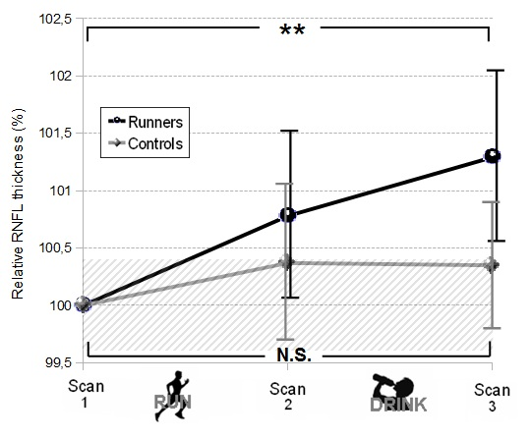
Figure 3(A) The relative physiological change of the RNFL thickness over time. The individual scans were normalised to the baseline value (100%). Changes over time were presented as relative to the individual baseline value (for absolute data and standard deviations see Tables 1&2). The range of expected noise between repeated OCT measurement was expressed as the measurement accuracy (also referred to as the coefficient of variation) above and below the 100% mark (gray shaded area). The vertical black and grey bars represent the (scan specific) 95% confidence intervals. In the control group repeated measurements remain within the noise level (gray shade area) and did not change significantly over time (N.S., p=0.56). In contrast, for the runners there was a significant (p=0.04) increase of the RNFL thickness over time which was clearly above the level of measurement noise.
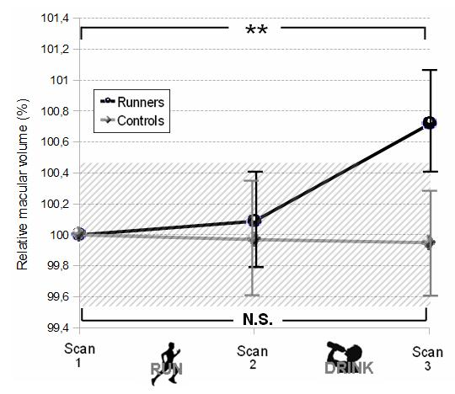
Figure 3(B) The relative physiological change of the macular volume over time. Individual scans were normalised to the baseline value (100%). Changes over time were presented as relative to the individual baseline value (for absolute data and standard deviations see Tables 1&2). The range of expected noise between repeated OCT measurement was expressed as the measurement accuracy (also referred to as the coefficient of variation) above and below the 100% mark (gray shaded area). The vertical black and grey bars represent the (scan specific) 95% confidence intervals. In the runners group a significant increase of the RNFL thickness over time (p=0.00001) was observed, clearly above the noise level at scan 3. In contrast, for the controls there was no significant change over time (p=0.94) and values remained within the noise level.

The anatomical presentation of the physiological RNFL thickness changes at the ONH
The changes of the RNFL thickness of the 768 A-scans around the ONH were related to the underlying anatomy. Multi-level analyses over the entire observation period (3 hours) demonstrated that the differences between runners and controls were not the same for all 12 sectors (figure 4A). Significant differences between the two groups were observed only for the nasal sectors (sectors 3 to 5 in figure 4A) and for sector 12. The relationship with the underlying anatomy was illustrated by figure 4B. As can be appreciated from the standard deviations in figures 3A&B these changes were not significant on a shorter time-intervals, but only over the entire observation period.
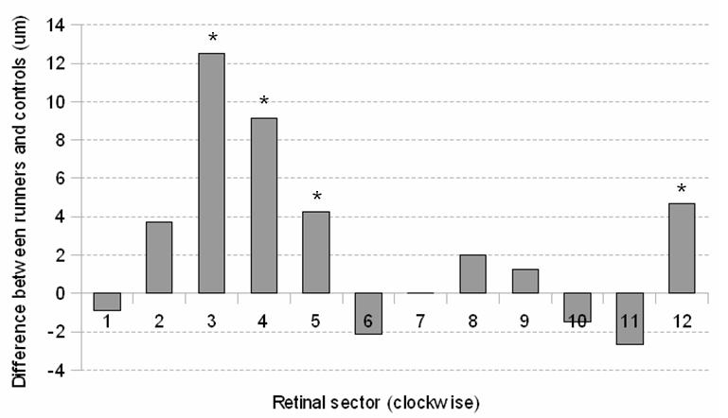
Figure 4A. The absolute difference between runners and controls (μm), independent from scan sequence (pre-run, pos-run or post-hydrate), is shown across 12 retinal sectors around the ONH. Significant differences are marked with an asterisk, which indicates a p-value <0.05. A positive value means higher RNFL thickness for controls.
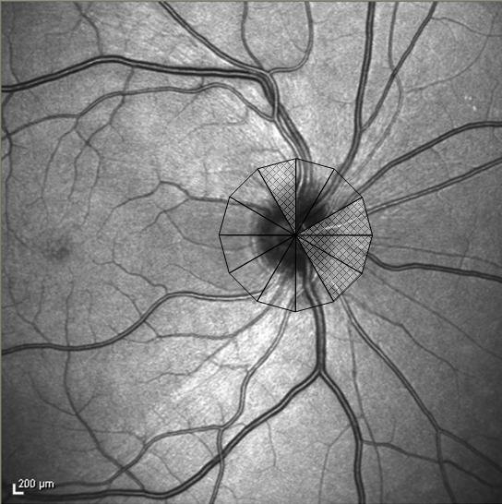
Figure 4B. For orientation the 12 positions of a clock are projected on the ONH. The sectors are labelled clockwise. Sectors in which the difference between runners and controls was significant are shaded in grey. The sectors 3-5 (p<0.05) correspond to the well vascularised nasal area of the retina. Sector 12 (p<0.05) is located superiorly, adjacent to the superior temporal retinal artery and vein.

Sensitivity analysis
Assuming that subjects who lost more weight had more changes in hydration status, subjects in the lowest tertile of weight loss were excluded from the following analyses. Consequently, 30 runners remained.
The previously reported differences between runners and controls (figures 3A and 3B) both slightly changed when subjects in the lowest tertile were excluded (RNFL thickness p=0.63, MV p=0.02). The exclusion of subjects did not change the significance of the results of the extended circular scan data (data not shown).
Discussion
Changes of the RNFL thickness and MV over time are firmly established as a robust measure for disease progression for glaucoma, macular degeneration and an increasing number of other ophtalmological disorders. Subsequently, it has been proposed to use the RNFL around the ONH and MV also as biomarkers for neuro-axonal degeneration in neurological disorders in general and for MS in particular.^{4,32,33} Because an increasing number of clinical trials include the RNFL thickness and inner MV as a secondary outcome measure it seemed timely to investigate the range of physiological variation in these eloquent areas in vivo. The present study examined whether physiological variation could cause detectable changes in RNFL thickness and MV in healthy human subjects as measured by sd-OCT.
The results of this prospective, longitudinal study clearly demonstrated that for the runners, both the RNFL at the ONH and the inner MV changed under physiological conditions (table 1&2). For controls, neither the circular nor the volume scan showed significant changes over time. To add further weight to this argument, the observed physiological change in the runners were clearly above the published measurement noise level (figure 3A&B, gray shaded area). This strongly suggests that the findings of this study were not only statistically significant, but also biologically relevant. The results of the analyses with extended RNFL thickness data give an indication of the anatomical presentation of the observed changes in RNFL thickness. These results should be interpreted with caution, since the analyses were performed using absolute data and there is considerable inter-subject variability of RNFL thickness.
The significant changes in RNFL thickness in runners, as a consequence of physiological variation, was on average 1.6 μm. This change is small, but over 10-times larger than the estimated annual RNFL thickness loss in healthy controls (0.1 μm)⁷. Given the high accuracy of the sd-OCT device, (CV=0.42%)³, the observed change is most unlikely to be caused by a measurement error. Furthermore, the data of a 2-year longitudinal multiple sclerosis cohort study of the RNFL thickness showed a change over time well within the range of physiological variation reported it this study.³⁴ It could be possible that the paradoxical finding of an increase of the RNFL thickness over time in patients with secondary progressive multiple sclerosis who did not suffer from optic neuritis (see empty triangles in figure 1 in reference ³⁴) may be due to physiological variation.
How can the observed physiological change of the RNFL thickness and MV be explained? Because this study was designed within the constraints of a public charity run there is no hard physiological data relying on invasive physiological or laboratory measures. It is therefore only possible to speculate on feasible mechanisms such as change in re-hydration related change of cellular volume which may be dependent on the runners electrolyte status.³⁵ Alternatively, the exercise induced hyperaemic state may be relevant. Future studies including blood and urine laboratory measures as well as experiments designed to induced controlled hypercapnia may be informative.
Of note, Kinkelder et al³⁶ have reported a measurement artefact that was not controlled for in this study. Heartbeat induced axial motion during OCT volume scanning of the retina can affect RNFL measurements. This artefact is likely to increase noise rather than to introduce a bias and is therefore an unlikely explanation for the here reported physiological changes. Additionally, the detailed anatomical analyses in the present study did not show that the change of RNFL thickness was confined to the retinal branch arteries and veins around the ONH. Finally, it may be that the measurement accuracy of the sd-OCT ring scan was lowest were the start and end-point of the scan met, which in this experiment was nasally. This issue may be addressed by programming the OCT software such that it permits for selection of ring-scan start point for future studies.
The reproducibility of the OCT device used in this study (Spectralis, Heidelberg) has shown to be excellent.^{3,23,29} This is most likely due to the systems eye tracking function (TruTrack) during the scanning process as well as automatic recognition of the exact same scan location for follow up examination. Using these features minimises extrinsic factors, such as the patients ability to fixate and measurements are therefore less sensitive to subjective operator judgement.²⁹ Moreover, Jo et al observed diurnal variation in retinal thickness, measured with time domain OCT (TD-OCT), but not with SD-OCT.³⁷ They stated that the difference was likely due to the good reproducibility of SD-OCT, in contrast with the TD-OCT. Consequently, the observed changes in RNFL thickness and macular volume in the present study were unlikely to represent a measurement error and strongly suggest relevant physiological variation.
In conclusion, this study showed for the first time that the physiological variation on RNFL thickness and MV not only exceeded the estimated measurement error of the sd-OCT device, but most importantly occurred at a proportion which, on an individual patient level was about 10 times above the estimated annual change. These findings are therefore relevant for the design and data interpretation of longitudinal studies which use the RNFL and MV as a biomarker in humans.

Reference List

(1) Serbecic N, Beutelspacher S, Kircher K, Reitner A, Schmidt-Erfurth U. Interpretation of RNFLT values in multiple sclerosis-associated acute optic neuritis using high-resolution SD-OCT device. Acta Ophthalmol. 2010.
(2) Barkhof F, Calabresi PA, Miller DH, Reingold SC. Imaging outcomes for neuroprotection and repair in multiple sclerosis trials. Nat Rev Neurol. 2009;5:256-266.
(3) Serbecic N, Beutelspacher SC, Aboul-Enein FC, Kircher K, Reitner A, Schmidt-Erfurth U. Reproducibility of high-resolution optical coherence tomography measurements of the nerve fibre layer with the new Heidelberg Spectralis optical coherence tomography. Br J Ophthalmol. 2011;95:804-810.
(4) Jindahra P, Hedges TR, Mendoza-Santiesteban CE, Plant GT. Optical coherence tomography of the retina: applications in neurology. Curr Opin Neurol. 2010;23:16-23.
(5) Costello F, Hodge W, Pan YI, Eggenberger E, Freedman MS. Using retinal architecture to help characterize multiple sclerosis patients. Can J Ophthalmol. 2010;45:520-526.
(6) Petzold A, de Boer JF, Schippling S et al. Optical coherence tomography in multiple sclerosis: a systematic review and meta-analysis. Lancet Neurol. 2010;9:921-932.
(7) Talman LS, Bisker ER, Sackel DJ et al. Longitudinal study of vision and retinal nerve fiber layer thickness in multiple sclerosis. Ann Neurol. 2010;67:749-760.
(8) Huang D, Swanson EA, Lin CP et al. Optical coherence tomography. Science. 1991;254:1178-1181.
(9) Jaffe GJ, Caprioli J. Optical coherence tomography to detect and manage retinal disease and glaucoma. Am J Ophthalmol. 2004;137:156-169.
(10) Burkholder BM, Osborne B, Loguidice MJ et al. Macular volume determined by optical coherence tomography as a measure of neuronal loss in multiple sclerosis. Arch Neurol. 2009;66:1366-1372.
(11) Costello F, Coupland S, Hodge W et al. Quantifying axonal loss after optic neuritis with optical coherence tomography. Ann Neurol. 2006;59:963-969.
(12) Kanamori A, Nakamura M, Escano MFT, Seya R, Maeda H, Negi A. Evaluation of the glaucomatous damage on retinal nerve fiber layer thickness measured by optical coherence tomography. Am J Ophthalmol. 2003;135:513-520.
(13) Massin P, Girach A, Erginay A, Gaudric A. Optical coherence tomography: a key to the future management of patients with diabetic macular oedema. Acta Ophthalmol Scand. 2006;84:466-474.
(14) Medeiros FA, Zangwill LM, Bowd C, Weinreb RN. Comparison of the GDx VCC scanning laser polarimeter, HRT II confocal scanning laser ophthalmoscope, and stratus OCT optical coherence tomograph for the detection of glaucoma. Arch Ophthalmol. 2004;122:827-837.
(15) Medeiros FA, Moura FC, Vessani RM, Susanna RJ. Axonal loss after traumatic optic neuropathy documented by optical coherence tomography. Am J Ophthalmol. 2003;135:406-408.
(16) Trip SA, Schlottmann PG, Jones SJ et al. Retinal nerve fiber layer axonal loss and visual dysfunction in optic neuritis. Ann Neurol. 2005;58:383-391.
(17) Albrecht P, Frohlich R, Hartung HP, Kieseier BC, Methner A. Optical coherence tomography measures axonal loss in multiple sclerosis independently of optic neuritis. J Neurol. 2007;254:1595-1596.
(18) Henderson APD, Trip SA, Schlottmann PG et al. A preliminary longitudinal study of the retinal nerve fiber layer in progressive multiple sclerosis. J Neurol. 2010;257:1083-1091.
(19) Kallenbach K, Frederiksen J. Optical coherence tomography in optic neuritis and multiple sclerosis: a review. Eur J Neurol. 2007;14:841-849.
(20) Pula JH, Reder AT. Multiple sclerosis. Part I: neuro-ophthalmic manifestations. Curr Opin Ophthalmol. 2009;20:467-475.
(21) Sergott RC, Frohman E, Glanzman R, Al-Sabbagh A. The role of optical coherence tomography in multiple sclerosis: expert panel consensus. J Neurol Sci. 2007;263:3-14.
(22) Siepman TAM, Bettink-Remeijer MW, Hintzen RQ. Retinal nerve fiber layer thickness in subgroups of multiple sclerosis, measured by optical coherence tomography and scanning laser polarimetry. J Neurol. 2010;257:1654-1660.
(23) Wu H, de Boer J, Chen T. Reproducibility of retinal nerve fiber layer thickness measurements using spectral domain optical coherence tomography. J Glaucoma. 2010.
(24) Dacey DM, Petersen MR. Dendritic field size and morphology of midget and parasol ganglion cells of the human retina. Proc Natl Acad Sci U S A. 1992;89:9666-9670.
(25) Arthur SN, Smith SD, Wright MM et al. Reproducibility and agreement in evaluating retinal nerve fibre layer thickness between Stratus and Spectralis OCT. Eye (Lond). 2011;25:192-200.
(26) Serbecic N, Beutelspacher S, Aboul-Enein F, Kircher K, Reitner A, Schmidt-Erfurth U. Reproducibility of high-resolution optical coherence tomography measurements of the nerve fibre layer with the new Heidelberg Spectralis optical coherence tomography. Br J Ophthalmol. 2010.
(27) Menke MN, Dabov S, Knecht P, Sturm V. Reproducibility of retinal thickness measurements in healthy subjects using spectralis optical coherence tomography. Am J Ophthalmol. 2009;147:467-472.
(28) Pierro L, Giatsidis SM, Mantovani E, Gagliardi M. Macular thickness interoperator and intraoperator reproducibility in healthy eyes using 7 optical coherence tomography instruments. Am J Ophthalmol. 2010;150:199-204.
(29) Wolf-Schnurrbusch UEK, Ceklic L, Brinkmann CK et al. Macular thickness measurements in healthy eyes using six different optical coherence tomography instruments. Invest Ophthalmol Vis Sci. 2009;50:3432-3437.
(30) Domalpally A, Danis RP, Zhang B, Myers D, Kruse CN. Quality issues in interpretation of optical coherence tomograms in macular diseases. Retina. 2009;29:775-781.
(31) Steiner MJ, DeWalt DA, Byerley JS. Is this child dehydrated? JAMA. 2004;291:2746-2754.
(32) Frohman EM, Fujimoto JG, Frohman TC, Calabresi PA, Cutter G, Balcer LJ. Optical coherence tomography: a window into the mechanisms of multiple sclerosis. Nat Clin Pract Neurol. 2008;4:664-675.
(33) Galetta KM, Calabresi PA, Frohman EM, Balcer LJ. Optical coherence tomography (OCT): imaging the visual pathway as a model for neurodegeneration. Neurotherapeutics. 2011;8:117-132.
(34) Serbecic N, Aboul-Enein F, Beutelspacher SC et al. High resolution spectral domain optical coherence tomography (SD-OCT) in multiple sclerosis: the first follow up study over two years. PLoS One. 2011;6:e19843.
(35) Petzold A, Keir G, Appleby I. Marathon related death due to brainstem herniation in rehydration-related hyponatraemia: a case report. J Med Case Reports. 2007;1:186
(36) de Kinkelder R, Kalkman J, Faber DJ et al. Heartbeat-induced axial motion artefacts in optical coherence tomography measurements of the retina. Invest Ophthalmol Vis Sci. 2011;52:3908-3913.
(37) Jo Y, Heo D, Shin Y, Kim J. Diurnal variation of retina thickness measured with time domain and spectral domain optical coherence tomography in normal subjects. Invest Ophthalmol Vis Sci. 2011.

