Passive Assembly of Parallel Optical Devices onto Polymer-based Optical Printed Circuit Boards

Structured Abstract

Purpose – to present the latest results from our research and development into future optical printed circuit board interconnects and low cost assembly methods

Design/methodology/approach – a novel method of high precision passive alignment and assembly to optical printed circuit boards was invented and a full evaluation platform developed to demonstrate the viability of this technique

Findings – The technique was successfully deployed to passively align and assemble a lens receptacle onto an embedded polymer waveguide array in an electro-optical printed circuit board. The lens receptacle formed a critical part of a dual lens pluggable in-plane connection interface between peripheral optical devices and an optical printed circuit board. A lateral in-plane mechanical accuracy of ±2 μm has been measured using this technique.

Research limitations/implications – as this is a free space optical coupling process, surface scattering at the exposed waveguide end facet was significant.

Originality/value – this paper details a novel method of passively assembling arbitrary optical devices onto multimode optical waveguides and outlines the procedure and equipment required. A lens coupling solution is also presented which reduces susceptibility of a connecting optical interface to contamination.

Keywords – optical alignment, optical waveguides, optical printed circuit board, polymer waveguides, dual lens coupling, optical interconnect, optical polymer, pluggable optical connector, optical circuit board, expanded beam connector

Paper type - Research paper

Biographies

Richard Pitwon is a senior research engineer at Xyratex Technology Ltd with over 8 years experience in the development of high speed photonic technologies for optical printed circuit boards, passive and active optical connectors and optical interconnect interfaces. He received his first degree in Physics from the University of St Andrews and Masters in Computer Science from Stirling University. He has authored a number of conference and journal papers and holds 13 patents in the field of optical waveguide, optical PCB and high speed connector technologies. He is a Chartered Engineer and UK nominated principal expert on UK, EU and International Standards committees for fibre optics and optical circuit boards.

Ken Hopkins graduated from University of Strathclyde in 1983 and joined IBM as a hardware design engineer. For just over 10 years, he designed motherboards and graphics systems. In 1994, he was appointed as hardware applications engineer at EM Microelectronic where he stayed for just over 3 years. In 1997, he moved to his present position as hardware architect at Xyratex Ltd.

Dave Milward, is the Development Manager, in Xyratex Technologies Ltd, received a BEng degree in Electrical and Electronic Engineering at Liverpool University. Before joining Xyratex, he spent 25 years working for IBM Hursley, initially as a Digital Design Engineer before moving into management. Since 1994, he has worked as Product Development Manager for Networking and Storage Systems and more recently as Project Manager for collaborative research projects involving academic and industrial partners. He is a Chartered Engineer and member of the IET. Dave Milward was the industrial project manager of the project reported in this paper.

Malcolm Muggeridge graduated with a BEng in Electrical Engineering and Electronics from University of Liverpool and joined IBM in 1976 where he gained experience in Disk drive and Disk subsystem Development, manufacturing, test, Quality assurance and Reliability. In 1994, he was appointed as Principal Architect at Xyratex Ltd. He progressed in 1997 to CTO for Xyratex Storage System Products. His good understanding of the storage industry, customer needs and expectations allowed him to define, manage and technically lead the development and manufacturing of numerous data storage subsystem products and solutions, growing Xyratex OEM business from zero to greater than $800m. He is now VP Emerging Technologies. He has particular interests in Cloud Storage, Object Storage, NAS, SAN, CAS, SAS, SCSI, FC, FC-AL, RAID, Electronic and Mechanical Engineering.

Kai Wang received his BSc in Electronic Engineering and Telecommunications from Shenzhen University, China in 2001, and his MSc in Microelectronic Systems and Telecommunications from Liverpool University in 2002 being awarded the International Student Scholarship. In 2003, he began PhD research in the Department of Electronic and Electrical Engineering, UCL, becoming a research fellow in 2004. He has advanced skills in ray trace modelling of LCDs, backlights and multimode waveguides. His current research is to establish design rules for multimode waveguides by experiment and modelling. He was awarded the IET Hudswell International Research Scholarship and the Master Degree Research Scholarship.

Dr David R. Selviah gained his Masters and PhD degrees from Trinity College, Cambridge University, in Physics and Theoretical Physics and in Optical Engineering respectively. Following research at the industrial electronics company Plessey, Caswell and subsequently at Oxford University, Department of Engineering Science on surface acoustic wave filters for radar pulse compression and communications at Department of Electronic Engineering, UCL, University College London since 1987 he has approaching 200 publications on Optical Devices, Interconnects, Algorithms and Systems, and was technical leader of the £1.6 million EPSRC IeMRC Flagship project on Optical waveguide Printed Circuit Boards (OPCBs) consisting of 3 university and 8 company partners. He serves as UK academic expert on the UK, EU and International Standards committees for fibre optics and optical circuit boards.

Passive Assembly of Parallel Optical Devices onto Polymer-based Optical Printed Circuit Boards

Richard C. A. Pitwon^{a*}, Ken Hopkinsª, Dave Milwardª, Malcolm Muggeridgeª, David R. Selviah^{b*} Kai Wang^{b}
ªXyratex Technology Ltd, 1000-40 Langstone Technology Park, Havant, Hampshire, PO9 1SA, UK; ^{b}Department of Electronic and Electrical Engineering, UCL, University College London, Torrington Place, London WC1E 7JE;
^{a*}rpitwon@xyratex.com, ^{b*}d.selviah@ee.ucl.ac.uk

Abstract
Emerging trends in data communication protocols and decreasing device form factors are fuelling the need for electro-optical printed circuit boards in high bandwidth systems in the IT sector including high performance computers and data storage systems. While significant advances have been made worldwide in embedding optical interconnect into printed circuit boards including optical fibre lamination and polymer waveguide fabrication, a number of challenges remain to be solved before this technology can reach its full commercial potential. One crucial issue is the development of low-cost techniques and equipment for the high-yield assembly of optical interface components onto polymer waveguides. In order to enable high volume assembly it is preferable that such techniques be passive and reproducible.
We have successfully developed and demonstrated a fabrication technique and method of passively aligning and assembling parallel optical lens receptacles to embedded polymer waveguide arrays. These form a critical part of a pluggable in-plane connection interface between arbitrary external optical devices, either passive or active, and an optical circuit embedded PCB. In addition a dual lens coupling method is presented which is designed to reduce susceptibility of a connecting optical interface to contamination by ensuring the signal beam width is maximized at the connecting plane.
These techniques have been successfully deployed in the design and application of a pluggable in-plane electro-optical PCB connector system. A characterisation and test regime was implemented whereby 10.3 Gb/s test signals were conveyed across the passively assembled interface with an acceptable level of signal recovery.

Keywords: optical alignment, optical waveguides, optical printed circuit board, polymer waveguides, dual lens coupling, optical interconnect, optical polymer, pluggable optical connector

INTRODUCTION
Optical printed circuit boards are an emerging technology in which high speed electronic traces in a printed circuit board (PCB) are replaced by densely arranged optical channels. While early efforts to create an optical PCB were based on the development of optical fibre embedded PCBs¹, research and development in Europe over the past decade has focussed on the direct fabrication of planar polymer optical waveguides on PCB substrates²⁻⁵. Xyratex as project manager and UCL as technical leader have recently led a large collaborative project in the UK “Integrated optical and electronic interconnect PCB manufacturing (OPCB)^{6,14,15,18} supported by the UK government’s Engineering and Physical Sciences Research Council (EPSRC), to develop and investigate varied waveguide fabrication techniques and materials including direct polymer printing. This approach has the potential to be a far less expensive option than directly embedded fibre due to the use of lower cost materials and patterning processes, which could be more easily accommodated by PCB foundries in the long term. When implemented this technology will bring about significant benefits over all electronic interconnect in high bandwidth systems including higher density, lower electro-magnetic interference, a reduction in power consumption and a reduction in PCB size of over 60%.
However at higher signal frequencies, the optical trace sizes become more constrained by signal integrity requirements and the supporting optical components. Multimode waveguides designed for Very Short Reach (VSR) data communication applications are typically of the order of one twentieth of a millimetre. This places a huge burden on the ability to accurately assemble optical components or optically plug peripheral devices onto printed circuit boards with embedded high-speed optical waveguides.
In this paper, a simple passive assembly solution is described, which overcomes the critical alignment challenges inherent to such optical PCBs. The solution uses the accuracy of the embedded channel structures themselves to allow direct mechanical registration and accurate alignment of optical components with respect to the embedded optical waveguides¹². Xyratex has successfully demonstrated this assembly technique in the design and construction of a complete optical backplane connection system, which includes innovative pluggable optical PCB connectors and an electro-optical printed circuit board⁷. The connectors incorporate flexible optical elements and guiding structures to latch their optical communications interfaces accurately into the optical PCB and include a dual lens coupling arrangement to reduce the susceptibility of the connecting interfaces to contamination that would be typically encountered in a real system.
Xyratex and UCL have led research and development in this field for over 8 years with a view to incorporating optical architectures into future high bandwidth data network systems in order to mitigate the projected system performance bottleneck as interconnect speeds continue to rise (Figure 1).

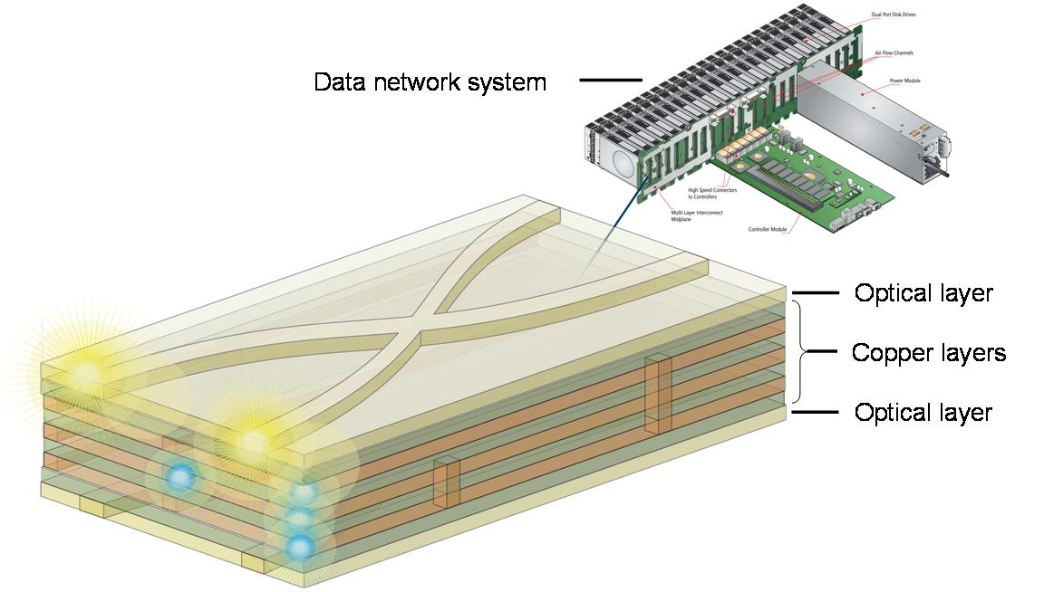

Figure 1: Electro-optical motherboards in dense future data network system

DESign benefits of optical waveguides over copper traces

Density comparison between printed copper and polymer optical channels
The minimum distance between high-speed electronic channels is determined by the maximum permissible crosstalk incurred between them. Electronic transmission lines required to convey data at around 10 Gb/s should be no less than 1.5 mm apart⁸. Conventional parallel optical layouts can accommodate horizontal separations between optical channels of 125 μm. Furthermore multiple optical layers can be accurately stacked to also allow 250 μm vertical separations between optical channels as demonstrated by Betschon^{5,9}. This results in a 36-fold increase in channel density when multilayer high-speed copper traces are replaced with multilayer polymeric optical channels as shown in Figure 2a.

Passive splitters and single layer crossovers
Optical waveguides can be split into multiple branches to allow division of the signal power along each waveguide branch (Figure 2b). In contrast, passive division of high-speed electronic traces cannot be reliably achieved without an integrated circuit to multicast the signal.
The most crucial advantage of laying out optical waveguides in lieu of electronic transmission lines is that while copper traces can only be routed across each other by redirecting at least one trace along a different PCB layer through the use of bridging vias, optical waveguides can intersect each other on the same layer (Figure 2c). This means that the number of layers devoted to optical transmission is only limited by spatial constraints.

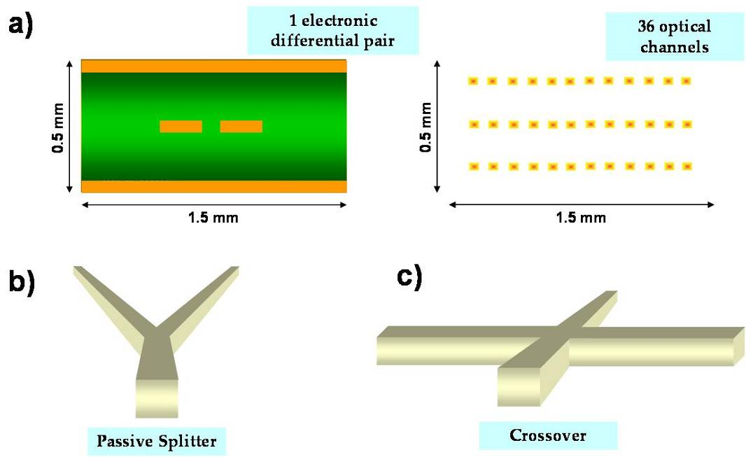

Figure 2: Design benefits of optical waveguides over copper traces:
a) Density comparison between electronic and optical waveguides operating at 10 Gb/s
b) Passive splitter on optical waveguide
c) Optical waveguide crossovers on same layer

Environmental benefits of optical printed circuit boards
Optical waveguides neither produce nor are affected by electro-magnetic (radio frequency) interference and are therefore not constrained by Electromagnetic Compatibility (EMC) regulations that impose a severe cost burden on the design of high speed copper PCBs. The layout advantages offered by optical waveguides will give rise to a reduction in layer count and functional area of the PCB. This level of reduction will strongly depend on the application with the more IO intensive applications subject to the greatest potential reduction in PCB volume. This will help to meet prevailing industrial trends of system integration and miniaturization. This will also give rise to substantial reductions in PCB waste materials including FR4, solder resist, copper and laminating adhesives. We have determined that by optically implementing the high-speed links in a conventional data storage array system, we can achieve a potential reduction in midplane PCB size of around 60%. This is based on an estimated 50% reduction in PCB thickness and 20% reduction in functional PCB area (Figure 3).


Figure 3: Reduction in PCB size of over 60%

In addition, the power consumption of signal drivers can also be reduced. As signal frequencies increase, an electronic signal driver will need to ramp up the signal power in order to overcome the fundamental loss mechanisms on a copper transmission line. These loss mechanisms include dielectric loss, Skin Effect and the surface roughness of the copper trace, which accentuates Skin Effect by increasing the effective surface area. Dielectric loss effects can be mitigated to some extent by using specialist high frequency circuit materials such as Rogers RO4000®¹¹, however at mounting cost to the system.
The main causes of signal power loss on a straight optical channel are 1) coupling loss, the scattering and Fresnel loss incurred at the boundary between the optical channel and the coupling element (e.g. fibre, lens or air), the mode mismatch loss and misalignment losses^{20,12}, 2) surface roughness¹³ of the waveguide, the scattering caused by imperfections along the “walls” of the waveguide and 3) propagation loss, due to the natural (wavelength dependent) absorption of light by the material comprising the waveguide. Though these losses can be severely limiting in a poorly fabricated waveguide, they can be more easily controlled by 1) proper polishing of the waveguide end facets to reduce scattering (but not Fresnel losses), 2) optimising the waveguide fabrication processes to ensure the smoothest side walls possible and 3) tuning the material formulations to increase transmissivity in the required wavelengths and 4) use of our proprietary passive alignment technique to reduce the amount of misalignment along all three Cartesian axes. Additional losses have been identified in other waveguide components such as bends¹⁶, tapers¹⁷ and tapered bends¹³. Typically, polymer waveguides become more absorbing at longer infrared wavelengths, however most commercially available formulations are tuned to provide excellent transmissivity in the near infrared, specifically 850 nm.

passive alignment method and assembly technique
One crucial requirement for the commercial deployment of optical PCB technology is a low-cost technique for the high-yield assembly of optical interface components onto the optical layers. In order to enable high volume assembly it is preferable that such techniques be passive and repeatable. We have successfully developed a proprietary fabrication technique and method of passively aligning and assembling parallel optical lenses to embedded polymer waveguide arrays. These form a critical part of the pluggable in-plane connection interface between arbitrary external optical devices, either passive or active, and a PCB embedded optical circuit.

Electro-optical printed circuit board with embedded polymer waveguides
An electro-optical printed circuit board backplane was designed and developed with Vario-optics, IBM Zürich and UCL (University College London) as part of a demonstration platform for pluggable optical PCB connectors⁷.
The board was built up of 10 electronic (copper) layers and a polymeric optical interconnect layer constructed on a polyimide sheet, which was laminated to the outer surface. The optical layer incorporated square step-index waveguides with a cross-section of 70 μm x 70 μm and a numerical aperture of 0.33. The waveguides were patterned in a photosensitive polymer core material using a vectorial laser direct write process, whereby a laser emitting at the ultraviolet frequencies, at which the polymer cured, was moved along the substrate to “write” the required waveguide pattern in the core. The board incorporated proprietary passive alignment structures based on a scheme developed by Xyratex and UCL¹². These alignment structures were used to assemble the lensed receptacles for the pluggable optical connector prototypes accurately onto the PCB embedded waveguides.

Fabrication of passive alignment features
The complete fabrication process for the optical layer is outlined in Figure 4a. A layer of liquid cladding polymer is deposited onto a substrate and is doctor-bladed to achieve a uniform thickness. The lower cladding is then cured by uniform exposure of the cladding layer to ultraviolet light, which causes this layer to harden. A liquid core polymer with a slightly higher refractive index than the cladding polymer is then deposited onto the hardened lower cladding layer and similarly doctor-bladed to achieve uniform thickness. The waveguides are then patterned by selective exposure of the core layer to ultraviolet light. This could be achieved through a variety of techniques including photolithography, UV embossing and laser direct write or imaging. The procedure involves the fabrication of passive mechanical registration features in the core layer during the same process step in which the waveguide cores themselves are patterned. Effectively these are additional waveguides which are positioned on either side of the signal waveguides and as a result their positional accuracy with respect to the signal waveguides is as high as those of the signal waveguides to each other. Instead of uniformly curing the upper cladding however, it must be selectively cured to ensure that the central signal waveguides are completely clad while the registration waveguides are not. This clearance allows for direct mechanical registration of arbitrary components to the waveguides. In addition, the fabrication tolerances required to pattern the upper cladding for this purpose are far lower than those required to pattern the waveguides themselves. It is only important that the outer edges of the registration waveguides, which form the mechanical datum, be exposed. Preferably, the upper cladding should partially cover the registration waveguides in order to provide structural reinforcement and reduce the risk of the registration waveguides delaminating under the strain. However, this is not strictly necessary and as shown in Figures 4b and 4c we opted to keep the registration waveguides completely exposed without any adverse effects.

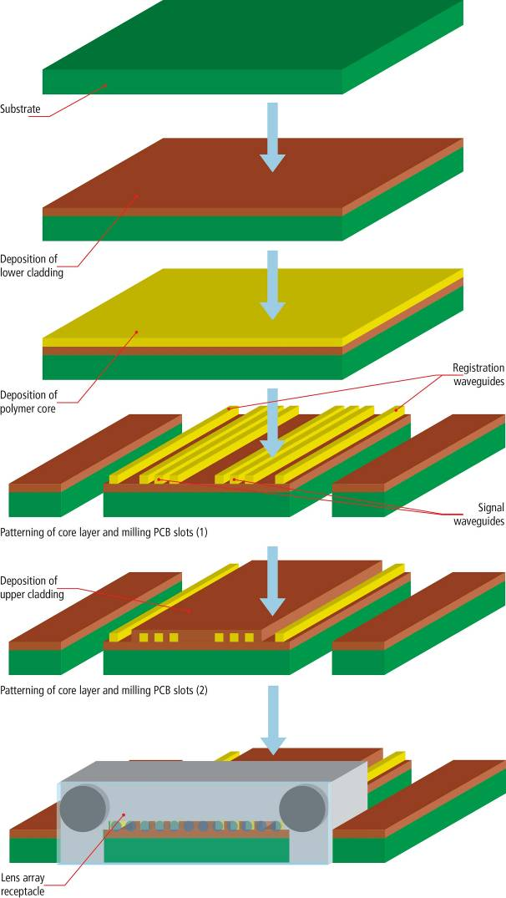
(c)
(b)
(a)

Figure 4:
(a) Process steps for the fabrication of optical waveguide channels, mechanical alignment features and assembly of parallel optical lens array
(b) Clearance areas in upper cladding layer to provide mechanical access for optical connector receptacle and waveguide end facet
(c) An exposed waveguide structure serves as a passive alignment feature for the assembly of the optical connector receptacle

This technique can be implemented using most waveguide fabrication processes. In our case, the upper cladding was uniformly deposited and a doctor blade applied to control the thickness (as with the lower cladding). However, instead of a uniform cure, certain areas of the upper cladding were masked in order to provide mechanical access clearance to the registration features in the core layer (Figure 6a). These registration features in turn allowed passive alignment and assembly of the MT compatible optical lens array receptacle to the waveguides (Figure 6b).
The positional tolerance of the mechanical registration features with respect to each other has been measured to be ±3 μm for lateral misalignment in-plane and ± 4 μm normal to the PCB plane¹².

Assembly technique and equipment
The lensed connector receptacle is comprised of a custom moulded receptacle and commercial lens array. The custom receptacle includes compliant structures to allow it to mechanically engage with the registration waveguides on the board and a recess to accommodate a standard MTP compliant lens array. The MTP compliant interface on the lens array includes two 0.7 mm pin slots and 12 microlenses arranged between the slots on a 250 μm pitch between lenses. In order to ensure that the lens array is accurately aligned within the receptacle, the receptacle has two MTP compliant pin slots fashioned into it which match the dimensions of the pin slots in the lens array. The lens array is fastened to the receptacle with a UV curable low shrinkage optical adhesive such as Dymax OP-21.
Figure 5 shows a mechanical jig designed to align the lens array into the custom receptacle and hold it tightly in place during the UV curing process. While in the open position the lens array is mounted onto compliant pins in the jig, while the receptacle is mounted into a compliant recess. When the jig is closed, the lens array is pressed into the receptacle under strong spring tension and a UV source is then applied to cure the adhesive between the lens and receptacle. The receptacle includes recesses to contain and channel the adhesive away from sensitive areas such as the MTP pin holes and the microlenses, while maximizing contact between those areas of the lens plate and receptacle which are neither in the signal path nor the mechanical registration path.

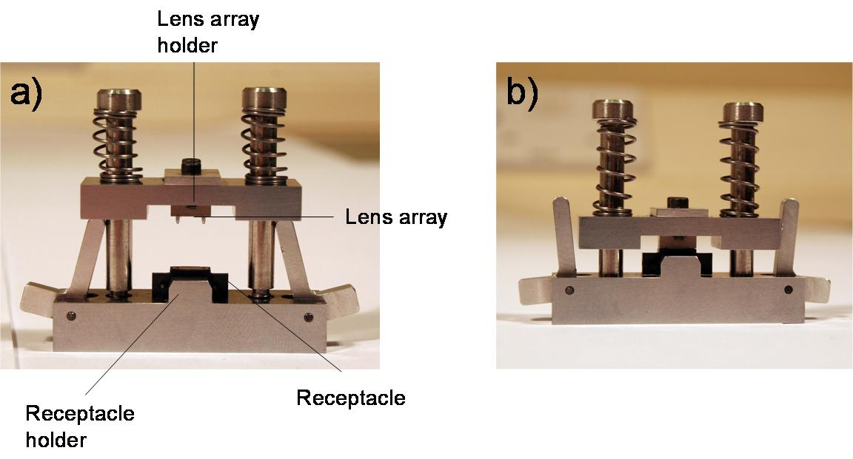
Figure 5: Lens assembly jig required to align a commercial lens array into a proprietary receptacle a) Open position b) Closed position

It was decided to fasten the lensed receptacle to the optical PCB again using a curable optical adhesive. As alignment of the receptacle to the waveguides is critical, it is important that the receptacle lays flat on the smooth exposed lower cladding and that none of the adhesive seeps underneath it.
Figure 6 shows a mechanical jig designed to hold the lensed receptacle tightly in position on the optical PCB while the adhesive is applied as fillet bonds around the edges of the receptacle and subsequently cured. As with the lens assembly jig described above, the receptacle assembly jig contains recesses to hold the lensed receptacle in place over the waveguides under strong spring tension and to snap fit into the connector aperture on the board.

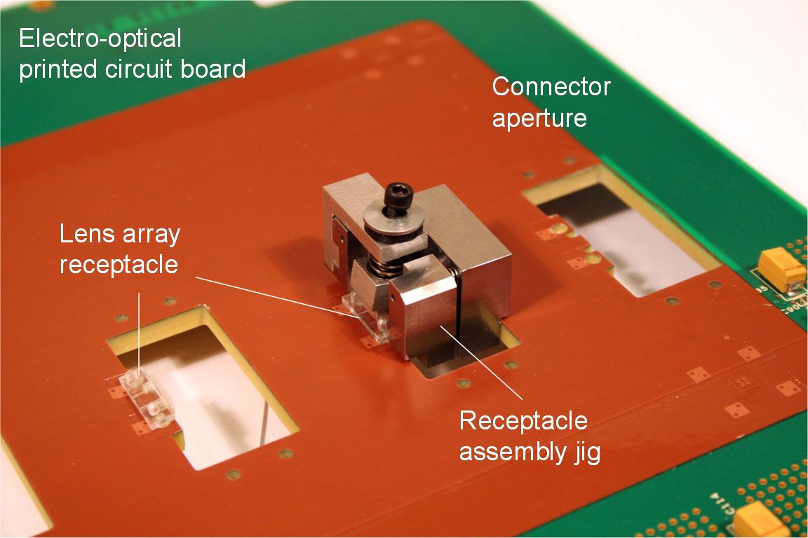
Figure 6: Receptacle assembly jig required to register lensed receptacle with waveguide alignment features and hold in place during adhesive curing process

Pluggable in-plane optical PCB connector and lens coupling configuration
A prototype active pluggable connector was developed to connect peripheral line cards to the optical layer embedded in the printed circuit board. The connector comprised a parallel optical transceiver, connector housing and a pluggable engagement mechanism (Figure 7a).
The optical transceiver circuit was constructed on a flexible laminate, which was partially reinforced to allow the parallel optical interface to float relative to the peripheral line card to which the circuit was connected. The mating optical interface comprised a 1 x 12 MTP compliant microlens array with registration pins extending 1.5 mm out of the outer lens plate surface. When the connector is fully mated with the receptacle the transceiver lens array and the receptacle lens array image the transceiver laser output into the optical waveguide and the waveguide output onto the transceiver photodiode. This free space coupling expanded beam connector configuration ensured that, at the point of interface between the two lenses, the optical beam was expanded to a width many times that of the source width making the connector less susceptible to contamination (Figure 7(b)).

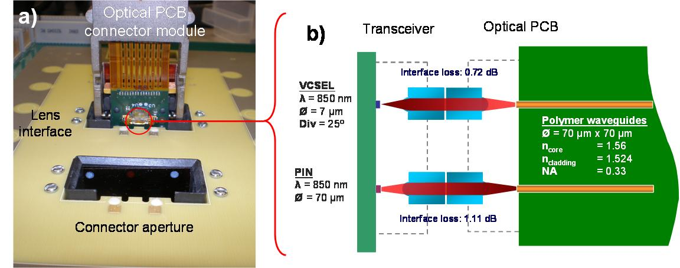
Figure 7: (a) Pluggable optical connector prior to engagement with electro-optical PCB. Parallel MT compliant optical interface is visible as connector starts to engage with connector receptacle
(b) Dual lens coupling interface between transceiver and electro-optical PCB

As this is a free space optical coupling process, surface scattering at the exposed waveguide end facet was strongly dependent on the surface finish. In our system, the waveguide end facets were manually polished with a fine grain polishing cloth after milling, nonetheless the resulting scattering losses were significant.

Electro-optical printed circuit board connector platform
An electro-optical PCB system with pluggable in-plane optical connectors was designed and constructed to assess the viability of technology solutions which could be deployed into future data storage systems (Figure 8).
To evaluate the viability of these technologies, a demonstration platform was constructed, which comprised a 10 U Compact PCI chassis with a single board computer, an electro-optical PCB and 4 peripheral test cards, each housing a pluggable optical connector (Figure 8). Test data from an external 10.3 Gb/s traffic source was successfully conveyed across the electro-optical midplane between the peripheral connectors with an acceptable level of signal recovery.
A more detailed description of the transceiver design, optical PCB connector mechanism and experimental set-up is provided in prior literature⁷.

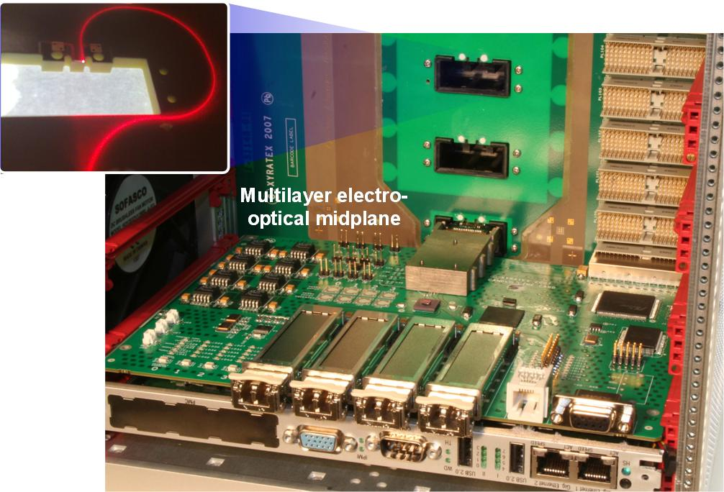
Figure 8: A peripheral test card and pluggable optical connector attached to electro-optical midplane. Waveguide illuminated with 635 nm light is shown exiting a connector slot

Conclusions
We have successfully developed and demonstrated a fabrication technique and low cost method of passively aligning and assembling optical devices onto an optical printed circuit board to a measured accuracy of the order ± 3 μm for lateral misalignment in-plane¹².
In addition, a dual lens coupling method was devised to reduce susceptibility of a connecting optical interface to contamination by ensuring the signal beam width is maximized at the connecting plane. These techniques have been successfully deployed in the design and application of a pluggable in-plane electro-optical PCB connector system. A characterisation and test regime was implemented whereby 10.3 Gb/s test signals were conveyed across the passively assembled interface with an acceptable level of signal recovery. The connector, alignment and electro-optical PCB technology have been successfully demonstrated and our results show that a complex optical interconnect pattern of polymer waveguides could be used to effectively convey high speed optical data across a densely populated board.

acknowledgements
We would like to sincerely thank IBM Research-Zürich and Vario-optics for their involvement in the design and fabrication of the electro-optical circuit board and Samtec for the design of the connector engagement mechanism and assembly jigs. We also gratefully acknowledge our partners on the IeMRC OPCB project for their counsel and assistance, in particular Stevenage Circuits, BAE Systems, Dow Corning, Cadence, NPL, Heriot Watt University and Loughborough University. We also thank the UK Engineering and Physical Sciences Research Council, EPSRC for funding via the Innovative Electronics Manufacturing Research Centre, IeMRC OPCB Flagship Project and via the UCL Platform Grant: Photonic Enabled Data Transport from Millimetric to Megametric Scales , and together with UK Government Technology Strategy Board, TSB (then DTI) for funding through the multi-industrial and academic partner collaborative StorLite project.

References
- M. Ohmura, K. Saito, "High-Density Optical Wiring Technologies for Optical Backplane Interconnection Using Downsized Fibers and Pre-Installed Fiber Type Multi Optical Connectors," Optical Fiber Communication Conference and Exposition and The National Fiber Optic Engineers Conference, Technical Digest, paper OWI71 (2006)
- C. Berger, M. Kossel, C. Menolfi, T. Morf, T. Toifl, and M. Schmatz, "High-density optical interconnects within large-scale systems," Proc. SPIE 4942, pp. 222-235 (2003)
- R. Dangel, C. Berger, R. Beyeler, L. Dellmann, M. Gmuer, R. Hamelin, F. Horst, T. Lamprecht, T. Morf, S. Oggioni, M. Spreafico, B. J. Offrein, "Polymer Waveguide based board-level optical interconnect technology for datacom applications," IEEE Trans. Advanced Packaging, 31, pp. 759-767 (2008).
- G. Van Steenberge, P. Geerinck, S. Van Put, J. Van Koetsem, H. Ottevaere, D. Morlion, H. Thienpont, and P. Van Daele, "MT-compatible laser-ablated interconnections for optical printed circuit boards," J. Lightwave Technol. 22, pp. 2083-2090 (2004)
- F. E. Doany, C.L. Schow, C.W. Baks, D.M. Kuchta, P. Pepeljugoski, L. Schares, R. Budd, F. Libsch, R. Dangel, F. Horst, B.J. Offrein, J.A. Kash, "160 Gb/s bidorectional polymer-waveguide board-level optical interconnects using CMOS-based transceivers," IEEE Trans. Advanced Packaging, 32, pp. 345-359 (2009).
- Selviah, D. et al, “Integrated optical and electronic interconnect PCB manufacturing research”, Circuit World, Vol. 36, Iss. 2 (pp.5-19)
- R. Pitwon, K. Hopkins, K. Wang, D.R. Selviah, H. Baghsiahi, B. Offrein, R. Dangel, F. Horst, M. Halter, M. Gmür "Design and implementation of an electro-optical backplane with pluggable in-plane connectors," Proc. SPIE 7607,doi:10.1117/12.841985 (2010)
- J. Mitchell, B. Das, "A High Channel Density, Ultra-High bandwidth Reference Backplane Designed and Manufactured for 10 Gb/s," DesignCon, (2004)
- F. Betschon, M. Michler, D. Craiovan, M. Halter, K. Dietrich, J. Kremmel, J. Franke, M. Gmür, S. Paredes, "Mass production of planar polymer waveguides and their applications," Proc. SPIE 7607, doi:10.1117/12.841581 (2010)
- K. Wang, D. R. Selviah, I. Papakonstantinou, G. Yu, H. Baghsiahi, and F. A. Fernández, "Photolithographically Manufactured Acrylate Multimode Optical Waveguide Loss Design Rules," 2nd Electronics System-Integration Technology Conference, (ESTC) Greenwich, UK, , Session Th-P-9 Optoelectronics: Interconnect Design and Applications. (2008)
- http://www.rogerscorp.com/acm/products/16/RO4000-Series-High-Frequency-Circuit-Materials-Woven-glass-reinforced-ceramic-filled-thermoset.aspx, “Product summary of RO4000® Series High Frequency Circuit Materials”, (2010)
- Papakonstantinou I, Selviah DR, Pitwon RCA, Milward D, Low-Cost, Precision, Self-Alignment Technique for Coupling Laser and Photodiode Arrays to Polymer Waveguide Arrays on Multilayer PCBs, IEEE Transactions on Advanced Packaging 31(3):502-511 (2008)Papakonstantinou I, James R, Selviah DR, Radiation and Bound Mode Propagation in Rectangular Multimode Dielectric Channel Waveguides with Sidewall Roughness, IEEE/OSA Journal of Lightwave Technology 27(18):4151-4163 2009
- Papakonstantinou I, Selviah DR, Wang K, Insertion Loss and Source Misalignment Tolerance in Multimode Tapered Waveguide Bends, IEEE Photonics Technology Letters 20(12):1000-1002 2008
- Selviah DR, Fernández FA, Papakonstantinou I, Wang K, Baghsiahi H, Walker AC, McCarthy A, Suyal H, Hutt DA, Conway PP, Chappell J, Zakariyah SS, Milward D, Integrated Optical and Electronic Interconnect Printed Circuit Board Manufacturing, Journal of the Institute of Circuit Technology 1(3):9-12 2008
- Selviah DR, Fernández FA, Papakonstantinou I, Wang K, Baghsiahi H, Walker AC, McCarthy A, Suyal H, Hutt DA, Conway P, Chappell J, Zakariyah SS, Milward D, Integrated Optical and Electronic Interconnect Printed Circuit Board Manufacturing, Circuit World 34(2):21-26 2008
- Papakonstantinou I, Wang K, Selviah DR, Fernandez FA, Transition, radiation and propagation loss in polymer multimode waveguide bends, Optics Express 15(2):669-679 22 Jan 2007
- Rashed AM, Selviah DR, Source misalignment in multimode polymer tapered waveguides for optical backplanes, Optical Engineering 46(1):015401(1)-015401(7) Article number 015401 26 Jan 2007
- Selviah DR, Walker AC, Hutt DA, Milward D, Wang K, Papakonstantinou I, Baghsiahi H, McCarthy A, Suyal H, Chappell J, Zakariyah SS, Innovative Optical and Electronic Interconnect Printed Circuit Board Manufacturing Research, 2nd Electronics System-Integration Technology Conference (ESTC) Greenwich, UK, 3rd September 2008. 3 Sep 2008
- Baghsiahi H, Selviah DR, Yu G, Wang K, Yau WYM, Fernández FA, Photolithographically Manufactured Acrylate Multimode Optical Waveguide Translation and Rotation Misalignment Tolerances, 2nd Electronics System-Integration Technology Conference (ESTC), Session We-A-1, Greenwich, UK, 3 Sep 2008. 2008
- Guoyu Yu; Selviah, D.R.; Modeling of optical coupling to multimode polymer waveguides: axial and lateral misalignment tolerance, The 17th Annual Meeting of the IEEE Lasers and Electro-Optics Society, LEOS 2004, Volume: 2 981 – 982 (2004)

