**Sex-Specific Genetic Predictors of Alzheimer’s Disease Biomarkers**

Yuetiva Deming*1 Logan Dumitrescu*2, Lisa Barnes3, Madhav Thambisetty4, Brian Kunkle5, Katherine Gifford2, William S. Bush5, Lori B. Chibnik6,7, Shubhabrata Mukherjee8, Phillip L. De Jager9,10, Walter Kukull11, Matt Huentelman12, Paul K. Crane8, Susan M. Resnick4, C. Dirk Keene13, Thomas J. Montine14, Gerard D. Schellenberg15, Jonathan L. Haines5, Henrik Zetterberg16,17,18,19, Kaj Blennow16,17, Eric B. Larson11,20, Sterling C. Johnson21, Marilyn Albert22, Abhay Moghekar22, Jorge L. del Aguila1, Maria Victoria Fernandez1, John Budde1, Anne M. Fagan23, Matthias Riemenschneider24, Ronald C. Petersen25, Lennart Minthon26, Vivianna M. Van Deerlin27, Virginia M-Y Lee27, Leslie M. Shaw27, John Q. Trojanowski27, Elaine R. Peskind28, Gail Li28, Nancy J. Cox2, for the Alzheimer’s Disease Neuroimaging Initiative, for the Alzheimer’s Disease Genetics Consortium, Alison M. Goate29, David A. Bennett3, Julie A. Schneider3, Angela L. Jefferson2, Carlos Cruchaga1, Timothy J. Hohman2

*1Department of Psychiatry, Washington University School of Medicine, Saint Louis, MO*

*2Vanderbilt Memory and Alzheimer’s Center, Vanderbilt University School of Medicine, Nashville, TN,*

*3Rush Alzheimer’s Disease Center, Rush University Medical Center, Chicago, IL*

*4Unit of Clinical and Translational Neuroscience,Laboratory of Behavioral Neuroscience, National Institute on Aging, National Institutes of Health, Baltimore, MD*

*5Department of Population & Quantitative Health Sciences, Institute for Computational Biology, Case Western Reserve University, Cleveland, OH*

*6Department of Epidemiology, Harvard T.H. Chan School of Public Health, Boston, MA*

*7Channing Division of Network Medicine, Brigham & Women’s Hospital, Boston, MA*

*8Department of Medicine, University of Washington, Seattle, WA*

*9Center for Translational & Computational Neuroimmunology, Department of Neurology, Columbia University Medical Center, New York, NY*

*10Cell Circuits Program, Broad Institute, Cambridge MA*

*11Department of Epidemiology, School of Public Health, University of Washington, Seattle, WA*

*12Neurogenomics Division, Translational Genomics Research Institute, Phoenix, AZ*

*13Department of Pathology, University of Washington, Seattle, WA*

*14Department of Pathology, Stanford University, Stanford, CA*

*15Department of Pathology and Laboratory Medicine, Perelman School of Medicine, University of Pennsylvania, Philadelphia, PA*

*16Department of Psychiatry and Neurochemistry, Institute of Neuroscience and Physiology, The Sahlgrenska Academy at University of Gothenburg, Mölndal, Sweden*

*17Clinical Neurochemistry Laboratory, Sahlgrenska University Hospital, Mölndal, Sweden*

*18Department of Molecular Neuroscience, UCL Institute of Neurology, Queen Square, London, UK*

*19UK Dementia Research Institute at UCL, London, UK*

*20Kaiser Permanente Washington Health Research Institute, Seattle, WA*

*21Alzheimer’s Disease Research Center, University of Wisconsin School of Medicine and Public Health, Madison, WI*

*22Department of Neurology, the Johns Hopkins University School of Medicine, Baltimore, MD*

*23Department of Neurology, Washington University School of Medicine, Saint Louis, MO*

*24Clinic of Psychiatry and Psychotherapy, Saarland University, Homburg/Saar, Germany*

*25Department of Neurology, Mayo Clinic, Rochester, MN*

*26Clinical Memory Research Unit, Dept of Clinical Sciences, Lund University, Sweden*

*27Department of Pathology and Laboratory Medicine, Perelman School of Medicine at the University of Pennsylvania, Philadelphia, Pennsylvania*

*28Department of Psychiatry and Behavioral Sciences, University of Washington, Seattle, WA*

*29Ronald M Loeb Center for Alzheimer’s Disease, Department of Neuroscience, Icahn School of Medicine at Mount Sinai, New York, NY*

*Authors contributed equally to this manuscript.

¥Data used in preparation of this article were obtained from the Alzheimer’s Disease Neuroimaging Initiative (ADNI) database (adni.loni.usc.edu). As such, the investigators within the ADNI contributed to the design and implementation of ADNI and/or provided data but did not participate in analysis or writing of this report. A complete listing of ADNI investigators can be found at:

http://adni.loni.usc.edu/wp-content/uploads/how_to_apply/ADNI_Acknowledgement_List.pdf

**RUNNING HEAD: Sex-Specific Genetic Effects on AD Biomarkers**

Number of characters in Title: 65

Number of characters in Running Head: 45

Number of Words in Abstract: 300

Number of Words in Introduction:377

Number of Words in Discussion: 1381

Number of Words in Text: 3739

Number of Tables: 4

Number of Figures:4

Number of Supplementary Materials: 16

*Address Correspondence to:

Timothy J Hohman, PhD

Vanderbilt Memory & Alzheimer’s Center

Vanderbilt University Medical Center

1207 17th Ave S

Nashville, TN 37212

Phone: 615–343–8429

Email: [Timothy.J.Hohman@Vanderbilt.edu](mailto:Timothy.J.Hohman@Vanderbilt.edu)

Summary

**Background.** Cerebrospinal fluid (CSF) levels of the 42 amino acid form of amyloid β (Aβ42) and tau have been evaluated as endophenotypes in genetic studies of Alzheimer’s disease (AD). Although there are sex differences in AD risk, sex differences have not been evaluated in genetic studies of AD endophenotypes. We performed sex-stratified and sex interaction genetic analyses of CSF biomarkers to identify sex-specific associations.

**Methods.** Data were extracted from a previous genome-wide association study (GWAS) of CSF Aβ42 and tau (1527 males, 1509 females). We evaluated sex interactions at previous loci, performed sex-stratified GWAS to identify sex-specific associations, and evaluated sex interactions at sex-specific GWAS loci. Finally, sex-specific associations between prefrontal cortex (PFC) gene expression at relevant loci and autopsy measures of plaques and tangles were evaluated using transcriptomic data from the Religious Orders Study and Memory and Aging Project.

**Findings.** In Aβ42 analyses, we observed sex interactions at one previous locus and one novel locus: rs316341 within *SERPINB1* (p=0.04) and rs13115400 near *LINC00290* (p=0.002). These loci showed stronger associations among females (β=‑0.03, p=5.63x10-8; β=0.03, p=3.97x10-8 respectively) than males (β=-0.02, p=0.008; β=0.01, p=0.20). Increased expression of *SERPINB1,* *SERPINB6, and SERPINB9* in the PFC was associated with increased amyloidosis in females (corrected p-values<0.02) but not males (p>0.38). In tau analyses, we observed a sex interaction at a previous locus, rs1393060 proximal to *GMNC* (p=0.004), driven by a stronger association among females (β=0.05, p=4.57x10-10) compared to males (β=0.02, p=0.03). There was also a sex-specific association between rs1393060 and tangle burden at autopsy (pfemale=0.047; pmale=0.96), and increased expression of two genes within this locus was associated with fewer tangles among females (*OSTN* p=0.006; *CLDN16* p=0.002) but not males (p≥0.32).

**Interpretation.** Results suggest a female-specific role for *SERPINB1* in amyloidosis and for *OSTN* and *CLDN16* in tau pathology. Findings demonstrate the important biological information that can be garnered from sex-specific genetic studies.

**Funding: National Institutes of Health; Alzheimer’s Association; Michael J Fox Foundation**

**Keywords:** CSF Biomarkers; Alzheimer Disease; Neuropathology; Gender; APOE; Amyloid; Tau

Research in context

**Evidence before this study.** Literature review was completed using Google Scholar, first focusing on previous genome-wide association studies (GWAS) of Alzheimer’s disease (AD) endophenotypes using the search terms “amyloid”, “tau”, and “GWAS”. We also surveyed all sex-specific genetic and non-genetic associations with AD biomarkers using the search terms “Alzheimer disease” and “sex difference” or “amyloid” and “sex difference” or “tau” and “sex difference”. No timeframe or language restrictions were used. Previous GWAS studies of CSF biomarkers have identified 7 genetic loci associated with CSF biomarker levels, but sex differences have not been evaluated. Previous work has identified a stronger association between *APOE* ε4 and clinical AD among females compared to males, and a stronger association between *APOE* ε4 and CSF tau levels among females compared to males. Previous studies have largely pooled data across case/control and epidemiological studies, with highly educated Caucasian samples over represented, leaving open the possibility of sampling and selection biases.

**Added value of this study.** This study is the first comprehensive sex-specific GWAS of CSF biomarker levels using the largest published dataset of CSF AD biomarker levels available to date. We provide the first evidence that multiple previously identified loci for amyloid and tau are driven by female gender, which suggests that signals in those regions are driven by sex-specific associations between brain gene expression and neuropathology. We also provide evidence of one new genetic locus that is associated with amyloid pathology only among females.

**Implications of all the available evidence.** Multiple previously reported genetic associations with CSF biomarkers of amyloid and tau show notable sex differences, with stronger associations among females compared to males. Our findings also confirm that *APOE* ε4 is more strongly associated with CSF tau levels among females compared to males.

1. Introduction

It is well established that two-thirds of all prevalent Alzheimer’ disease (AD) cases are female,1,2 but emerging evidence has also highlighted striking sex differences in the genetic drivers,3 clinical severity,4 and neuropathological presentation of AD.5-7 For that reason, the *Lancet Neurology* Commission has asserted that a focus on sex differences in AD is essential to move the field towards effective interventions.1 The identification of sex-specific genetic drivers of AD neuropathology and cognitive decline could transform the way treatments are developed and administered, and be a critical step towards personalized interventions for AD.

AD is characterized by plaques consisting of aggregated amyloid β (Aβ) and neurofibrillary tangles composed of truncated and phosphorylated tau protein. Alterations in both of these proteins are measurable in cerebrospinal fluid (CSF) years prior to the clinical onset of disease,8,9 and have become a focus of the preclinical characterization of AD.10 Work over the past five years has sought to uncover the genetic architecture of age-related changes in CSF amyloid and tau through genome-wide association studies.11-13 *APOE* has a strong and expected association with both CSF amyloid and CSF tau. Interestingly, recent work from our group14 and others15 has suggested that the *APOE* association with tau is stronger among females compared to males, while there is no such sex difference in the association between *APOE* and amyloidosis. Outside of the *APOE* region, there have been two loci identified in relation to amyloidosis, and four loci related to CSF tau.13 Yet, sex differences have not been integrated into the GWAS studies of CSF AD biomarkers to date, leaving open the possibility that the genetic architecture of CSF amyloid and tau may vary by sex. This manuscript provides a comprehensive characterization of the sex-specific genetic predictors of CSF amyloid and tau. First, we perform a sex-stratified GWAS of CSF amyloid and tau to identify loci that show consistent and disparate associations between males and females. For all sex-specific genome-wide associations, we then formally assess whether the association differs by sex by testing sex interactions. Finally, we leverage transcriptomic data from prefrontal cortex (PFC) to test whether we observe sex-specific associations between gene expression at the relevant loci and levels of AD neuropathology at autopsy. The outcome of this work will highlight sex-specific markers of amyloid and tau, and clarify the degree to which known loci act in a sex-specific manner.

1. Methods

Data used in this analysis were previously described in a recently published GWAS of CSF biomarkers.13 Briefly, data were acquired from 7 independent studies of cognitive aging all of which included lumbar puncture and clinical assessments. The quantification of CSF biomarker levels was completed by each site. Clinical and demographic characteristics of the sample are presented in **Table 1**. Secondary analyses of all data were approved by the Vanderbilt University Medical Center IRB.

2.1 Genotyping and QC

As previously reported,13 genotyping was completed by each study and imputed using 1000 Genomes Project Phase 3 data. Prior to imputation, all genotype data were processed through the same quality control (QC) protocol, including removing single nucleotide polymorphisms (SNPs) that had a poor call rate (98%) or were outside of Hardy-Weinberg equilibrium (p<1x10-6). Samples were excluded if there was a reported compared to observed sex inconsistency or if cryptic relatedness was identified (Pihat≥0.25). *APOE* genotype was completed within each dataset by direct genotyping using a Taqman assay. Imputation was completed using IMPUTE2 (version 2.3.2) and genotyping calls were used for all genotypes with a probability of 90% or greater. Finally, imputed genotypes were excluded with a minor allele frequency (MAF) <2% or with an information score<0.30.

2.2 Quantification of Biomarker Outcomes

The harmonization procedures for the CSF analyses have been outlined previously.13 Briefly, the raw values were log-transformed within each study and centered using the study mean. This normalization approach has been leveraged previously13 and is an effective approach to minimize the influence of study differences in measurement. For the present analyses we excluded one small dataset from the original analysis, the Saarland University sample from Hamburg (HB), which did not include CDR or diagnostic information and did not include all CSF measures. Our decision to drop HB (n=105) was primarily driven by visual inspection of outcome distributions across all datasets which revealed an inequivalent variance structure in HB relative to the other datasets.

In addition to our primary analyses outlined below, secondary analyses are also outlined that check for study specific effects including a meta-analysis approach and the comparison of regression coefficients across datasets to evaluate the robustness of observed effects.

2.3 Autopsy Measures of Gene Expression and Neuropathology

To assess both single-SNP and gene expression associations with neuropathology measured at autopsy, we leveraged publically available data from the Religious Orders Study/Memory and Aging Project (ROS/MAP) made available through the Accelerating Medicines Partnership AD project (https://www.synapse.org/#!Synapse:syn2580853/wiki/). ROS began in 1994 and involves older Catholic nuns, priests, and brothers recruited from across the US. MAP began in 1997 and involves older lay persons recruited from retirement communities, subsidized housing facilities, and social service agencies in the Chicago metropolitan area. Participants in ROS/MAP enrolled without dementia and agreed to annual clinical evaluations and organ donation.16,17 RNA expression levels were obtained from frozen sections of the dorsolateral prefrontal cortex that were manually dissected from postmortem brain tissue. Details of RNA extraction, processing and data quality control and normalization have been previously published.18 In brief, RNA was isolated using the RNeasy lipid tissue kit (Qiagen, Valencia, CA) and was reverse transcribed and biotin-UTP labeled using the llumina® TotalPrep™ RNA Amplification Kit from Ambion (Illumina, San Diego, CA). Expression signals were generated using the Beadstudio software suite (Illumina, San Diego, CA). Standard control and normalization methods were employed to account for technical variability due to differences in hybridization dates. For the present analyses, low abundance genes (expressed in <10% of the cohort) were filtered out from analyses to reduce confounding due to floor effects.

For neuropathology, we measured amyloid plaques and tau tangles using immunohistochemistry and quantified by image analysis.16,17 Specifically for amyloid pathology, we used levels of Aβ measured in 8 cortical regions of the brain.16,17 For tau tangle pathology, we used levels of abnormally phosphorylated tau measured with AT8 antibody across 8 brain regions.16,17 A total of 362 males and 704 females had both neuropathology data and SNP data available for analysis, while a total of 207 males and 374 females had both neuropathology data and gene expression data available.

2.4 Statistical Analyses

Statistical analyses were completed using PLINK (Version 1.9, <https://www.cog-genomics.org/plink/1.9>) and RStudio (Version 1.0.136; <https://www.rstudio.com/>). Additive genetic coding was used for all analyses, and all analyses included covariates for age, study, and the first two population principal components. For sex-interaction analyses, a sex x SNP interaction term was included in each statistical model. Sex-specific analyses were then evaluated using the same covariates stratifying by males and females.

First, to identify sex differences at known loci, we re-evaluated the most significant single-SNP associations from 7 genome-wide significant loci for Aβ-42, total tau, and phosphorylated tau (p-tau) that had been published previously.13 For these analyses, we noted any loci with a significant sex-interaction effect (p<0.05) on the published outcome. Next, to identify novel sex-specific loci, we assessed all GWAS markers for genome-wide significant associations within one sex using the established genome-wide threshold for statistical significance (α=5x10-8). All significant sex-stratified effects were also assessed for sex x SNP interactions to test whether the coefficients differed between males and females. Sex-stratified Miami plots were generated using EasyStrata (version 16.0).19 Genomic inflation factors for the genome-wide association analyses ranged from λ=1.00-1.03 (**Supplemental Figure 1**).

Sex-specific loci identified in candidate and genome-wide analyses were further evaluated for functional significance. Expression quantitative trait loci (eQTL) analyses were completed using published gene expression data from Braineac (<http://www.braineac.org/>) and the Genotype-Tissue Expression project (GTEx; [www.gtexportal.org](http://www.gtexportal.org)). For eQTL association analyses, we corrected for the total number of tissue-gene combinations using the false discovery rate (FDR) procedure.

Additional analyses were completed using the measures outlined in **Section 2.3** above. First, we evaluated SNP associations with the relevant neuropathology covarying for age at death and education. Second, we tested sex interaction and sex-stratified associations between prefrontal cortex expression of genes implicated in eQTL bioinformatic analyses and the neuropathology of interest, correcting for the total number of genes evaluated using the FDR procedure. If Braineac and GTEx did not provide strong eQTL evidence at a given locus, we evaluated all genes within the cis region of the locus (i.e., 1 MB upstream and downstream of the SNP) and corrected for multiple comparisons using the FDR procedure.

2.5 Role of the Funding Source

The funders of the study had no role in the collection, analysis, or interpretation of data; in the writing of the report; or in the decision to submit the paper for publication. The corresponding author had full access to all the data in the study and had final responsibility for the decision to submit for publication.

1. Results

In the combined sample across cohorts, sex differences in clinical and demographic characteristics were evaluated using an independent samples t-test for continuous variables and a χ2 test for categorical variables. Females were younger than males (p<0.001), had lower levels of CSF amyloid than males (p=0.01), and males were more likely to have a diagnosis of AD (p=0.001). Males and females did not differ in levels of CSF tau, CSF ptau, or *APOE* ε4 carrier status (p-values>0.10). Given the difference in age and diagnostic status observed, secondary analyses were performed for all significant associations matching for age and stratifying by diagnostic status. Methodology and detailed results for age-matched analyses are presented in **Supplemental Materials.**

3.1 Sex Differences for the Top SNP at Previously Published Loci

Sex interaction and sex-stratified results for the SNPs with the strongest reported associations at previously published genome-wide significant loci for amyloid and tau are presented in **Table 2**. In CSF Aβ-42 analyses, we observed a significant interaction between sex and rs316341 on chromosome 6 (p=0.04), whereby the association was stronger among females (p=4.25x10-8) compared to males (p=0.009). In total tau analyses, the previously identified locus on chromosome 3 (rs35055419) showed a genome-wide association among females (p=2.57x10-8), but a nominal association among males (p=0.0003). However, the sex x SNP interaction did not reach statistical significance (p=0.17).

We did not observe a significant sex interaction between the SNP in the *APOE* locus (rs769449) and any of the CSF biomarkers (p>0.10). We have previously published a *sex x APOE ε4* interaction on CSF tau and p-tau levels,14 and here we also observed a sex difference in the association between *APOE* ε4 (determined by Taqman genotyping of rs7412 and rs429358) and total tau (p=0.008) in the present sample when meta-analyzing across cohorts. Further, when meta-analyzing across the datasets included here and the non-overlapping datasets previously published, we confirmed a sex x *APOE* ε4 interaction on both total tau (β=0.21, p=0.00002) and p-tau (β=0.13, p=0.01). In 8 out of the 9 total datasets that were analyzed across the two studies, the point estimate for the *APOE* ε4 association with CSF tau was larger among females compared to males (**Supplemental Figure 2**).

3.2 Genome-Wide Sex-Specific Associations

Significant sex-stratified genome-wide association results outside of the *APOE* locus are presented in **Table 3**. In CSF Aβ-42 analyses (**Figure 1; Supplemental Tables 2 and 3**) rs13115400 on chromosome 4 was significant among females (p=4.61x10-8), but not among males (p=0.19, interaction p=0.003). As highlighted above, one previous SNP on chromosome 6, rs316341, also showed a genome wide significant association with CSF Aβ-42 among females, but not males. In CSF total tau analyses (**Figure 2; Supplemental Tables 4 and 5**), a SNP within the same chromosome 3 locus previously identified by Deming et al.13 (*GMNC* locus) was associated among females (rs1393060, p=8.27x10-10), with only a nominal association among males (p=0.03, interaction p=0.004). There were no sex-specific associations with p-tau that met genome-wide significance (p<5x10-8), with the exception of the *APOE* locus (**Supplemental Figure 3, Supplemental Tables 6 and 7**).

As a secondary approach in addition to our combined analyses, we also analyzed each dataset separately and performed meta-analyses for the three loci identified in candidate and GWAS analyses. The directions of effect for all three identified SNPs were consistent within sex and across studies when analyzed separately, and results from meta-analyses of the individual studies were consistent with the joint analysis (**Supplemental Figures 5-7**). Moreover, we have included age-matched results right in the results (**Supplemental Tables** **2-7**), and our estimates for genome-wide SNPs remain consistent, suggesting that observed associations are not driven by differences in age.

3.3 eQTL Results for Sex-Specific Associations

In CSF Aβ42 analyses, one previously identified SNP (rs316341) and one novel SNP (rs13115400) showed sex-specific associations and were further evaluated for eQTL associations within Braineac and GTEx databases. When evaluating rs316341, significant eQTL associations across all 10 brain tissues in Braineac were seen with *SERPINB1*, *SERPINB6,* and *SERPINB9* (aveALL p-values<0.0012, FDR aveALL p‑values=0.047; **Supplemental Table 8**). When looking at the region-specific associations, this eQTL signal appears to be driven by gene expression in the hippocampus (p=4.3x10-5 and 6.5x10-5 for *SERPINB1* and *SERPINB9*, respectively). Similarly, when evaluating rs316341 in GTEx, significant eQTL associations were observed with *SERPINB1* expression in brain cerebellar hemisphere (p=4.9x10-6) and transformed fibroblasts (p=0.00001) and with SERPINB9 pseudogene 1 (*RP11‑420G6.4*) expression in the cortex of the brain (p=1.4x10-6; **Supplemental Table 9**). No significant eQTL associations for rs13115400 were observed in Braineac (**Supplemental Table 10**) or GTEx.

In CSF tau analyses, the previously identified *GMNC* locus showed a sex-specific association. The top female-specific association within that locus was rs1393060 and was further evaluated for eQTL associations. In Braineac, we did not observe any eQTL association between rs1393060 and genes in the locus that survived correction for multiple comparisons. However, the strongest observed association was between rs1393060 and *OSTN* expression in the frontal cortex (p=0.00057; **Supplemental Table 11**). No significant eQTL associations were observed in tissues within the GTEx database.

3.4 Autopsy Validation and Extension of Sex-Specific Effects

The three identified SNPs with potential sex-specific effects on CSF biomarker levels (rs1393060, rs13115400, and rs316341) were then tested for sex differences in measures of AD neuropathology in 1056 ROS/MAP participants. While none of the three SNPs had a significant sex interaction (**Table 4**), rs1393060 did show evidence of an association with tau pathology at autopsy among females (p=0.047) but not males (p=0.96; **Table 4**).

Given the strong eQTL evidence for rs316341 on *SERPINB1,* *SERPINB6,* and *SERPINB9*, PFC expression of these three genes was further assessed for sex-specific associations with amyloid burden (**Supplemental Table 12**). Consistent with SNP results, we observed associations between expression levels of *SERPINB1* (β[SE]=0.08[0.04], p=0.01), *SERPINB6* (β=0.02[0.004], p=0.0002; **Figure 4**) and *SERPINB9* (β[SE]=0.17[0.04], p=0.01) with amyloid levels among females that were not observed among males (p-values>0.38). Sex interactions were not statistically significant.

There was not strong eQTL evidence at the rs1393060 locus, so we evaluated all 18 genes in *cis* that were measured in ROS/MAP autopsy samples. Of these 18 genes, four showed an association with PHF tau levels across males and females at autopsy, including *RP11-1976K.*1, *CLDN16*, *GMNC*, and *OSTN* (**Supplemental Table 13**). Interestingly, both *CLDN16* and *OSTN* showed a significant association among females (corrected-p<0.02), but not among males (p-values≥0.32). As displayed in **Figure 3**, higher levels of both *OSTN* and *CLDN16* were associated with lower levels of tangle pathology among females, but not males.

We did not observe strong eQTL evidence at the rs316341 locus, so we evaluated all 5 cis genes that were available for analysis in ROS/MAP (**Supplemental Table 14)**. Three genes showed significant associations, two of which were associated just in females (*AC108142.1* and *TENM3*, corrected-p≤0.0018) and one just in males (*RP11‑433O3.1*, corrected-p=0.0074). There were no significant sex-interactions.

1. Discussion

We evaluated sex-specific genetic associations with biomarkers of AD neuropathology measured in CSF. We observed female-specific associations with amyloid levels in one previously identified locus on chromosome 6 and one novel locus on chromosome 4, both of which did not show an association among males. In tau analyses, we provide confirmation that the association between the *APOE* locus and CSF tau levels is stronger among females compared to males,14 and provide new evidence that the previously observed tau association on chromosome 4 is driven by females. Finally, we provide strong functional evidence that the sex-specific association on chromosome 6 is driven by a female-specific effect of *SERPINB1* gene expression levels on amyloidosis, and that the sex-specific association at chromosome 4 may be driven by a female-specific association between *OSTN* or *CLDN16* expression on tau levels. Together, our results highlight the importance of sex considerations in models of AD risk, and suggest potential candidate pathways that may differentially drive levels of AD neuropathology among males and females.

We provide strong evidence that genetic variation within Serpin Family B Member 1 (*SERPINB1)* is related to amyloidosis, particularly among females. Our eQTL results and prefrontal cortex expression results provide additional support for the functional role of *SERPINB1* in amyloidosis, and suggest that expression levels of *SERPINB1* in the brain are associated with amyloidosis among females. Serpins have been implicated as potential inhibitors of Aβ toxicity previously,20 likely through a role in regulating neutrophil infiltration21 in response to amyloidosis.13 Neutrophil response has been shown to be sex dimorphic and modulated by sex hormones in rats,22 and there is substantial evidence that estrogen has direct effects on neutrophil infiltration and neutrophil clearance.23 Our results suggest that *SERPINB1* is strongly associated with amyloid levels among females, and the previous work on *SERPINB1* and neutrophil signaling highlights the need to better understand how gonadal hormonal changes in late life may impact the innate immune response to amyloidosis.

In tau analyses, our results provide a fundamental shift in the way the previous *GMNC* region associations with CSF tau levels have been interpreted. First, our results suggest that the association at this locus is notably stronger in females than in males. Second, our eQTL and gene expression results highlight comparable sex-specific effects in the association between two genes in this locus and tau levels in the brain, suggesting that the SNP association may be partially driven by *OSTN* or *CLDN16* rather than *GMNC.* *OSTN* expression levels have been shown to be down regulated in human neurons that are grafted into the brain of an AD mouse model,24 suggesting that *OSTN* may be modulated by the presence of amyloidosis. It is also notable that osteocrin is activity regulated in the brain, but only in the primate brain, suggesting involvement in higher-order brain functions that are specific to primates.25 Osteocrin is highly expressed in the neocortex of primates, and regulates dendritic growth.25 Outside of the brain, the primary role of *OSTN* is in bone development, and *OSTN* responds to low-dose estradiol treatment *in vitro*,26 leaving open the possibility that *OSTN* function in brain may act in a hormone-dependent manner. Another candidate gene in this region was claudin 16 (*CLDN16*). *CLDN16* is a tight junction protein with a particular role in magnesium processing in the kidney.27 Other claudin proteins have been implicated in AD previously,28,29 and claudins 1, 11 and 16 have been shown to be differentially expressed between male and female rats when measured in the kidney.30 Together with our results, these previous findings highlight *CLDN16* and *OSTN* as strong candidate genes that may have a sex-specific association with CSF tau levels.

One novel association locus on chromosome 4 was identified in amyloid analyses and showed a stronger association among females compared to males. The signal was proximal to a non-protein coding RNA *LINC00290*, but we did not observe any eQTL associations in the region. In gene expression analyses, we observed some evidence of a comparable female specific association between teneurin transmembrane protein 3 (*TENM3*)levels and amyloidosis. *TENM3* is involved in neuronal development, axon guidance, and retinal mapping, and mutations in the gene cause an eye disorder called Microphthalmia.31 *TENM3* has not been implicated in AD previously, but represents an interesting candidate gene for follow-up.

In addition to the novel associations with CSF amyloid and tau levels, we also confirmed the sex difference in the association between *APOE* and CSF tau levels whereby females show a stronger association than males. We have previously published this sex difference in a combined sample including a subset of the datasets included herein, and two additional datasets not included in this analysis (for which GWAS data were not available).14 When meta-analyzing across all of the non-overlapping studies across these two projects, the estimate of the sex interaction is particularly strong. Of all the datasets analyzed, only the Mayo dataset showed an inverse direction of effect whereby the association between *APOE* and CSF total tau was slightly stronger in males compared to females, although the interaction did not reach statistical significance. The Mayo dataset included the lowest percentage of females and the lowest percentage of *APOE* carriers, which may have contributed to the divergent signal. Despite this one difference, the preponderance of data support a stronger association between *APOE* and CSF tau levels among females compared to males.

The present study has multiple strengths, including the large sample size, the clinical characterization in the majority of the datasets, the inclusion of comprehensive eQTL analysis, and the autopsy follow-up analyses that successfully identified strong functional candidate genes that show comparable sex-specific associations with AD neuropathology. Our results highlight the value that sex-specific analytical models can provide to genetic association studies, and re-emphasize the need to consider sex differences in GWAS. Our study is not without limitations. Our sample size did not provide adequate power to complete a full genome-wide interaction analysis that may highlight gene signals that go in opposite directions, rather than simply identifying associations that reach genome-wide significance in one sex. Additionally, the samples analyzed come from cohort studies that are highly educated and primarily of European ancestry, limiting generalizability. Future work extending CSF biomarker measurement to minority cohorts will be needed to more fully characterize the genetic architecture of CSF Aβ-42 and tau. Additionally, there is substantial evidence that the sex difference in the association between *APOE* and clinical AD varies by age,32 suggesting that larger samples will be needed to better model how genetic associations with biomarkers of AD neuropathology change across the course of normal aging and disease.

In conclusion, our work has highlighted sex differences in the genetic predictors of AD biomarkers, including stronger associations between Serpin genes and amyloidosis among females. Modeling sex differences in GWAS analyses provides insights into novel genetic signals associated with disease, and provides a helpful framework for prioritizing and evaluating functional candidate genes within regions of association.

1. References

1. Mazure CM, Swendsen J. Sex differences in alzheimer’s disease and other dementias. *The Lancet Neurology* 2016;15:451-452.

2. Mielke MM, Vemuri P, Rocca WA. Clinical epidemiology of alzheimer’s disease: Assessing sex and gender differences. *Clinical Epidemiology* 2014;6:37-48.

3. Farrer LA, Cupples LA, Haines JL, Hyman B, Kukull WA, Mayeux R, et al. Effects of age, sex, and ethnicity on the association between apolipoprotein e genotype and alzheimer disease: A meta-analysis. *JAMA* 1997;278:1349-1356.

4. Henderson VW, Buckwalter JG. Cognitive deficits of men and women with alzheimer's disease. *Neurology* 1994;44:90-90.

5. Apostolova LG, Dinov ID, Dutton RA, Hayashi KM, Toga AW, Cummings JL, et al. 3d comparison of hippocampal atrophy in amnestic mild cognitive impairment and alzheimer's disease. *Brain* 2006;129:2867-2873.

6. Hua X, Hibar DP, Lee S, Toga AW, Jack CR, Weiner MW, et al. Sex and age differences in atrophic rates: An adni study with n= 1368 mri scans. *Neurobiology of Aging* 2010;31:1463-1480.

7. Barnes LL, Wilson RS, Bienias JL, Schneider JA, Evans DA, Bennett DA. Sex differences in the clinical manifestations of alzheimer disease pathology. *Archives of General Psychiatry* 2005;62:685-691.

8. Jack CR, Knopman DS, Jagust WJ, Petersen RC, Weiner MW, Aisen PS, et al. Tracking pathophysiological processes in alzheimer's disease: An updated hypothetical model of dynamic biomarkers. *The Lancet Neurology* 2013;12:207-216.

9. Jack CR, Knopman DS, Jagust WJ, Shaw LM, Aisen PS, Weiner MW, et al. Hypothetical model of dynamic biomarkers of the alzheimer's pathological cascade. *The Lancet Neurology* 2010;9:119.

10. Jack CR, Bennett DA, Blennow K, Carrillo MC, Feldman HH, Frisoni GB, et al. A/t/n: An unbiased descriptive classification scheme for alzheimer disease biomarkers. *Neurology* 2016;87:539-547.

11. Cruchaga C, Kauwe John S, Harari O, Jin Sheng C, Cai Y, Karch Celeste M, et al. Gwas of cerebrospinal fluid tau levels identifies risk variants for alzheimers disease. *Neuron* 2013;78:256-268.

12. Cruchaga C, Kauwe JSK, Mayo K, Spiegel N, Bertelsen S, Nowotny P, et al. Snps associated with cerebrospinal fluid phospho-tau levels influence rate of decline in alzheimer's disease. *PLoS Genetics* 2010;6:e1001101.

13. Deming Y, Li Z, Kapoor M, Harari O, Del-Aguila JL, Black K, et al. Genome-wide association study identifies four novel loci associated with alzheimer's endophenotypes and disease modifiers. *Acta Neuropathologica* 2017;133:839-856.

14. Hohman TJ, Dumitrescu L, Barnes LL, Thambisetty M, Beecham GW, Kunkle B, et al. Sex-specific effects of apolipoprotein e on cerebrospinal fluid levels of tau. *JAMA Neurology* 2018.

15. Altmann A, Tian L, Henderson VW, Greicius MD. Sex modifies the apoe-related risk of developing alzheimer disease. *Ann Neurol* 2014;75:563-573.

16. Bennett DA, Schneider JA, Arvanitakis Z, Wilson RS. Overview and findings from the religious orders study. *Current Alzheimer Research* 2012;9:628.

17. Bennett DA, Schneider JA, Buchman AS, Barnes LL, Boyle PA, Wilson RS. Overview and findings from the rush memory and aging project. *Current Alzheimer Research* 2012;9:646.

18. Lim AS, Srivastava GP, Yu L, Chibnik LB, Xu J, Buchman AS, et al. 24-hour rhythms of DNA methylation and their relation with rhythms of rna expression in the human dorsolateral prefrontal cortex. *PLoS genetics* 2014;10:e1004792.

19. Winkler TW, Kutalik Z, Gorski M, Lottaz C, Kronenberg F, Heid IM. Easystrata: Evaluation and visualization of stratified genome-wide association meta-analysis data. *Bioinformatics* 2014;31:259-261.

20. Schubert D. Serpins inhibit the toxicity of amyloid peptides. *European Journal of Neuroscience* 1997;9:770-777.

21. Farley K, Stolley JM, Zhao P, Cooley J, Remold-O’Donnell E. A serpinb1 regulatory mechanism is essential for restricting neutrophil extracellular trap generation. *The Journal of Immunology* 2012;189:4574-4581.

22. Deitch EA, Ananthakrishnan P, Cohen DB, Xu DZ, Feketeova E, Hauser CJ. Neutrophil activation is modulated by sex hormones after trauma-hemorrhagic shock and burn injuries. *American Journal of Physiology-Heart and Circulatory Physiology* 2006;291:H1456-H1465.

23. Petrone AB, Simpkins JW, Barr TL. 17β-estradiol and inflammation: Implications for ischemic stroke. *Aging and disease* 2014;5:340.

24. Espuny-Camacho I, Arranz AM, Fiers M, Snellinx A, Ando K, Munck S, et al. Hallmarks of alzheimer’s disease in stem-cell-derived human neurons transplanted into mouse brain. *Neuron* 2017;93:1066-1081. e1068.

25. Ataman B, Boulting GL, Harmin DA, Yang MG, Baker-Salisbury M, Yap E-L, et al. Evolution of osteocrin as an activity-regulated factor in the primate brain. *Nature* 2016;539:242.

26. Bord S, Ireland DC, Moffatt P, Thomas GP, Compston JE. Characterization of osteocrin expression in human bone. *Journal of Histochemistry & Cytochemistry* 2005;53:1181-1187.

27. Hou J, Goodenough DA. Claudin-16 and claudin-19 function in the thick ascending limb. *Current opinion in nephrology and hypertension* 2010;19:483.

28. Romanitan MO, Popescu BO, Spulber Ş, Băjenaru O, Popescu L, Winblad B, et al. Altered expression of claudin family proteins in alzheimer’s disease and vascular dementia brains. *Journal of cellular and molecular medicine* 2010;14:1088-1100.

29. Spulber S, Bogdanovic N, Romanitan MO, Bajenaru OA, Popescu BO. Claudin expression profile separates alzheimer's disease cases from normal aging and from vascular dementia cases. *Journal of the neurological sciences* 2012;322:184-186.

30. Sabolić I, Asif AR, Budach WE, Wanke C, Bahn A, Burckhardt G. Gender differences in kidney function. *Pflügers Archiv-European Journal of Physiology* 2007;455:397.

31. Chassaing N, Ragge N, Plaisancié J, Patat O, Geneviève D, Rivier F, et al. Confirmation of tenm3 involvement in autosomal recessive colobomatous microphthalmia. *American Journal of Medical Genetics Part A* 2016;170:1895-1898.

32. Neu SC, Pa J, Kukull W, Beekly D, Kuzma A, Gangadharan P, et al. Apolipoprotein e genotype and sex risk factors for alzheimer disease: A meta-analysis. *JAMA neurology* 2017.

Acknowledgements

The authors report no conflicts of interest. We thank the study participants and staff of the Rush Alzheimer’s Disease Center and of the Kaiser Permanente (formerly Group Health)/ University of Washington Adult Changes in Thought study. This research was supported in part by K01 AG049164, K12 HD043483, K24 AG046373, HHSN311201600276P, R01 AG034962, R01 HL111516, R01 NS100980, R01 AG056534, P30 AG10161, RF1 AG15819, R01 AG17917, R01 AG30146, R01 AG019085, R01 AG15819, R01 AG17917, R01 AG30146, R01 AG027161, R01 AG021155, R01 AG037639, U01 AG46152, U01 AG006781, U01 AG032984, U01 HG004610, U01 HG006375, U24 AG021886, U24 AG041689, R01 AG044546, P01 AG003991, RF1 AG053303, R01 AG035083, R01 NS085419, and the Alzheimer’s Association (NIRG-11-200110), further supported in part by the Intramural Research Program, NIA, NIH and the Vanderbilt Memory & Alzheimer’s Center. YD is supported by an NIMH training grant (T32MH014877). Support for PDJ was provided by R01 AG048015. SK received support from NIA R03 AG050856, Alzheimer’s Association, Michael J Fox Foundation, and ARUK Biomarkers Across Neurodegenerative Diseases (BAND). MR received support from the German Federal Ministry of Education and Research (BMBF) National Genome Research Network (NGFN) Grant No. 01GS08125 and through the Helmholtz Alliance for Mental Health in an Aging Society (HELMA) Grant No. Ha-15.

The NACC database is funded by NIA/NIH Grant U01 AG016976. NACC data are contributed by the NIA-funded ADCs: P30 AG019610 (PI Eric Reiman, MD), P30 AG013846 (PI Neil Kowall, MD), P50 AG008702 (PI Scott Small, MD), P50 AG025688 (PI Allan Levey, MD, PhD), P30 AG010133 (PI Andrew Saykin, PsyD), P50 AG005146 (PI Marilyn Albert, PhD), P50 AG005134 (PI Bradley Hyman, MD, PhD), P50 AG016574 (PI Ronald Petersen, MD, PhD), P50 AG005138 (PI Mary Sano, PhD), P30 AG008051 (PI Steven Ferris, PhD), P30 AG013854 (PI M. Marsel Mesulam, MD), P30 AG008017 (PI Jeffrey Kaye, MD), P30 AG010161 (PI David Bennett, MD), P30 AG010129 (PI Charles DeCarli, MD), P50 AG016573 (PI Frank LaFerla, PhD), P50 AG016570 (PI David Teplow, PhD), P50 AG005131 (PI Douglas Galasko, MD), P50 AG023501 (PI Bruce Miller, MD), P30 AG035982 (PI Russell Swerdlow, MD), P30 AG028383 (PI Linda Van Eldik, PhD), P30 AG010124 (PI John Trojanowski, MD, PhD), P50 AG005133 (PI Oscar Lopez, MD), P50 AG005142 (PI Helena Chui, MD), P30 AG012300 (PI Roger Rosenberg, MD), P50 AG005136 (PI Thomas Grabowski, MD, PhD), P50 AG033514 (PI Sanjay Asthana, MD, FRCP), and P50 AG005681 (PI John Morris, MD). The funders had no role in study design, data collection and analysis, decision to publish, or preparation of the manuscript.

1. Potential Conflicts of Interest

Dr. Larson reports royalties from UpToDate. Dr. Schneider reports personal fees from Avid Radiopharmaceuticals, personal fees from Navidea Biopharmaceuticals, outside the submitted work. Dr. Zetterberg has served at advisory boards of Eli Lilly, Roche Diagnostics and Pharmasum Therapeutics and is one of the founders of Brain Biomarker Solutions in Gothenburg AB, a GU Ventures-based platform company at the University of Gothenburg. Dr. Blennow has served at advisory boards of Alzheon, Eli Lilly, IBL International, Fujirebio, Merck, and Roche Diagnostics and is one of the founders of Brain Biomarker Solutions in Gothenburg AB, a GU Ventures-based platform company at the University of Gothenburg.

1. Tables

Table 1. Participant Characteristics

|  |  |  |  |  |  |  |  |  |
| --- | --- | --- | --- | --- | --- | --- | --- | --- |
|  | **Knight ADRC** | **ADNI1** | **ADNI2** | **BIOCARD** | **MAYO** | **SWEDEN** | **UPENN** | **UW** |
| Total Sample (n=3036) | 805 | 390 | 397 | 183 | 433 | 292 | 164 | 372 |
| Males (n=1527) | 371 | 234 | 218 | 76 | 262 | 109 | 68 | 189 |
| Females (n=1509) | 434 | 156 | 179 | 107 | 171 | 183 | 96 | 183 |
| Age (years) | 70.39 ± 9.12 | 77.89 ± 6.89 | 73.28 ± 7.47 | 62.10 ± 9.47 | 78.73 ± 6.35 | 75.15 ± 7.63 | 71.60 ± 8.98 | 62.35 ± 16.00 |
| % *APOE ε4* | 41% | 50% | 38% | 34% | 28% | 76% | 56% | 43% |
| % CDR > 0 | 29% | 71% | 71% | 5% | 22% | 100% | 85% | 34% |
| CSF Aβ-42  (pg/mL) | 650.44 ± 305.59 | 169.83 ± 56.00 | 179.98 ± 51.31 | 386.33 ± 90.15 | 331.04 ± 122.21 | 262.74 ± 72.70 | 163.55 ± 53.54 | 142.27 ± 61.53 |
| CSF Total Tau  (pg/mL) | 372.43 ± 235.41 | 97.26 ± 52.03 | 76.69 ± 47.79 | 66.71 ± 26.71 | 104.29 ± 58.06 | 783.12 ± 301.86 | 93.66 ± 54.29 | 61.53 ± 42.76 |
| CSF Phosphorylated Tau  (pg/mL) | 64.94 ± 34.26 | 34.13 ± 18.52 | 38.63 ± 21.21 | 38.93 ± 12.35 | 23.16 ± 10.55 | 105.76 ± 41.82 | 36.96 ± 26.80 | 56.41 ± 29.27 |

Knight ADRC=Charles F. and Joanne Knight Alzheimer’s Disease Research Center, ADNI=Alzheimer’s Disease Neuroimaging Initiative, BIOCARD=Predictors of Cognitive Decline Among Normal Individuals, MAYO=Mayo Clinic, SWEDEN=Sahlgren’s University Hospital, Sweden, UPENN=Perelman School of Medicine at the University of Pennsylvania, UW=University of Washington, CDR=clinical dementia rating.

Table 2. Sex-Specific Effects of Previously Reported Loci

|  |  |  |  |  |  |  |  |  |  |  |  |
| --- | --- | --- | --- | --- | --- | --- | --- | --- | --- | --- | --- |
| **SNP** | **Chr** | **Gene** | **Function** | **CSF Aβ-42** | | | | | | | |
| **Original β (SE)** | **Original P** | **Male β (SE)** | **Male P** | **Female β (SE)** | **Female P** | **Interaction β (SE)** | **Interaction P** |
| rs185031519 | 1 | *GLIS1* | Intergenic | **-0.06 (0.01)** | **2.08x10-8** | -0.06 (0.01) | 1.06x10-4 | -0.06 (0.02) | 7.92x10-5 | -0.003 (0.02) | 0.90 |
| rs316341 | 6 | *SERPINB1* | Intronic | **-0.025 (0.004)** | **1.72x10-8** | -0.02 (0.01) | 0.009 | **-0.03 (0.01)** | **4.25x10-8** | -0.02 (0.01) | 0.04**\*** |
| rs769449 | 19 | *APOE* | Intronic | **-0.10 (0.005)** | **4.78x10-94** | **-0.11 (0.01)** | **3.29x10-53.** | **-0.09 (0.01)** | **6.76x10-43** | 0.01 (0.01) | 0.31 |
| **SNP** | **Chr** | **Gene** | **Function** | **CSF Total Tau** | | | | | | | |
| **Original β (SE)** | **Original P** | **Male β (SE)** | **Male P** | **Female β (SE)** | **Female P** | **Interaction β (SE)** | **Interaction P** |
| rs35055419 | 3 | *GMNC* | Intergenic | **0.04 (0.01)** | **3.07x10-11** | 0.03 (0.01) | 0.0003 | **0.05 (0.01)** | **2.57x10-8** | 0.02 (0.01) | 0.17 |
| rs769449 | 19 | *APOE* | Intronic | **0.08 (0.01)** | **4.05x10-29** | **0.07 (0.01)** | **4.41x10-12** | **0.09 (0.01)** | **5.58x10-20** | 0.02 (0.01) | 0.10 |
| **SNP** | **Chr** | **Gene** | **Function** | **CSF Phosphorylated Tau** | | | | | | | |
| **Original β (SE)** | **Original P** | **Male β (SE)** | **Male P** | **Female β (SE)** | **Female P** | **Interaction β (SE)** | **Interaction P** |
| rs9527039 | 13 | *PCDH8* | Intergenic | **-0.06 (0.01)** | **5.95x10-9** | -0.05 (0.01) | 0.002 | -0.08 (0.02) | 5.64x10-7 | -0.03 (0.02) | 0.15 |
| rs12961169 | 18 | *CTDP1* | Intergenic | **0.05 (0.01)** | **5.12x10-10** | 0.05 (0.01) | 1.16x10-5 | 0.05 (0.01) | 3.58x10-5 | -0.004 (0.02) | 0.81 |
| rs35055419 | 3 | *GMNC* | Intergenic | **0.04 (0.01)** | **7.62x10-10** | 0.03 (0.01) | 0.0002 | 0.04 (0.01) | 1.48x10-6 | 0.01 (0.01) | 0.45 |
| rs514716 | 9 | *GLIS3* | Intronic | **-0.05 (0.01)** | **2.94x10-8** | -0.04 (0.01) | 0.0004 | -0.05 (0.01) | 3.45x10-5 | -0.01 (0.02) | 0.51 |
| rs769449 | 19 | *APOE* | Intronic | **0.08 (0.01)** | **5.30x10-33** | **0.07 (0.01)** | **5.83x10-14** | **0.09 (0.01)** | **4.31x10-22** | 0.02 (0.01) | 0.10 |

**Boldface** font signifies genome-wide significant association, * indicates interaction p<0.05.

Table 3. Genome-Wide Sex-Specific Effects

|  |  |  |  |  |  |  |  |  |  |
| --- | --- | --- | --- | --- | --- | --- | --- | --- | --- |
| **SNP** | **Chr** | **Gene** | **Function** | **CSF Aβ-42** | | | | | |
| **Male β (SE)** | **Male P** | **Female β (SE)** | **Female P** | **Interaction β (SE)** | **Interaction P** |
| rs13115400 | 4 | *LINC00290* | Intergenic | 0.01 (0.01) | 0.20 | **0.03 (0.01)** | **3.97x10-8** | 0.03 (0.01) | 0.002* |
| rs316341 | 6 | *SERPINB1* | Intronic | -0.02 (0.01) | 0.009 | **-0.03 (0.01)** | **4.25x10-8** | -0.02 (0.01) | 0.04**\*** |
| **SNP** | **Chr** | **Gene** | **Function** | **CSF Total Tau** | | | | | |
| **Male β (SE)** | **Male P** | **Female β (SE)** | **Female P** | **Interaction β (SE)** | **Interaction P** |
| rs1393060 | 3 | *GMNC* | Intergenic | 0.02 (0.01) | 0.03 | **0.05 (0.01)** | **4.57x10-10** | 0.03 (0.01) | 0.004* |

**Boldface** font signifies, *interaction p<0.05

Table 4. Replication of Sex-Specific Effects in Autopsy Samples from ROS/MAP

|  |  |  |  |  |  |  |  |  |  |
| --- | --- | --- | --- | --- | --- | --- | --- | --- | --- |
| **SNP** | **Chr** | **Gene** | **Function** | **Amyloid Burden** | | | | | |
| **Male β (SE)** | **Male P** | **Female β (SE)** | **Female P** | **Interaction β (SE)** | **Interaction P** |
| rs316341 | 6 | *SERPINB1* | Intronic | 0.19 (0.10) | 0.06 | -0.001 (0.07) | 0.99 | -0.18 (0.12) | 0.14 |
| rs13115400 | 4 | *LINC00290* | Intergenic | 0.02 (0.09) | 0.79 | 0.07 (0.06) | 0.24 | 0.06 (0.11) | 0.59 |
| **SNP** | **Chr** | **Gene** | **Function** | **Neuronal Neurofibrillary Tangles** | | | | | |
| **Male β (SE)** | **Male P** | **Female β (SE)** | **Female P** | **Interaction β (SE)** | **Interaction P** |
| rs1393060 | 3 | *GMNC* | Intergenic | -0.01 (0.10) | 0.93 | **0.14 (0.07)** | **0.047** | 0.16 (0.12) | 0.18 |

**Boldface** font signifies p<0.05.

1. Figure Legends

Figure 1. Sex-Stratified Genome-Wide Association Results for CSF Aβ-42

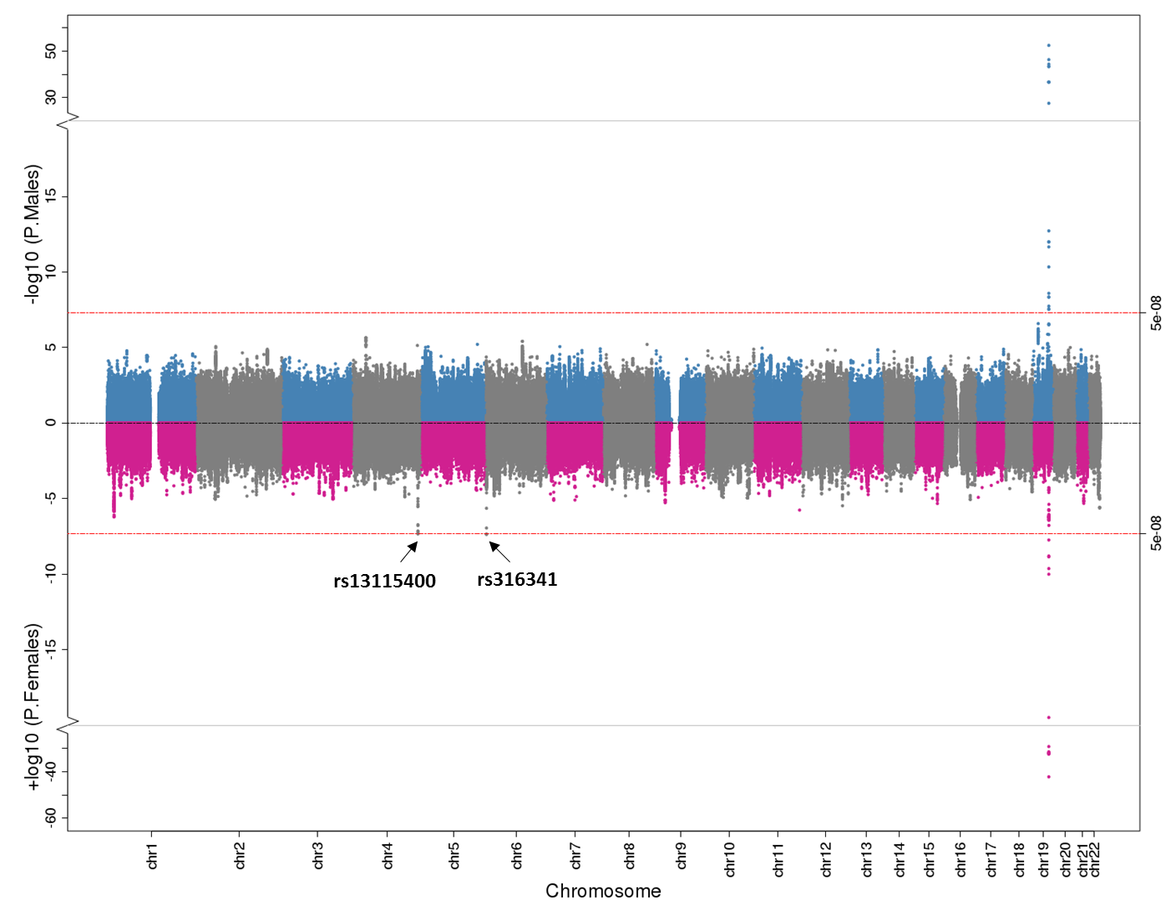

**Figure 1:** Miami plot illustrating CSF Aβ-42 genome-wide association results stratified by males and females. Male findings are plotted in blue and grey on the top and female results are plotted in pink and grey at the bottom. The red lines at the top and bottom represent the genome-wide threshold for statistical significance (p<5x10-8).

Figure 2. Sex-Stratified Genome Wide-Association Results for CSF Tau

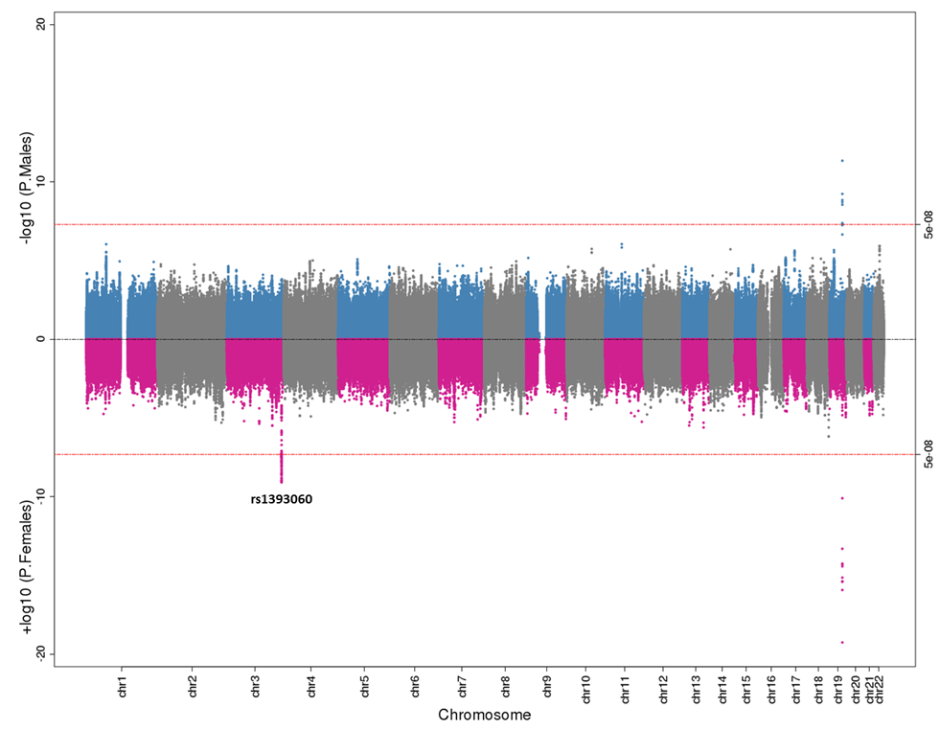

Figure 2: Miami plot illustrating CSF total tau genome-wide association results stratified by males and females. Male findings are plotted in blue and grey on the top and female results are plotted in pink and grey at the bottom. The red lines at the top and bottom represent the genome-wide threshold for statistical significance (p<5x10-8).

Figure 3. Significant Sex-Specific Gene Expression Associations with Tangle Pathology Among Genes in the rs1393060 Locus.

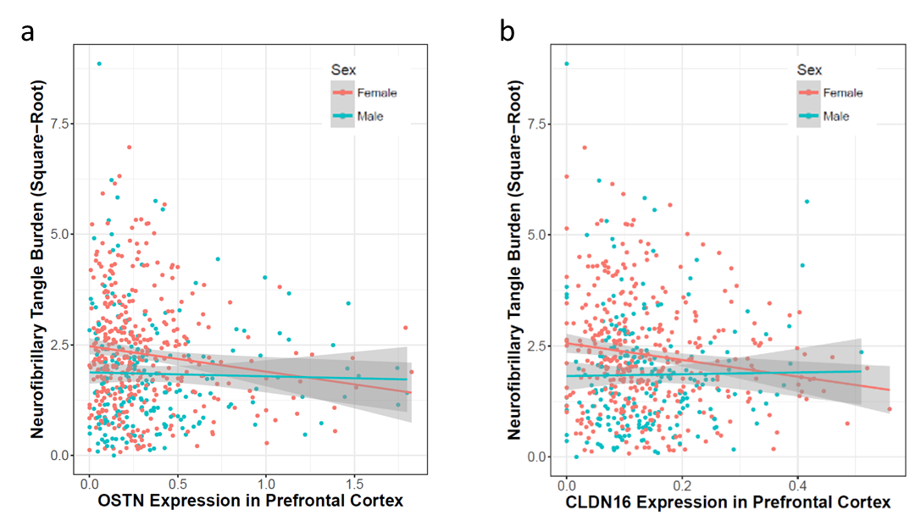

Figure 3: (a) *OSTN* and (b) *CLDN16* expression in the prefrontal cortex are presented on the X-axis, square-root transformed neurofibrillary tangle burden (measured with immunohistochemistry) is presented on the Y-axis. Females are presented in red and males are presented in blue.

Figure 4. Significant Sex-Specific Association Between SERPINB6 Expression in the Prefrontal Cortex and Amyloid Burden.

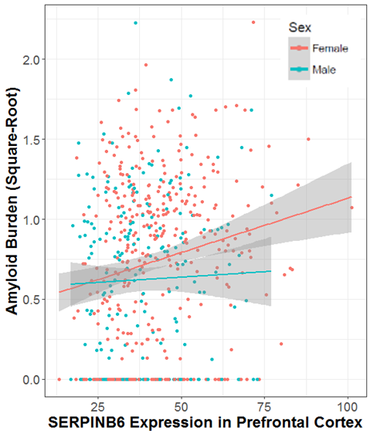

Figure 4: *SERPIN6* expression in the prefrontal cortex is presented on the X-axis, square-root transformed amyloid burden (measured with immunohistochemistry) is presented on the Y-axis. Females are presented in red and males are presented in blue.