Supplemental Material

Murine Methodology

Generation of genetically modified mice

Animals were cared for according to the Animals (Scientific Procedures) Act 1986 (PPL 70/6732). Floxed DSP mice (kindly provided by E. Fuchs, Rockefeller University, New York)⁶, where the second exon of the DSP gene is flanked by loxP sequences, were crossed with mice expressing Cre recombinase under the control of the cardiac αMHC promoter (kindly provided by Michael Schneider, Imperial College, London)⁷, to generate mice with cardiac restricted genetic deletion of DSP age and sex matched littermates with a normal, a DSP(flx, +) or αMHC cre+ genotype were used as a pooled control population as there was no difference in response between these individual genotypes. Mice were genotyped using PCR of extracted tail DNA. Mice were studied at 2 and 6 months of age to investigate whether electrophysiological changes occur before overt structural anomalies.

Electrophysiological studies & Conduction curves

Electrophysiological studies were performed as previously described using standard techniques ⁸.

Conduction curves were obtained by plotting activation delay (interval between stimulus and activation time – which was taken as the point of peak negative dV/dt on the intracardiac electrogram) against the coupling interval of the premature stimulus. Mean increase of delay (MID) was calculated by dividing the integrated increase in delay by the interval between the basic cycle length and the ventricular refractory period⁹.

Echocardiography
Echocardiography was performed on a Vivid 7 system (GE Healthcare, Bedford, UK) using a 14MHz probe with the mice under 1-1.5% isoflurane anaesthesia. Cardiac dimensions were measured from 3 consecutive M mode cardiac cycles from both a parasternal long axis and short axis view, using the leading edge convention.

Murine Histology
Thin sections of myocardial tissue were stained with H&E and Masson Trichrome to detect fibrosis. For Oil Red O staining, sections were fixed in 4% paraformaldehyde, washed in distilled water, stained with Oil Red O solution in isopropanol and rinsed in isopropanol.

Immunostaining
Murine:- 10μm sections of frozen myocardial sections were fixed with 4% paraformaldehyde, permeabilized with 0.2% Triton X-100 in TBS and blocked with 5% goat serum. They were incubated with mouse monoclonal antibodies against DSP (Progen, Germany), mouse monoclonal antibody against plakoglobin (BD Biosciences Pharmingen), rabbit polyclonal antibody against Cx43 (Invitrogen) or rabbit polyclonal antibody against the sodium channel (Alomone Labs, Jerusalem, Israel) overnight at 4°C. Sections were washed with TBS and fluorescence labelled secondary antibodies (Cy3 goat anti-rabbit and Cy2 goat anti-mouse, Jackson Immunoresearch, Pennsylvania) were added for 1 hour -they were examined using confocal microscopy.
Human:- Myocardial biopsies were obtained from 3 subjects-(5, 8 &9) and immonostained according to previously published techniques¹¹.

Real time RT-PCR
Quantitative real time RT-PCR was performed on mouse hearts using Taqman gene expression assays (Applied Biosystems). Hearts were washed with cold PBS and immediately placed in liquid nitrogen. They were ground in liquid nitrogen with a pestle and mortar and RNA was extracted using the RNeasy kit (Qiagen). cDNA was synthesized using the High Capacity cDNA Reverse Transcription Kit (Applied Biosystems). All genes were assayed in triplicate with GAPDH as the housekeeping gene by the 2-ΔΔCt method.

Isolation of murine cardiomyocytes and single cell electrophysiology
Cardiomyocyte isolation and patch clamping to assess Na channel current activity were performed using standard techniques. Peak current inactivation was assessed by fitting the time-decay with a single exponential using ClampFit.

Isolation of cardiomyocytes
Mice were injected with heparin sodium (250 IU) and anaesthetised with a combination of ketamine/xylazine/atropine. The hearts were rapidly excised, cannulated and perfused with buffer containing (in mmol/L) 113 NaCl, 4.7 KCl, 0.6 KH2PO4, 0.6 Na2HPO4, 1.2 MgSO4.7H2O, 12 NaHCO3, 10 KHCO3, 30 taurine, 10 HEPES, 11 glucose and 10 2,3-butanedione monoxime, saturated with 95% O2-5% CO2 at 37°C. The hearts were perfused at 3 ml/min with perfusion buffer for 4 min, then with digestion buffer (perfusion buffer containing 0.9 mg/ml collagenase (Worthington type II), 0.125 mg/ml hyaluronidase and 12.5 μmol/L CaCl2) for 10 min. The ventricles were then cut into several pieces and agitated in digestion buffer at 37oC with oxygenation for 10 min twice. The supernatant was collected and 5% foetal calf serum was added. After centrifugation at 600 rpm for 3 min, the cell pellet was suspended in 10 ml of perfusion buffer containing 12.5 μM CaCl2 and the calcium concentration was gradually restored to 1 mM over 20 min. The myocytes were re-centrifuged at 600 rpm for 3 min, the cell pellet was suspended in culture medium (M-199 medium containing 2 mg/ml bovine serum albumin, 0.66 mg/ml creatine, 0.62 mg/ml taurine, 0.32 mg/ml carnitin hydrochloride, 10 units/ml penicillin, 10 μg/ml streptomycin and 25 μM blebbistatin) and seeded onto sterilised laminin-coated coverslips for 60 min in humidified 5% CO2-95% air at 37°C. Myocytes were then gently washed once with blebbistatin-free culture medium to removed unattached cells use on the same day of isolation.

Single cell electrophysiology
Patch-clamp current recordings were performed with an Axopatch 200B amplifier (Axon Instruments) using fire-polished pipettes with a resistance of 3-4 MΩ, pulled from filamented borosilicated glass capillaries (Harvard Apparatus, 1.5 mm OD x 1.17 mm ID). Data were acquired and analysed by using a Digidata 1322A interface (Axon Instruments) and pCLAMP software (version 10, Axon Instruments). All experiments were done at room temperature. Whole cell cardiac sodium currents (INa) were recorded from adult mice ventricular myocytes freshly isolated. All recordings were done in a low sodium extracellular solution containing (mM): NaCl 25, CsCl 120, CaCl2 1, MgCl2 1, H-HEPES 5, Glucose 10 (buffered to pH 7.4 with CsOH). The intracellular solution was (mM): NaCl 5, CsCl 125, MgATP 2, EGTA 10, HEPES 20 (buffered to pH 7.2 with CsOH). To characterize the voltage dependency of the peak I_{Na}, cells were held at -120 mV, and 200 ms steps were applied from -90 mV to +30 mV in 5 mV increments. The interval between the voltage steps was 3 s. Peak current inactivation was assessed by fitting the time-decay with a single exponential using ClampFit.

Human Methodology
The multi-electrode array (MEA) (Ensite, St Jude Medical) was deployed via the left femoral vein in the RVOT. Right ventricular geometry was created by dragging a 5F mapping catheter along the endocardial surface of the RV. The RV geometry was created in the usual manner taking care to ensure that the array was positioned at a site within 4cm of the RV apex, body and RVOT surfaces to obtain accurate NC unipolar electrogram data from these sites. Detailed geometry creation was assessed by ensuring dense surface point acquisition and editing during collection to eliminate inaccurate interpolated surface projections with sparse geometric points in any given area. RV pacing was established using a quadrapolar catheter placed in the RV apex.

Study Protocol
After 3 minutes of steady state RV apical pacing at 400msec, an extrastimulus (S₂) was introduced after a drivetrain of 10 beats according to a standard S1-S2 restitution protocol. The coupling interval of S₁-S₂ was increased in stepwise fashion in increments of 50msec until a sinus beat occurred and then decremented by 50ms every cycle to the baseline coupling interval, by 20 ms every cycle to 300ms and by 5ms every cycle from 300ms until the ventricular effective refractory period (ERP) was encountered.

The non-contact mapping data were collected with a recording bandwidth of 0-300Hz in all cases and measurements made with a filter band width of 0.1-25Hz as previously described¹⁶. Investigators (PL, AA, EJC, MF) were blinded to the measurements of other investigators. The array was maintained in the same position throughout the performance of the restitution curves.

The time from the pacing artefact to electrogram peak negative dV/dt was used as the local activation time (AT). Activation-recovery interval (ARI) was defined as the interval between activation time (AT) and repolarization time (RT) and measured as previously described^{15, 16}. In summary, the RT was measured at the dV/dt_{max} for the the dV/dt_{min} of the positive T-wave (Wyatt method). The unipolar electrograms with flat T waves and ST-segment elevation without discernable T-wave upstroke were excluded from measurement. Diastolic interval was measured from the end of repolarization (RT) from the preceding beat to the AT of the following beat. The slope of the restitution curve was calculated using the least mean squares method¹⁷. The RV was divided into 16 anatomical segments¹⁵ and the restitution slopes studied in the segments from the RVOT, RV body and apex.

Measurement of Endocardial Local Activation Delay
Areas of local activation delay during sinus rhythm were determined to estimate the location of the diastolic pathway using a method termed activation gradient quantification. During sinus rhythm without pacing, activation times determined from NC unipolar recordings at 64 locations defined by Cartesian coordinates were used to construct a three-dimensional activation map^{26,27}. Conduction velocity was determined by computing the linear regression of activation times from 4-6 recording sites that were spatially aligned in the direction of the propagating wavefront and in proximity to one another along the endocardial surface in sinus rhythm. From regression analysis, the slope of the regression line in milliseconds and the regression coefficient is obtained. The conduction velocity of the propagating wavefront was calculated from the mean distance between adjacent recording sites used for regression divided by the slope of the regression line. The regression coefficient is an estimate of the uniformity of wavefront propagation along the endocardial surface at any measured region. This regression analysis was performed at all regions of the activation map. Where slow conduction occurred on the map (i.e., greatest local activation delay), the three-dimensional position, conduction velocity magnitude (CV), and regression coefficient (r²) were calculated.

Statistical Analysis
Statistical analysis was performed using GraphPad Prism v4. ECG, electrophysiology, telemetry and echocardiography data were analyzed by the Mann-Whitney U test. Numbers of mice with VT were compared using Fisher’s exact test. P values less than 0.05 were considered statistically significant. The mean ± SD of computed values of AG and r² at the region of greatest local activation delay was determined for DSP+ versus control patients. The unpaired t-test was used to assess the statistical significance of the difference between DSP+ patients and controls for each of these parameters (SigmaStat ver. 3.11, 2004). This AT & ARI data were compared using curve fitting. MLWin ver 2.01 was used to fit a regression model to the restitution curve data and statistical significance was inferred from the model fit. Mean MID values (between RV regions within each patient group and between patient groups) were compared with ANOVA and corrected for multiple comparisons. A logistic regression model (STATA 8.2) was fitted to evaluate the odds a segment of control/DSP+ hearts having S_{max} >1. As multiple segments were analysed in each heart, clustering was used to adjust for error.

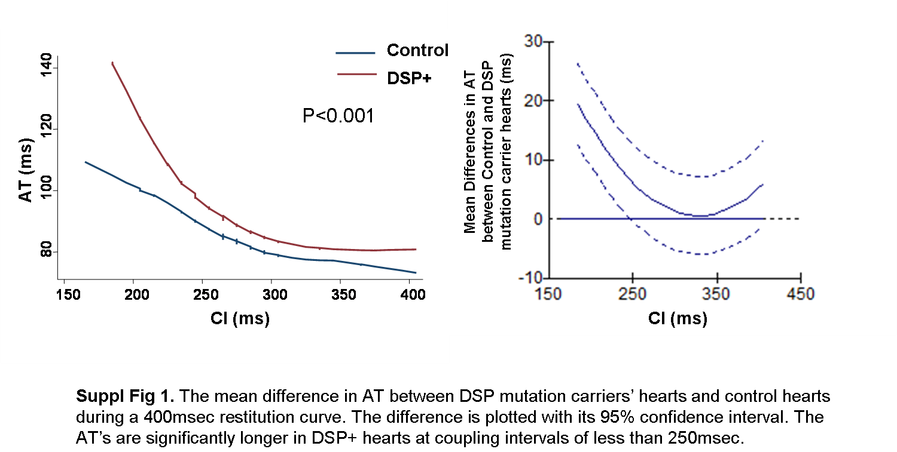
Supplementary Table 1. ICD Indications and Follow-Up

Subject No | Age  (M/F) | ICD Implant date | Reason for Implantation |  | Last FU |  |  |  | Months FU |  | ICD discharge |  | Rhythm ICD discharge |  | NSVT detected by ICD |  | ICD |  | Criteria Maj/Min
1 | 43 F | 23/07/2002 | Secondary (VF) |  | 01/07/2011 |  |  |  | 108 |  | yes |  | VF |  | yes |  | 1 |  | 1/1
2 | 50 F | 27/01/2005 | Primary  (VT, FHxSCD) |  | 04/03/2011 |  |  |  | 74 |  | yes |  | VT |  | yes |  | 1 |  | 1/1
4 | 28 F | 28/11/2003 | Primary – syncope, FHx SCD |  | 05/09/2011 |  |  |  | 94 |  | No |  | - |  | yes |  | 1 |  | 1/1
5 | 72 F | 02/08/2005 | Primary – syncope, Reduced LV EF, FhSCD |  | 04/07/2008 |  |  |  | 35 |  | no |  | - |  | no |  | 1 |  | 1/2
6 | 53 F | 28/11/2003 | Primary- NSVT FhSCD |  | 21/10/2011 |  |  |  | 95 |  | no |  | - |  | no |  | 1 |  | 2/1
8 | 22 M | 09/05/2008 | Primary (syncope, NSVT, inducible VT on EPS) |  | 01/09/2011 |  |  |  | 40 |  | yes |  | VT |  | yes |  | 1 |  | 1/2
10 | 33 M | 30/01/2007 | Primary- NSVT FhSCD |  | 23/09/2011 |  |  |  | 56 |  | no |  | - |  | bo |  | 1 |  | 1/1

.

