Supplementary material
Suppression of protein aggregation by chaperone modification of high molecular weight complexes John Labbadia, Sergey S. Novoselov, et al

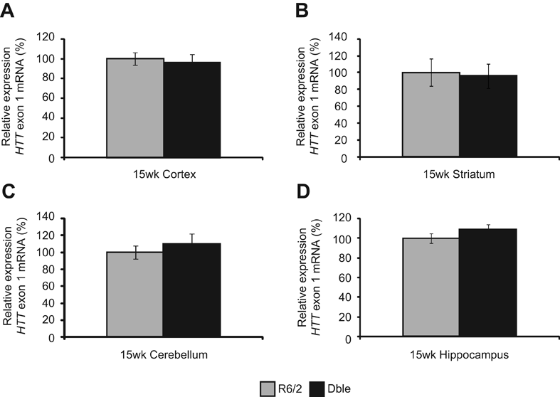
Supplementary Figure 1 – Over-expression of human HSJ1a does not alter huntingtin exon 1 transgene expression in R6/2 brain tissues
Taqman RT-qPCR was performed on cDNA synthesized from (A) cortex, (B) striatum, (C) cerebellum, and (D) hippocampus of R6/2 (grey bars) and Double transgenic (Dble) (black bars) mice. The Δ Ct method was used to determine relative HTT exon 1 expression and mean values were plotted +/- SEM for each group (n = 6). The reference genes used were: Cortex - Atp5b and Canx, Striatum - Atp5b and Yhwaz, Cerebellum – Atp5b and Eif2a and Hippocampus – Atp5b.

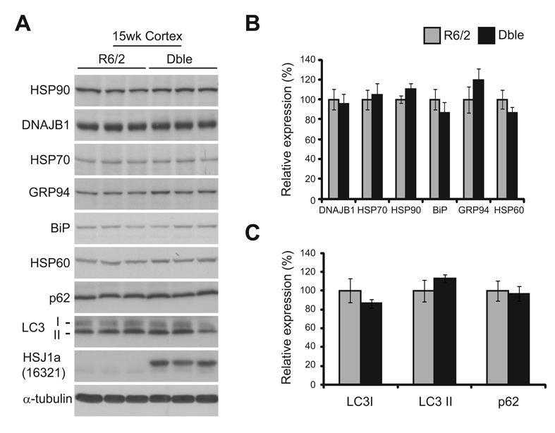
Supplementary Figure 2 – Over-expression of HSJ1a does not alter levels of major molecular chaperones or markers of autophagy in R6/2 brain tissue
(A) Representative western blots of cortical HSP90, HSP70, DNAJB1, GRP94, BiP, HSP60, p62, LC3, and α-tubulin levels in R6/2 and Double transgenic (Dble) mice at 15 weeks of age. Relative expression of (B) major chaperones or (C) autophagy markers was determined by densitometry. Expression levels were calculated relative to levels of α-tubulin and mean values were plotted +/- SEM for R6/2 (grey bars) or Dble (black bars) mice (n = 6).

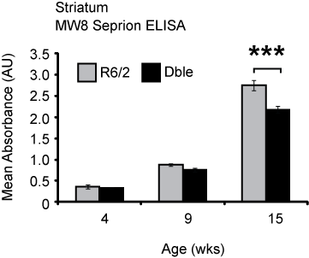

Supplementary Figure 3 – The effect of HSJ1a over-expression on aggregate load and soluble HTT in R6/2 striatum
Striatum from 4, 9, and 15 week old R6/2 (light grey bars) and Double transgenic (Dble) mice (black bars) was subjected to MW8 SeprionELISA to determine levels of aggregated HTT. WT and HSJ1a signals were considered to be background and were subtracted from R6/2 and Dble readings respectively. Mean values were plotted +/- SEM for each group (n = 6). Statistical analysis was performed by Student's t-test (*** p < 0.005).

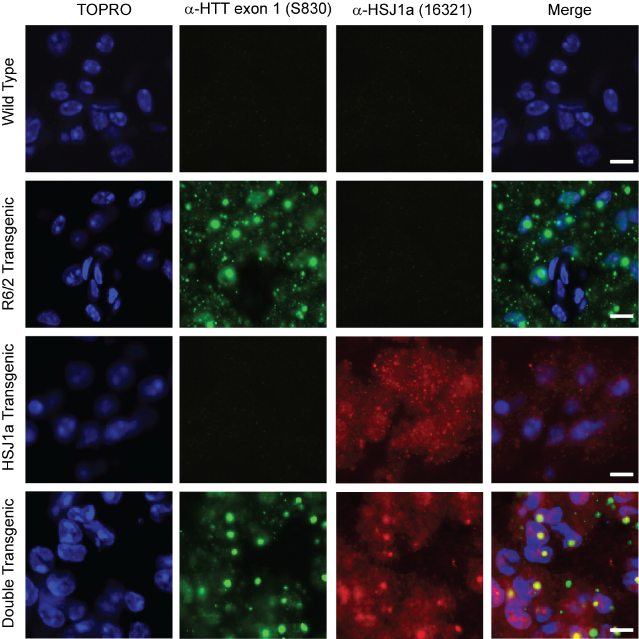

Supplementary Figure 4 – HSJ1a co-localizes with nuclear but not cytoplasmic inclusions at 15 weeks when over-expressed in R6/2 cortex
Representative cortical confocal microscopy images from 15 week old paraformaldehyde fixed brain sections (15µm) obtained from WT, HSJ1a, R6/2, and Double transgenic (Dble) mice. Sections were stained using anti-huntingtin exon 1 (HTT) (S830; green) or anti-HSJ1a (16321; red) antibodies. TOPRO (blue) was used to stain nuclei. Scale bars represent 10 µm.

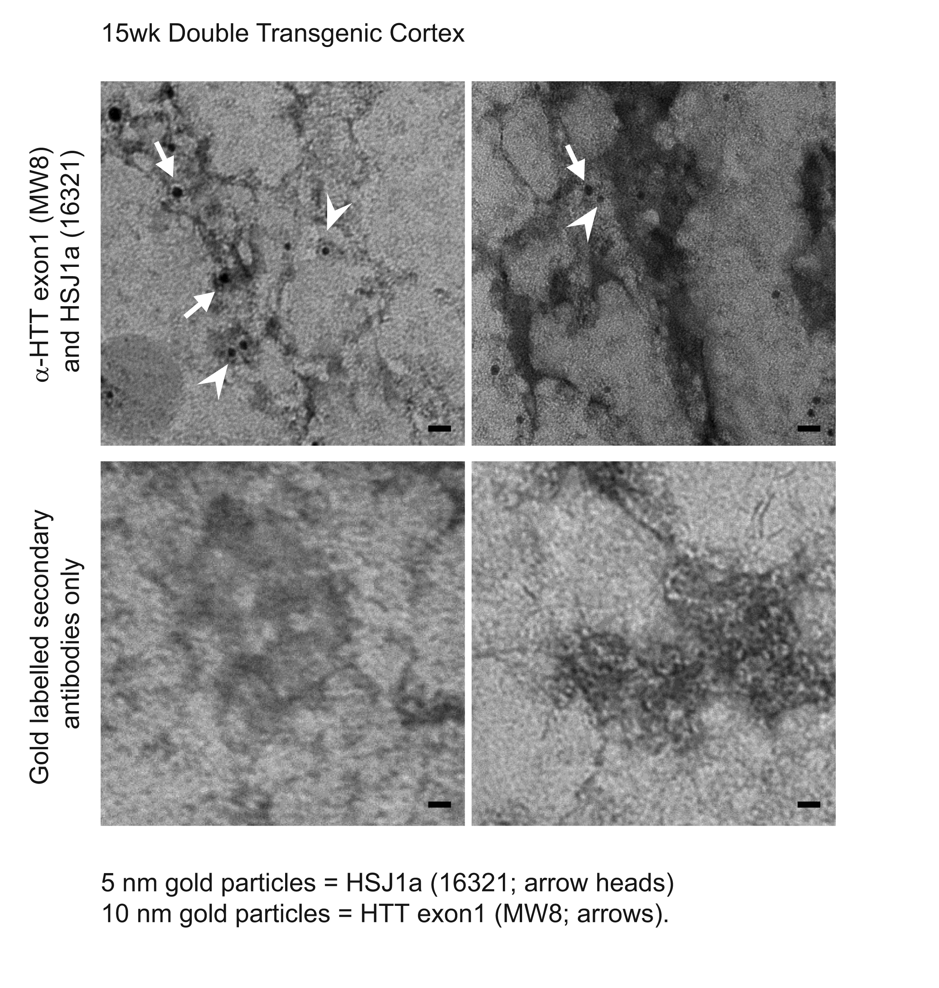

Supplementary Figure 5 - HSJ1a co-localizes with aggregated material isolated from 15 week old double transgenic mouse cortex
Representative TEM images obtained from double immuno-gold labelled aggregated material isolated from 15 week old double transgenic cortices by SERION ligand pull down. Isolated material was mounted on nickel grids and immuno-gold labelling was performed using anti- huntingtin exon 1 (HTT) (MW8; 10 nm gold particles; arrows) and anti-HSJ1a (16321; 5 nm gold particles; arrowheads) antibodies, or with secondary antibodies alone. Scale bars represent 20 nm.

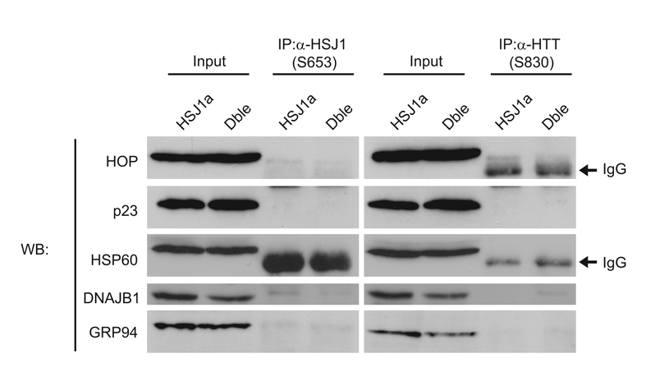

Supplementary Figure 6 - HSJ1a does not form complexes with HOP, p23, HSP60, DNAJB1, or GRP94 in mice
Additional western blots of major chaperones in 15 week HSJ1a and Double transgenic (Dble) mouse brain tissue after IP with anti-huntingtin exon 1 (HTT) (S830) or anti-HSJ1 (S653) antibodies showing no or minimal immuno-complex precipitation.

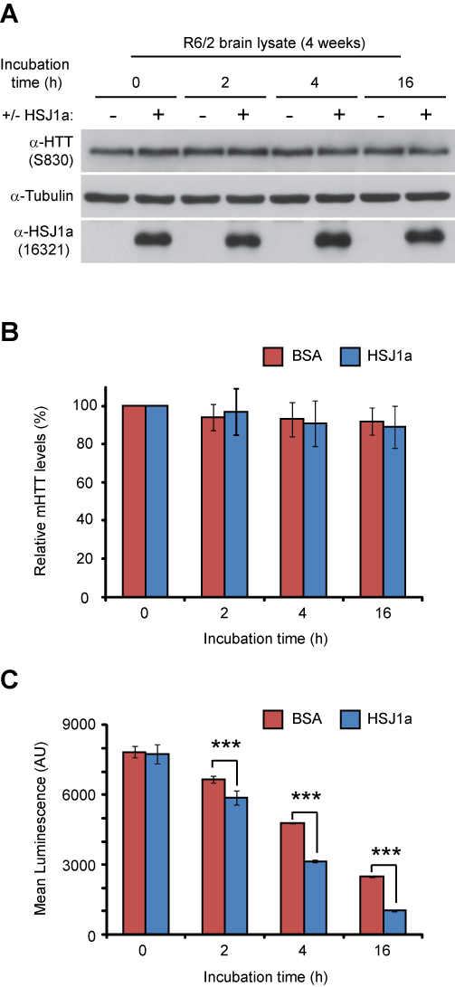

Supplementary figure 7 - HSJ1a does not promote degradation of HTT exon 1 in R6/2 brain lysates
(A) Representative western blots of HTT, β-tubulin, and HSJ1a levels in 4 week R6/2 brain lysates 0, 2, 4, or 16 hours after incubation at 37°C in the presence of 1 μg of BSA or HSJ1a. (B) Levels of soluble HTT were calculated relative to levels of tubulin and the mean HTT/tubulin ratio was plotted +/- SEM for samples in the presence of BSA (red bars) or HSJ1a (blue bars) (n = 7 per group). (C) R6/2 brain lysates were mixed with 1 μg of BSA or HSJ1a and 10⁵ U of luciferase. Luciferase activity was measured 0, 2, 4, and 16 hours after incubation at 37°C and mean values were plotted +/- SEM for each time point (n=4 per group). Statistical analysis was performed by Student's t-test (*p < 0.05, ** p < 0.01, *** p < 0.005).
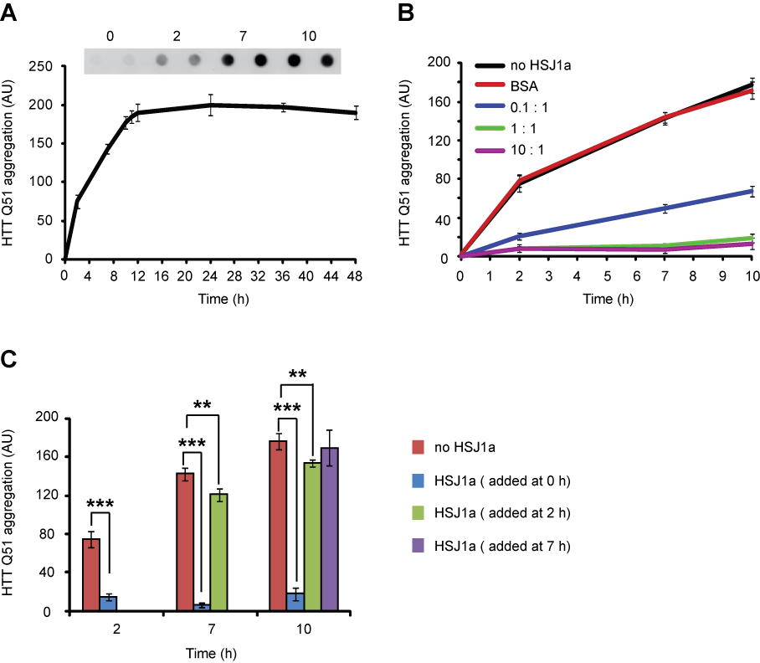
Supplementary Figure 8 – HSJ1a reduces the amount of insoluble material in an in vitro assay of huntingtin exon 1 aggregation
(A) SDS-insoluble S-tagged huntingtin exon 1 (HTT) Q51 was collected by filter trap 0, 2, 7, 10, 24, 36, and 48 hours after removal of GST by cleavage with TEV protease. Immunoblotting with HRP conjugated S-protein and densitometry were then used to determine relative levels of aggregated HTT Q51 and mean values +/- SEM were plotted for each time point (n = 4). (B) SDS-insoluble HTT Q51 was collected by filter trap 2, 7 or 10 hours after removal of GST by TEV cleavage (black line) in the presence of BSA (10:1 BSA:HTT Q51 - red line), or purified recombinant HSJ1a added to reactions at ratios (HSJ1a:HTT Q51) of 1:10 (blue line), 1:1 (green line) or 10:1 (purple line). Relative levels of aggregated HTT Q51 were determined by immunoblotting and densitometry and mean values +/- SEM were plotted for each time point (n = 4). (C) SDS-insoluble HTT Q51 was collected by filter trap 2, 7 or 10 hours after removal of GST by TEV cleavage (blue bar) in the presence of purified recombinant HSJ1a (red bar) at a ratio of 1:1 (HSJ1a:HTT Q51). HSJ1a was added to reactions either 0 (red), 2 (green), or 7 (purple) hours after initiation of aggregation by TEV protease cleavage. Relative levels of aggregated HTT Q51 were determined by immunoblotting and densitometry and mean values +/- SEM were plotted for each time point (n = 4). Statistical analysis was performed by Student's t-test (** p < 0.01, *** p < 0.005).

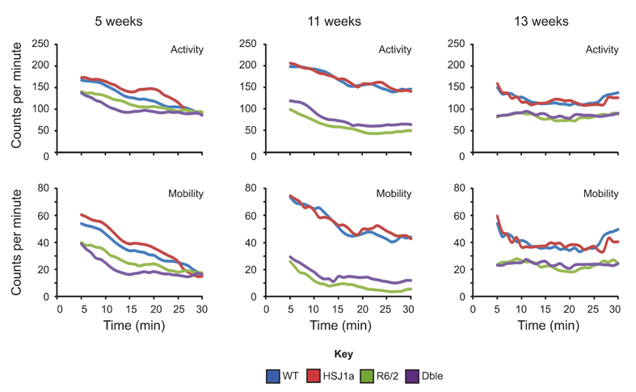
Supplementary Figure 9– HSJ1a over-expression improves hypo-activity in R6/2 mice at 11 weeks
Activity and mobility were measured for 30 minutes in WT (blue lines), HSJ1a (red lines), R6/2 (green lines) and Double transgenic (purple lines) mice at (A) 5, (B) 11 and (C) 13 weeks of age. The mean number of counts (beam breaks) per minute for each group was plotted for both parameters at each age (n ≥ 16 per group).
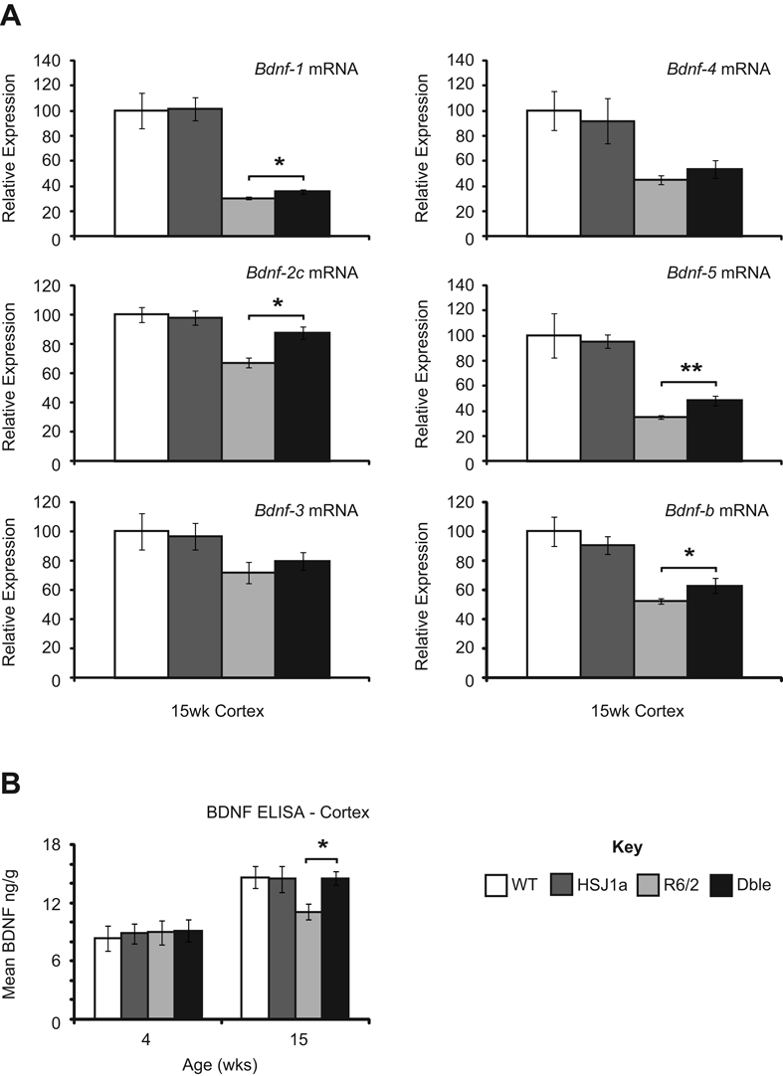
Supplementary Figure 10 – HSJ1a over-expression increases levels of BDNF mRNA and protein in R6/2 cortex at 15 weeks of age
(A) Taqman RT-qPCR was performed on cDNA synthesized from cortical RNA of WT (white bars), HSJ1a (dark grey bars), R6/2 (grey bars) and Double transgenic (Dble) (black bars) mice. The Δ Ct method was used to determine relative Bdnf transcript levels and mean values were plotted +/- SEM for each group (n = 6). Bdnf mRNA was normalized to the
reference genes Atp5b and Canx. (B) BDNF protein levels were determined using Promega BDNF Emax ImmunoAssay system modified as described. Mean values were plotted +/- SEM for each group (n=5). Statistical analysis was performed by Student's t-test (*p < 0.05).

Supplementary Table 1 - Overall mouse numbers and repeat sizes

 | Wild Type | HSJ1a Transgenic | R6/2 Transgenic | Double Transgenic
Total Study Mice | 84 | 62 | 72 | 61
Male Trial Mice | 17 | 7 | 12 | 9
Female Trial Mice | 18 | 9 | 16 | 7
Total Trial Mice | 35 | 16 | 28 | 16
Mean CAG Repeat Size | N/A | N/A | 193 | 192
Standard Deviation | N/A | N/A | ± 4 | ± 2
Supplementary Table 2 - Activity and mobility P-values
Comparison | Week | Activity | Mobility
Time | 5 | < 0.001 | < 0.001
 | 7 | < 0.001 | < 0.001
 | 11 | < 0.001 | < 0.001
 | 13 | 0.076 | < 0.001
Genotype | 5 | 0.004 | 0.001
 | 7 | < 0.001 | < 0.001
 | 11 | 0.003 | < 0.001
 | 13 | 0.015 | 0.002
Genotype *Time | 5 | < 0.001 | < 0.001
Genotype *Time | 7 | < 0.001 | < 0.001
 | 11 | 0.147 | 0.276
 | 13 | 0.248 | 0.042
Treatment | 5 | 0.957 | 0.925
 | 7 | 0.327 | 0.491
 | 11 | 0.375 | 0.545
 | 13 | 0.08 | 0.557
Treatment *Time | 5 | 0.357 | 0.822
Treatment *Time | 7 | 0.461 | 0.404
 | 11 | 0.689 | 0.734
 | 13 | 0.248 | 0.191
Treatment *Genotype | 5 | 0.234 | 0.246
Treatment *Genotype | 7 | 0.983 | 0.781
 | 11 | 0.044 | 0.047
 | 13 | 0.976 | 0.893
Treatment *Genotype *Time | 5 | 0.587 | 0.85
Treatment *Genotype *Time | 7 | 0.084 | 0.104
Treatment *Genotype *Time | 11 | 0.741 | 0.729
 | 13 | 0.354 | 0.76

Key: Pink = P < 0.001, Orange = P < 0.01, Yellow = P < 0.05
Supplementary Table 3 - Table of antibodies, applications, and dilutions used in this study
Antibody | Catalogue number | Source | Dilution /amount | Application
HSP25 | SPA-801 | Stressgen | 1 in 1000 | WB
HSP40 | SPA-400 | Stressgen | 1 in 5000 | WB
HSP60 | SPA-828 | Stressgen | 1 in 1000 | WB
HSP70 | SPA-810 | Stressgen | 1 in 1000 | WB
HSP70 | BRM-22 | Stressgen | 1 in 1500 | WB
HSP90 | SPA-835 | Stressgen | 1 in 5000 | WB
BiP | SPA-826 | Stressgen | 1 in 500 | WB
GRP94 | ab2791 | Abcam | 1 in 5000 | WB
HOP | SRA-1500 | Stressgen | 1 in 2000 | WB
p23 | MA3-414 | ABR | 1 in 1000 | WB
3B5H10 | P1874 | Sigma | 1 in 500 | IP
S830 | N/A | In House | 1 in 3000 | WB
S830 | N/A | In House | 1 in 2000 | IHC
MW8 | N/A | P.Patterson | 1 in 500 | IP
MW8 | N/A | P.Patterson | 1 in 500 | TEM
MW1 | N/A | P.Patterson | 1ng in 6ul | TR-FRET
MW1 | N/A | P.Patterson | 1 in 500 | IP
2B7 | N/A | Novartis | 10ng in 6ul | TR-FRET
UbK63 | PW0600 | Biomol | 1 in 500 | IHC
Ubiquitin | Z0458 | Dako | 1 in 2000 | WB
Ubiquitin | Z0458 | Dako | 1 in 20 | IP
p62 | 2C11 | Abnova | 1 in 20,000 | WB
LC3 | NB100-2331 | Novus | 1 in 500 | WB
HSJ1 (S653) | N/A | In House | 1 in 3000 | WB
HSJ1 (S653) | N/A | In House | 1 in 300 | IP
HSJ1a (16321) | N/A | In House | 1 in 300 | WB
HSJ1a (16321) | N/A | In House | 1 in 30 | IHC
HSJ1a (16321) | N/A | In House | 1 in 30 | TEM
Ovalbumin | A6075 | Sigma | 1 in 2000 | WB
S-protein HRP | 69047-3 | Novagen | 1 in 5000 | WB
α-tubulin | T9026 | Sigma | 1 in 30,000 | WB
α-β-tubulin | T4026 | Sigma | 1 in 3000 | WB
α-Goat HRP | P044901 | Dako | 1 in 5000 | WB
α-Mouse HRP | P0260 | Dako | 1 in 5000 | WB
α-Rat HRP | P0450 | Dako | 1 in 5000 | WB
α-Rabbit HRP | 32460 | Pierce | 1 in 20,000 | WB
α-Rabbit Alexa 546 | A10040 | Invitrogen | 1 in 1000 | IHC
α-Goat Alexa 488 | A11055 | Invitrogen | 1 in 1000 | IHC
α-Mouse Alexa 488 | A21202 | Invitrogen | 1 in 1000 | IHC
α-Rabbit Alexa 647 | A31573 | Invitrogen | 1 in 1000 | IHC
α-Sheep Alexa 555 | A21436 | Invitrogen | 1 in 1000 | IHC

Key: WB = Western Blotting, IP = Immunoprecipitation, IHC = Immunohistochemistry
TEM = Transmission electron microscopy (gold labelling)
Supplementary materials and methods
Production of hHSJ1a transgenic mice
The hHSJ1a transgene PrP-hHSJ1a-poly(A) was created by cloning the bovine PrP promoter fragment (Lemaire-Vieille et al. , 2000) upstream of the hHSJ1a cDNA open reading frame (Chapple and Cheetham, 2003) with a simian virus 40 poly(A) sequence. An 8 kb linearised, gel purified fragment in injection buffer (10mM Tris-HCl pH 7.4, 0.25mM EDTA) at
50 ng/µl was used for pronuclear injection of B6/CBA F1 blastocysts by Dr Jose Gonzalez (EMBL), with subsequent founder generation. Founders were screened by PCR using hHSJ1 specific primers F3 (5’-CAA TCA ATG GTG TCC CAG ATG ACC TGG-3’) and R3 (5’-CCA CAA CTA GAA TGC AGT G-3’). Positive founders were crossed to C57Bl/6 animals. The hHSJ1a line 52a was derived and hHSJ1a expression confirmed, then backcrossed onto a C57Bl/6 background for use in this study.
Mouse maintenance, breeding, genotyping and CAG repeat sizing
All mouse experiments were performed under project and personal licenses approved and issued by the UK Home Office. These licenses require humane end points to be applied before they die as part of the disease process. Hemizygous R6/2 mice (Mangiarini et al. , 1996) were bred by backcrossing R6/2 males to (CBA x C57Bl/6) F1 females (B6CBAF1/OlaHsd, Harlan Olac, Bicester, UK). All animals were subject to a 12 h light/dark cycle and had unlimited access to water and breeding chow (Special Diet Services, Witham, UK). Housing conditions and environmental enrichment were as previously described (Hockly et al. , 2003). R6/2 mice were always housed with wild type mice. R6/2 mice were genotyped and CAG repeat sized as previously described (Sathasivam et al. , 2010). Mouse brains or brain regions were snap-frozen in liquid nitrogen and stored at −80°C.

Cell culture, plasmids and transfection
Human neuroblastoma SK-N-SH cells were maintained at 37 °C and 5% CO₂ for 24 hrs in DMEM/F12 containing 10% FCS (Invitrogen) and 50 µg/ml gentamicin (Sigma-Aldrich) to reach 70% confluency in 6 well plates (Becton Dickinson). Cells were then transfected with
1 µg/well of pCMV-Tag3a-HSJ1a (wild type, H31Q or UIM mutants described previously (Chapple and Cheetham, 2003, Westhoff et al. , 2005) or empty vector (Stratagene) using Lipofectamine and Plus reagents (Invitrogen) according to manufacturer’s instructions. 24 hrs post transfection cells were lysed in 200 µl/well of HEPES buffer containing 5% of protease inhibitor cocktail (PIC) (Sigma-Aldrich) or Ac-TEV assay buffer without PIC, sonicated, aliquoted and frozen at -70 ^{º}C until further use.
Protein extraction from mouse brain tissue
Mouse brain tissue was homogenized in RIPA (150 mM NaCl; 1% NP40; 0.5% Na deoxycholate; 0.1% SDS; 50 mM Tris-HCl pH8.0; 1mM 2-Mercaptoethanol; 1 mM PMSF; complete protease inhibitors [1 tablet per 10 ml - Roche]) or HEPES buffer (50 mM HEPES pH 7.0, 150mM NaCl, 10mM EDTA, 10mM DTT, 1% NP40, 0.5% Na deoxycholate, 0.1% SDS, 5% Protease inhibitor cocktail) 1:15 (w/v). All samples were sonicated 3 times x 5 seconds on ice. RIPA lysates were used for experiments in Figures 1, 2, and S2. All other experiments were performed with HEPES isolated protein extracts.
Cellular fractionation from mouse brain tissues
Nuclear and cytosolic fractions were prepared from mouse brain tissues as previously described (Landles et al. , 2010) with the exception that half brains minus cerebellum were used. Briefly, brains were dounce homogenized (10 pestle strokes) in sucrose buffer
(575 mM sucrose, 25 mM KCl, 50 mM triethanolamine hydrochloride (pH 7.5), 5 mM MgCl₂, 1 mM DTT, 0.5 mM PMSF, Roche complete protease inhibitor cocktail) and centrifuged at 800 g for 15 min at 4°C. The resulting supernatant was retained as the cytosolic fraction. The remaining pellet was re-dounced in 3 ml of sucrose buffer (5 pestle strokes) and centrifuged across a sucrose gradient at 124,000 g for 1 h at 4°C. The resulting nuclei were washed twice with, and then re-suspended in, sucrose buffer and stored at -80°C. Purity of fractions was determined by SDS-PAGE and western blotting with histone H3 and α-tubulin specific antibodies.
SDS-PAGE, western blotting and immunodetection
Protein lysates were diluted in 2x Laemmli loading buffer and subjected to SDS-PAGE. Proteins were then transferred to Protran nitrocellulose membranes by western blotting as previously described (Woodman et al. , 2007). Nitrocellulose membranes were blocked with 3 – 5% non fat dried milk with 0.05 % (v/v) Tween-20 in PBS for 1h at RT or at 4°C overnight. Membranes were then incubated with appropriate primary and secondary antibodies (Table S2) and signal was detected using ECLplus reagents (GE Healthcare) and ECL hyperfilm (Amersham). Films were processed using a Xenograph developer.
Seprion ligand ELISA
2.5% protein lysates were made from mouse brain tissues in RIPA buffer using lysing
matrix-D tubes and a FastPrep Ribolyser (MP Biomedicals). Lysates were incubated with Seprion ligand coated 96 well plates (Microsens Technologies) for 1 h at RT before sample aspiration and washing with PBS 0.1% (v/v) Tween-20. Plates were then incubated with anti-HTT antibody (MW8), washed with PBS 0.1% (v/v) Tween-20, incubated with HRP conjugated secondary antibody, washed as before, and then incubated with TMB plus (Serotec). Reactions were allowed to proceed for 10 minutes before being stopped with
0.5 M HCl. Absorbance was then measured using a Biorad 680 microplate reader. For Seprion analysis of cellular fractions, nuclear and cytosolic fractions were diluted to a concentration of 1 μg/μl and 5 μg/μl respectively in RIPA buffer before use.

Time resolved Forster resonance energy transfer (TR-FRET)
Sample preparation and huntingtin TR-FRET were essentially performed as previously described (Weiss et al. , 2009). Brain tissues were homogenized in 10 volumes of lysis buffer (0.4% Triton PBS, complete protease inhibitors) and 10μl of sample was incubated with 1.5 ng of europium cryptate conjugated 2B7 and 30ng of D2 conjugated MW1 in each well of a 384 well plate for 1h at 4 °C. Signal was then measured at 620nm using a xenon lamp Envision plate reader (PerkinElmer) after excitation at 320nm.
Agarose gel electrophoresis for resolving aggregates (AGERA)
Sample preparation and AGERA were essentially performed as previously described (Weiss et al. , 2008). Mouse brain tissues were dounce homogenized in 10 volumes of Tris-saline (100mmol/L Tris-HCl pH 7.4, 150mmol/L NaCl, complete protease inhibitors) and briefly sonicated. 100 μg of protein was diluted in non-reducing loading buffer (150mmol/L Tris-HCl pH 6.8, 33% glycerol, 1.2% SDS, bromophenol blue) and subjected to electrophoresis on a 1.5% Agarose - Tris - SDS (1.5% agarose, 0.1% SDS, 375mmol/L Tris HCl pH 8.8) gel. Western blotting and immunodetection were then performed as previously described (Woodman et al. , 2007).
Taqman real time quantitative PCR
Taqman RT-qPCR reactions were performed in triplicate for each sample using white 96 well PCR plates and a Chromo4 real-time PCR machine (Bio-Rad). Reactions for housekeeping (HK) genes were set up in 20 μl reactions containing 5 μl of diluted cDNA, 10 μl of 2x Precision Mastermix, 1 μl of reconstituted primer/probe mix and 4 μl of ultra-pure water. Real-time PCR amplification was then performed using a thermal light cycler with conditions of 10 min at 95°C followed by 40 cycles of 15 s at 95°C and 30 s at 50°C. For genes of interest, 25 μl reactions containing 5 μl of diluted cDNA, 10 μl of 2x Precision Mastermix, 0.75 μl of forward primer (10 μM), 0.75 μl of reverse primer (10 μM), 0.5 μl of 5’ 6-FAM,
3’ TAMRA probe (10 μM), and 5.5 μl of ultra-pure water. Real-time PCR amplification was then performed using conditions of 15 min at 95°C followed by
40 cycles of 15 s at 95°C and 1 min at 50°C. All samples were performed in triplicate. Gene expression was then calculated relative to levels of HK genes using the delta Ct method.
Immunoprecipitation (IP), co-IP and sequential IP
100 µl of protein lysate was incubated with 25 µl of protein-G Dynabeads (Invitrogen) and antibody (Table S3) for 1 h at room temperature on a rotating wheel. Precipitated material was eluted from beads by heating for 3 min at 98°C in 30 µl of 4x SDS sample buffer and subjected to SDS-PAGE and Western blotting. In the case of sequential IP, material isolated after HSJ1 (S653) IP was eluted from beads with 1% SDS. Samples were then diluted 10 fold and used as inputs for IP with S830.
Exogenous IP and HSJ1 competition assays
HSJ1 IP was performed using anti-HSJ1 (S653) (Chapple and Cheetham, 2003) or anti-myc antibodies (Sigma) in R6/2 brain lysate mixed with 1-5 µg of either affinity purified HSJ1a
(wild type or ΔUIM) or SK-N-SH cell lysate HSJ1a (myc-tagged wild type, H31Q or ΔUIM). For competition assays, d-Ova or ubiquitin chains were pre-incubated for 30 min with purified or myc-tagged HSJ1a prior to the addition of R6/2 brain lysate and antibody.
Ex-vivo protein degradation assay
4 week old R6/2 mouse brain tissue was homogenised 1:15 (w/v) in 50 mM HEPES pH 7.0, 150mM NaCl, 1% NP40, 0.5% Na deoxycholate, 0.025% SDS, sonicated and pre-cleared by centrifugation at 13000 g. 10 μl of lysate was used in a 50 μl reaction mixture containing 1μg of purified recombinant HSJ1a or BSA (Sigma-Aldrich) in the presence of an ATP regeneration system (2 mM ATP, 10 mM phosphocreatine and 50 μg/ml of creatine phosphokinase; Sigma-Aldrich). Reactions were performed over a period of 16 hours at
37°C. HTT levels relative to β-tubulin were determined for at each time point by western blotting and densitometry using ImageJ software. Luciferase degradation was assessed under the same conditions as above, with an addition of 10⁵ U of luciferase (Sigma-Aldrich) added to each sample. Luciferase activity was then measured by addition of luciferase substrate (Promega) after 0, 2, 4, and 16 hours of incubation at 37°C and quantified with an Orion microplate luminometer (Berthold Detection Systems).
Immunohistochemistry and immunofluorescence
Mouse brains were frozen in isopentane at -50°C and 15 µm coronal sections were cut using a Bright instruments cryostat. Sections were rehydrated in TBS, fixed in
4% paraformaldehyde in PBS for 15 min, washed twice for 15 min in TBS, and then permeabilized by incubation in 0.1% TBS-Triton-X100 (v/v) for 15 min. After being washed twice for 15 min in TBS, sections were incubated in 4% hydrogen peroxide for 10 min, washed in water, and blocked for 30 min at room temperature in immuno-peroxidase blocking solution (2% BSA (w/v), 0.1% Triton-X100 (v/v) in TBS). Primary antibody (S830) was diluted in blocking solution and incubated with sections at 4°C overnight. Sections were then washed twice in TBS for 15 min and incubated for 1 h at room temperature in biotinylated horse anti-goat secondary antibody in blocking solution. After washing twice with TBS, sections were incubated in ABC-HRP complex using an Elite ABC kit
(Vector Labs) according to manufacturer’s instructions before incubation with staining solution (0.05% (w/v) DAB, 100 mM Tris–HCl pH 7.5, 0.03% (v/v) H₂O₂ solution). Colour was allowed to develop for 10 min and sections were washed extensively in water before counterstaining with Methyl Green. Sections were then allowed to dry overnight and further dehydrated by washing with 100% ethanol and histoclear. After removal of histoclear, slides were mounted with cover slips using DPX mounting media prior to viewing on an Axioscope 2 light microscope. Images were captured using an Axiocam camera, and Axiovision software.
Evaluation of nuclear inclusion size and number in mouse brain sections
Immuno-histochemistry was performed as described above and images were captured using an Axioscope light microscope and Axiocam digital camera. Nuclear inclusion number and area were counted manually using Axiovision software image analysis tools. All images were acquired blind to genotype and all subsequent measurements were also made blind to genotype.
Seprion ligand pulldown, immuno-gold labelling, and transmission electron microscopy
Sample preparation, Seprion ligand pulldown (Microsens technologies) and immuno-gold labelling were essentially performed as previously described (Sathasivam et al. , 2010). Briefly, aggregate material was isolated from 10% mouse brain homogenates by incubation with Seprion ligand coated magnetic beads and capture buffer (Microsens technologies) for 1 hour at RT. Beads were then washed once with capture buffer and twice with TBS before aggregated material was eluted from beads by heating at 100 °C for 5 min in the presence of 0.75% SDS. Eluted material was dried and re-suspended in 9 μl of ultrapure water before 3 μl of sample was added to carbon coated electron microscopy grids, air-dried for 5 min, and blocked in 0.1% BSA-CTM (Aurion) in PBS for 15 min. Grids were then incubated with anti-HTT (MW8) and anti-HSJ1a (16321) antibodies for 1 hour at RT, washed with PBS, incubated for 1 hour at RT with 5 and 10 nm colloidal gold conjugated secondary antibodies (BB international), washed, and negative stained in 1% uranyl-acetate. Images were taken using a transmission electron microscope (Tecnai-12 Biotwin; FEI) at 120kV.
Protein purification
Wild type and mutant HSJ1a were expressed in E.coli BL21-Gold cells (Stratagene) as GST-tagged fusion proteins and affinity purified upon tag cleavage on glutathione sepharose column. GST-TEV-huntingtin exon1-Q51-S_{tag} was purified as described earlier (Tam et al. , 2009). Recombinant protein purity was assessed by Coomassie staining. Purified ubiquitin monomer and chains were purchased from Enzo Life Sciences, ovalbumin was purchased from Sigma-Aldrich.
Ovalbumin denaturation
Ovalbumin (Sigma-Aldrich) was dissolved in 20 mM Tris HCl pH 7.5 up to a concentration of approximately 30 mg/ml, heated 100 ^{º}C for 15 min in the presence of 6 M guanidine HCl and dialysed overnight in Slide-A-Lyzer cassettes (Pierce) against PBS with 0.1% Triton X-100. Dialysed solution was cleared by centrifugation at 14000 x g for 15 min and biotinylated with EZ-Link Sulfo-NHS-Biotin (Pierce) according to manufacturer’s instructions. The resulting reaction mix was buffer exchanged using PD-10 desalting column (GE Healthcare) and denatured ovalbumin (d-Ova) concentrated using Slide-A-Lyzer cassettes and concentrating solution (Pierce).
In vitro aggregation and filter trap
Reactions were essentially performed as previously described (Tam et al. , 2009). Typically, 3.0 µM of freshly purified GST-HTT Q51 was incubated with Ac-TEV protease (Invitrogen) in the presence of an ATP regeneration system (2 mM ATP, 10 mM phosphocreatine and 50 µg/ml of creatine phosphokinase - Sigma-Aldrich) and different ratios of chaperones or albumin (Sigma-Aldrich). GST-HTT Q51, BSA and purified HSJ1a concentrations were calculated using BCA kit (Bio-Rad). HSJ1a protein concentration in SK-N-SH cell extracts was estimated using multiple serial dilutions immunoblotted with HSJ1 specific antibody using a calibration curve of purified HSJ1a as a reference. Reactions were performed in Ac-TEV assay buffer (50 mM Tris pH 7.5, 50 mM KCl, 5 mM MgCl₂, 1.5 mM CaCl₂, 0.5 mM EDTA, 1 mM DTT) and were stopped by flash-freezing in liquid nitrogen. Material was then thawed and subjected to filter trap analysis using 0.22 µm cellulose acetate (Whatman). Membranes were then blocked with 3% (w/v) fat free skimmed milk in PBS with 0.05 % (v/v) Tween-20 and incubated with S-Protein-HRP conjugate (Novagen). Signal was detected using ECLplus reagent kit (GE Healthcare) and results were quantified using ImageJ software.
Purification of HTT seeds from mouse brain and seeding experiment
Isolation of detergent insoluble material was performed similar to previously described method (Nekooki-Macheda et al, 2009). Approximately 200 mg of brain tissue from 15 week old WT control animals, R6/2, and DBLE transgenic was homogenised in 100 mM Tris pH 7.5, 150 mM NaCl₂, 0.5% Triton X-100, 5% protease inhibitor cocktail (Sigma) and sonicated for 10 seconds. Pre-cleared supernatant was supplemented with SDS up to 2% and subjected to ultracentrifugation at 540000 g for 30 minutes. The resulting pellet was resuspended in 2% SDS, sonicated and ultracentrifuged again. The process was repeated 3 times with one step of boiling for 5 minutes included before the last ultracentrifugation. Final pellets (“seeds”) were reconstituted in TEV assay buffer, sonicated and protein concentration was measured using BCA kit (BioRad). Seeds were then titrated on nitrocellulose using dot-blot apparatus (BioRad) and stained with Tub2.1 and S830 antibodies from which a relative concentration of HTT material was estimated. For the seeding experiment, 0.3 µM of GST-HTT Q51 was incubated with Ac-TEV protease (Invitrogen) in the presence of 120 ng or 160 ng of insoluble material isolated from WT, R6/2 or Dble transgenic mouse brains in the absence of the ATP regeneration system. Reactions were stopped at 0, 2 or 5 hours, then used in filter trap assay and analysed as described above.
Antibodies
The antibodies MW1 (Ko et al. , 2001), MW8 (Ko et al. , 2001), and 2B7 (Weiss et al. , 2009) were kind gifts from Dr Andreas Weiss (Novartis Pharma AG), S830 (Sathasivam et al. , 2001), S635 (Chapple and Cheetham, 2003), and 16321 (Chapple and Cheetham, 2003) were generated in house.

Supplementary references
Chapple JP, Cheetham ME. The chaperone environment at the cytoplasmic face of the endoplasmic reticulum can modulate rhodopsin processing and inclusion formation. J Biol Chem. 2003 May 23;278(21):19087-94.

Hockly E, Woodman B, Mahal A, Lewis CM, Bates G. Standardization and statistical approaches to therapeutic trials in the R6/2 mouse. Brain Res Bull. 2003 Sep 30;61(5):469-79.

Ko J, Ou S, Patterson PH. New anti-huntingtin monoclonal antibodies: implications for huntingtin conformation and its binding proteins. Brain Res Bull. 2001 Oct-Nov 1;56(3-4):319-29.

Lemaire-Vieille C, Schulze T, Podevin-Dimster V, Follet J, Bailly Y, Blanquet-Grossard F, et al. Epithelial and endothelial expression of the green fluorescent protein reporter gene under the control of bovine prion protein (PrP) gene regulatory sequences in transgenic mice. Proc Natl Acad Sci U S A. 2000 May 9;97(10):5422-7.

Mangiarini L, Sathasivam K, Seller M, Cozens B, Harper A, Hetherington C, et al. Exon 1 of the HD gene with an expanded CAG repeat is sufficient to cause a progressive neurological phenotype in transgenic mice. Cell. 1996 Nov 1;87(3):493-506.

Sathasivam K, Woodman B, Mahal A, Bertaux F, Wanker EE, Shima DT, et al. Centrosome disorganization in fibroblast cultures derived from R6/2 Huntington's disease (HD) transgenic mice and HD patients. Hum Mol Genet. 2001 Oct 1;10(21):2425-35.

Sathasivam K, Lane A, Legleiter J, Warley A, Woodman B, Finkbeiner S, et al. Identical oligomeric and fibrillar structures captured from the brains of R6/2 and knock-in mouse models of Huntington's disease. Hum Mol Genet. 2010 Jan 1;19(1):65-78.

Tam S, Spiess C, Auyeung W, Joachimiak L, Chen B, Poirier MA, et al. The chaperonin TRiC blocks a huntingtin sequence element that promotes the conformational switch to aggregation. Nat Struct Mol Biol. 2009 Dec;16(12):1279-85.

Weiss A, Klein C, Woodman B, Sathasivam K, Bibel M, Regulier E, et al. Sensitive biochemical aggregate detection reveals aggregation onset before symptom development in cellular and murine models of Huntington's disease. J Neurochem. 2008 Feb;104(3):846-58.

Weiss A, Abramowski D, Bibel M, Bodner R, Chopra V, DiFiglia M, et al. Single-step detection of mutant huntingtin in animal and human tissues: a bioassay for Huntington's disease. Anal Biochem. 2009 Dec 1;395(1):8-15.

Weiss A, Roscic A, Paganetti P. Inducible mutant huntingtin expression in HN10 cells reproduces Huntington's disease-like neuronal dysfunction. Mol Neurodegener. 2009;4:11.

Westhoff B, Chapple JP, van der Spuy J, Hohfeld J, Cheetham ME. HSJ1 is a neuronal shuttling factor for the sorting of chaperone clients to the proteasome. Curr Biol. 2005 Jun 7;15(11):1058-64.
Woodman B, Butler R, Landles C, Lupton MK, Tse J, Hockly E, et al. The Hdh(Q150/Q150) knock-in mouse model of HD and the R6/2 exon 1 model develop comparable and widespread molecular phenotypes. Brain Res Bull. 2007 Apr 30;72(2-3):8

