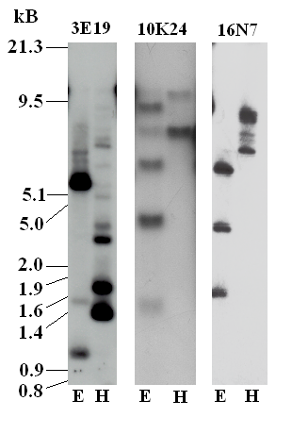
Figure S3. Southern blots of BAC clones 3E19, 10K24, and 16N7 that hybridized to cDNA probes corresponding to SSSGP-4, SSSGP-31, and SSSGP-8, respectively. BAC DNA samples were digested with EcoR1 (E) or Hind III (H), separated on a 0.8% agarose gel, and hybridized to a ³²P-labelled cDNA probe. DNA marker sizes were given on the left.

