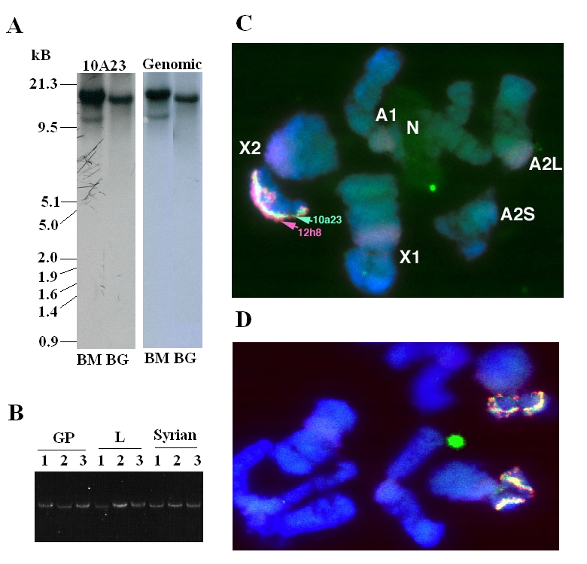
Figure S5. Evidence for a single copy of SSSGP-1A2, 1B1, and 1C1. A: Southern blots of BAC clone 10A23 (from which the sequences of the SSSGP-1 gene family members were derived) and genomic DNA samples. DNA samples were digested with BamH1 (BM) and Bgl1 (BG) restriction enzymes and separated on a 0.8% agarose gel. The blot was hybridized to a ³²P-labeled probe derived from the SSSGP-1A1 cDNA. The same hybridization pattern was observed for both the BAC and genomic DNA samples. The single 15 kB Bgl I band in both BAC and genomic DNA samples suggests a single location of the BAC insert in Hessian fly genome. B: PCR analysis of genomic DNA samples isolated from individual insects from three different populations: biotype GP, biotype L, and a Syrian population. The primer pair for the PCR reaction covers the second exon of SSSGP-1A2 (5’-CATGGAAAGATCGTCAAATTGGT) and second exon of SSSGP-1C1 (5’-TTCGAAATATGATTCGAAATCTT). Each PCR reaction resulted in a single band with expected size (5.7 kB). The single PCR band from individual insects from different populations was also consistent with a single copy of the genes. C: In situ hybridization with the BAC clone 10A23 as a probe. A single hybridization band corresponding to 10A23 (green fluorescence) was observed, indicating a single location of the BAC. D: A different view of the same in situ hybridization. In situ hybridization was carried as described previously (Chen et al., 2004). The overall evidence suggests a single cluster of the seven genes in the Hessian fly genome.

